UNITED STATES

SECURITIES AND EXCHANGE COMMISSION

Washington, D.C. 20549

FORM 8-K

CURRENT REPORT

Pursuant to Section 13 or 15(d)

of the Securities Exchange Act of 1934

Date of Report (Date of earliest event reported): February 20, 2024

DIGITALBRIDGE GROUP, INC.

(Exact Name of Registrant as Specified in Its Charter)

Maryland

(State or Other Jurisdiction of
Incorporation or Organization)

001-37980 | 46-4591526
(Commission | (I.R.S. Employer
File Number) | Identification No.)

750 Park of Commerce Drive, Suite 210

Boca Raton, Florida 33487

(Address of Principal Executive Offices, Including Zip Code)

(561) 570-4644

Registrant’s telephone number, including area code:

N/A

(Former name or former address, if changed since last report.)

Check the appropriate box below if the Form 8-K filing is intended to simultaneously satisfy the filing obligation of the registrant under any of the following provisions (see General Instruction A.2. below):

- Written communications pursuant to Rule 425 under the Securities Act (17 CFR 230.425)

- Soliciting material pursuant to Rule 14a-12 under the Exchange Act (17 CFR 240.14a-12)

- Pre-commencement communications pursuant to Rule 14d-2(b) under the Exchange Act (17 CFR 240.14d-2(b))

- Pre-commencement communications pursuant to Rule 13e-4(c) under the Exchange Act (17 CFR 240.13e-4(c))

 |  | Securities registered pursuant to Section 12(b) of the Act:
Title of Class |  |  |  | Trading Symbol(s) |  | Name of Each Exchange on Which Registered
Class A Common Stock, $0.01 par value |  |  |  | DBRG |  | New York Stock Exchange
Preferred Stock, 7.125% | Series H Cumulative Redeemable, $0.01 par value |  |  | DBRG.PRH |  | New York Stock Exchange
Preferred Stock, 7.15% Series I Cumulative Redeemable, $0.01 par value |  |  |  | DBRG.PRI |  | New York Stock Exchange
Preferred Stock, 7.125% | Series J Cumulative Redeemable, $0.01 par value |  |  | DBRG.PRJ |  | New York Stock Exchange

Indicate by check mark whether the registrant is an emerging growth company as defined in Rule 405 of the Securities Act of 1933 (§230.405 of this chapter) or Rule 12b-2 of the Securities Exchange Act of 1934 (§240.12b-2 of this chapter).

Emerging growth company | ☐
If an emerging growth company, indicate by check mark if the registrant has elected not to use the extended transition period for complying with any new or revised financial accounting standards | ☐
provided pursuant to Section 13(a) of the Exchange Act.

Item 2.02 Results of Operations and Financial Condition.

On February 20, 2024, DigitalBridge Group, Inc. (the “Company”) issued an earnings release and detailed presentation announcing its financial position as of December 31, 2023 and its financial results for the quarter and full year ended December 31, 2023. A copy of the earnings release is attached as Exhibit 99.1 to this Current Report on Form 8-K.

On February 20, 2024, the Company also made available a Supplemental Financial Disclosure Presentation for the quarter ended December 31, 2023. A copy of the Supplemental Financial Disclosure Presentation is attached as Exhibit 99.2 to this Current Report on Form 8-K.

The information included in this Current Report on Form 8-K (including Exhibits 99.1 and 99.2 hereto) shall not be deemed “filed” for the purposes of Section 18 of the Securities Exchange Act of 1934, as amended (the “Exchange Act”), or otherwise subject to the liabilities of that section, nor shall it be deemed incorporated by reference into any filing made by the Company under the Exchange Act or the Securities Act of 1933, as amended, except as shall be expressly set forth by specific reference in such a filing.

Use of Website to Distribute Material Company Information

The Company’s website address is www.digitalbridge.com. The Company uses its website as a channel of distribution for important company information. Important information, including press releases, analyst presentations and financial information regarding the Company, is routinely posted on and accessible on the Shareholders subpage of its website, which is accessible by clicking on the tab labeled “Shareholders” on the website home page. The Company also uses its website to expedite public access to time-critical information regarding the Company in advance of or in lieu of distributing a press release or a filing with the U.S. Securities and Exchange Commission disclosing the same information. Therefore, investors should look to the Shareholders subpage of the Company’s website for important and time-critical information. Visitors to the Company’s website can also register to receive automatic e-mail and other notifications alerting them when new information is made available on the Shareholders subpage of the website.

Item 9.01 Financial Statements and Exhibits.

- Exhibits. The following exhibits are being furnished herewith to this Current Report on Form 8-K.

 | Exhibit No. |  |  |  | Description
 | 99.1 |  |  |  | Earnings Release dated February 20, 2024
99.2 |  |  |  |  | Supplemental Financial Disclosure Presentation for the quarter ended December 31, 2023
104 |  |  |  |  | Cover Page Interactive Data File (embedded within the Inline XBRL document)

SIGNATURES

Pursuant to the requirements of the Securities Exchange Act of 1934, as amended, the registrant has duly caused this report to be signed on its behalf by the undersigned hereunto duly authorized.

Date: February 20, 2024 DIGITALBRIDGE GROUP, INC.

By: /s/ Jacky Wu

Jacky Wu

Executive Vice President, Chief Financial Officer and Treasurer

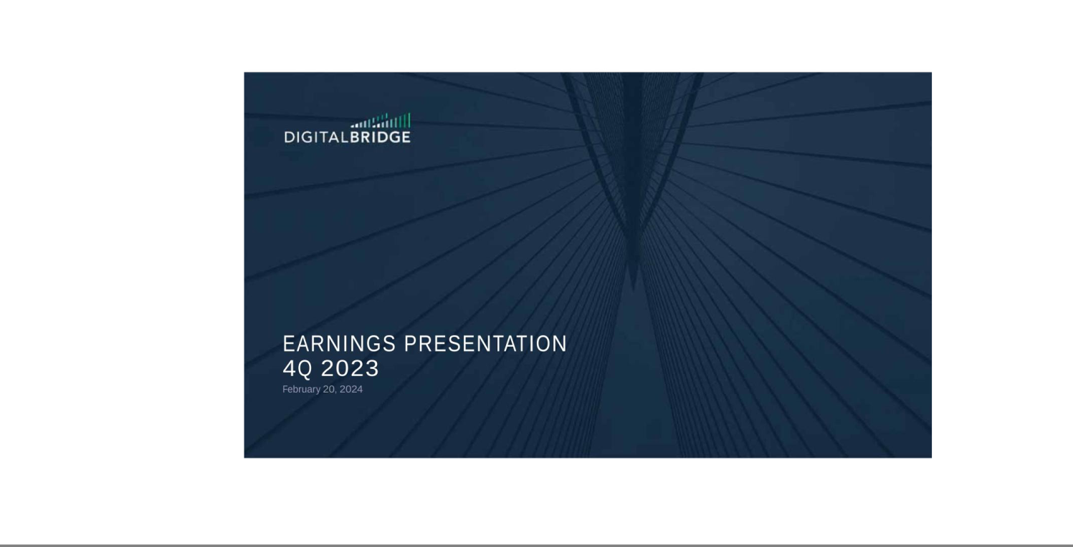

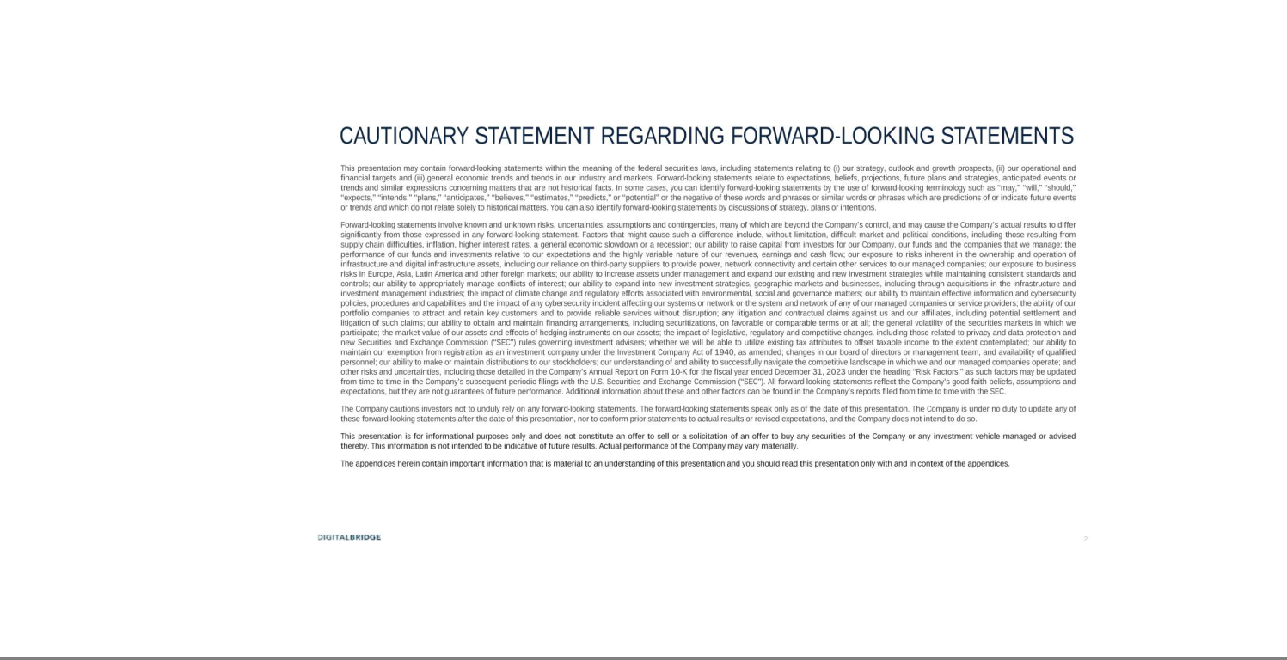

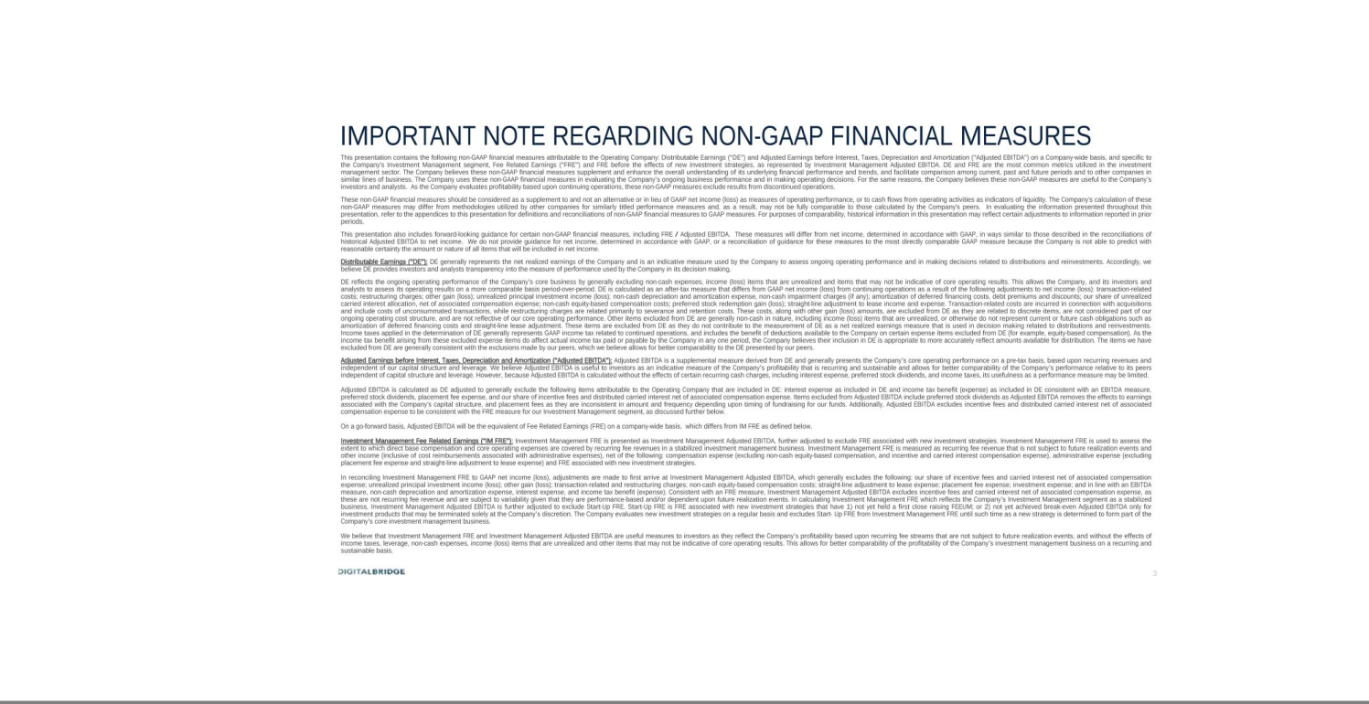

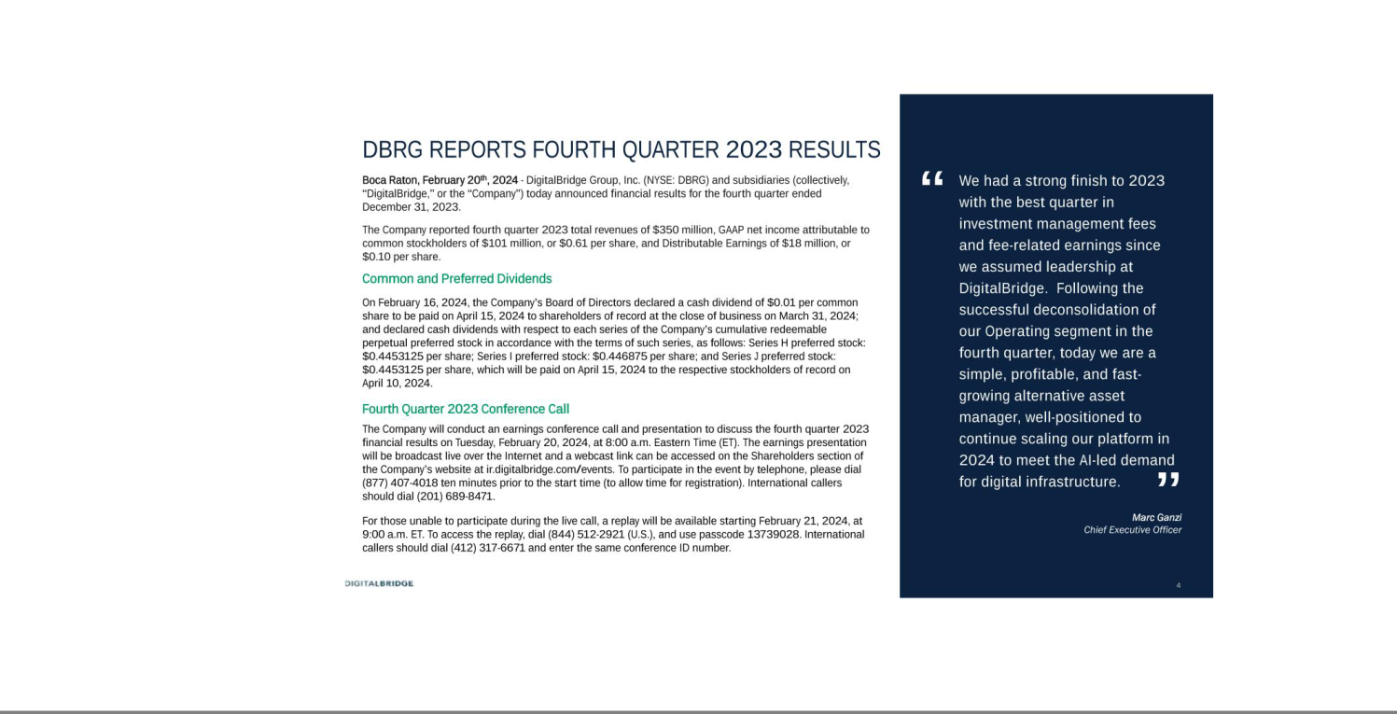

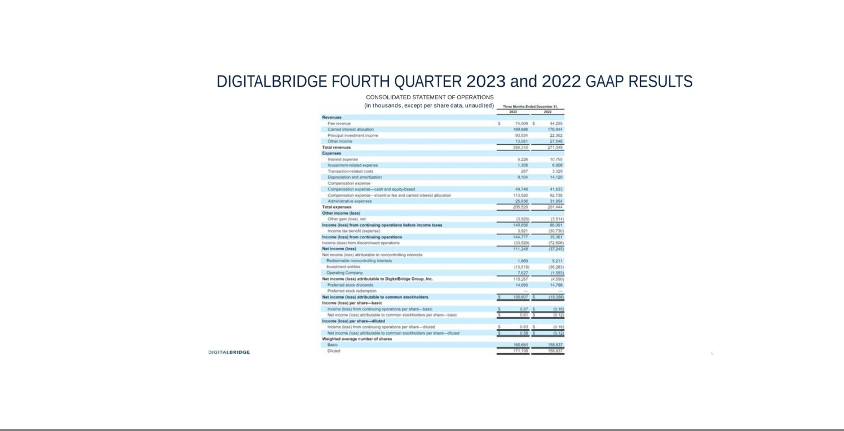



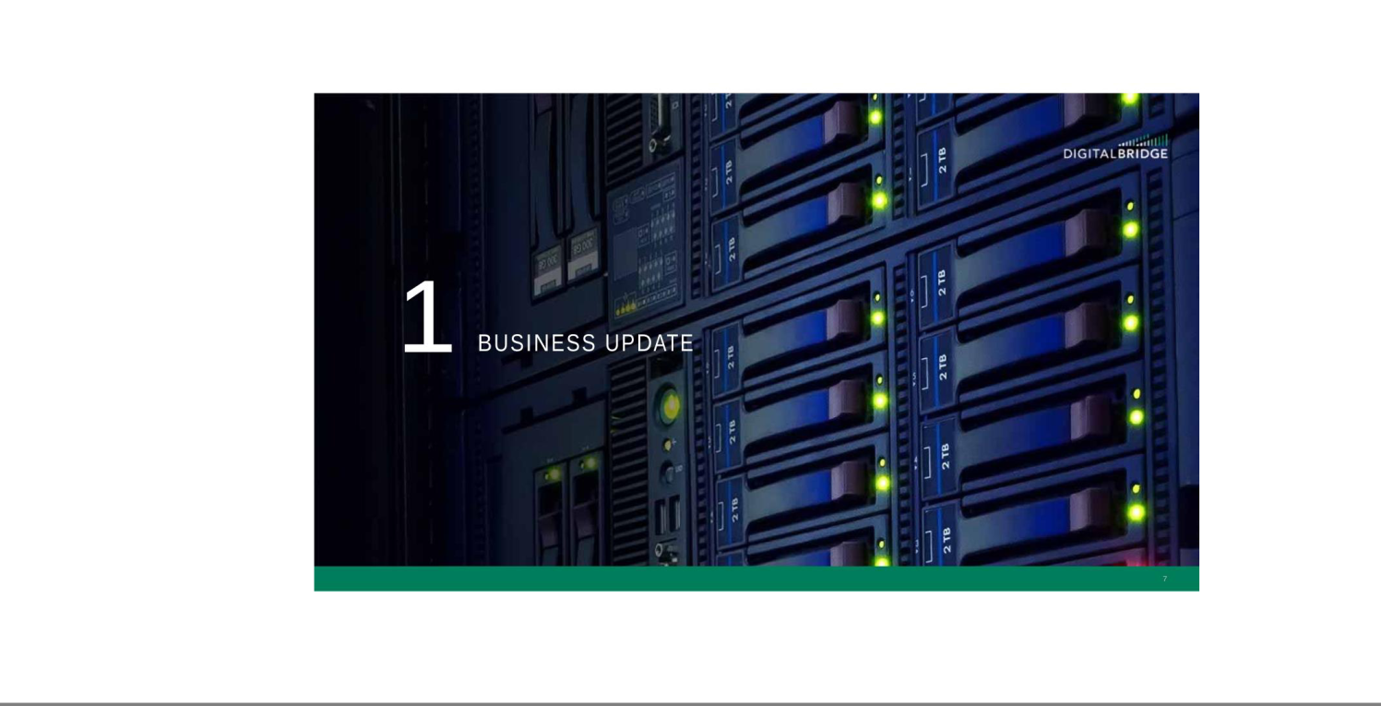

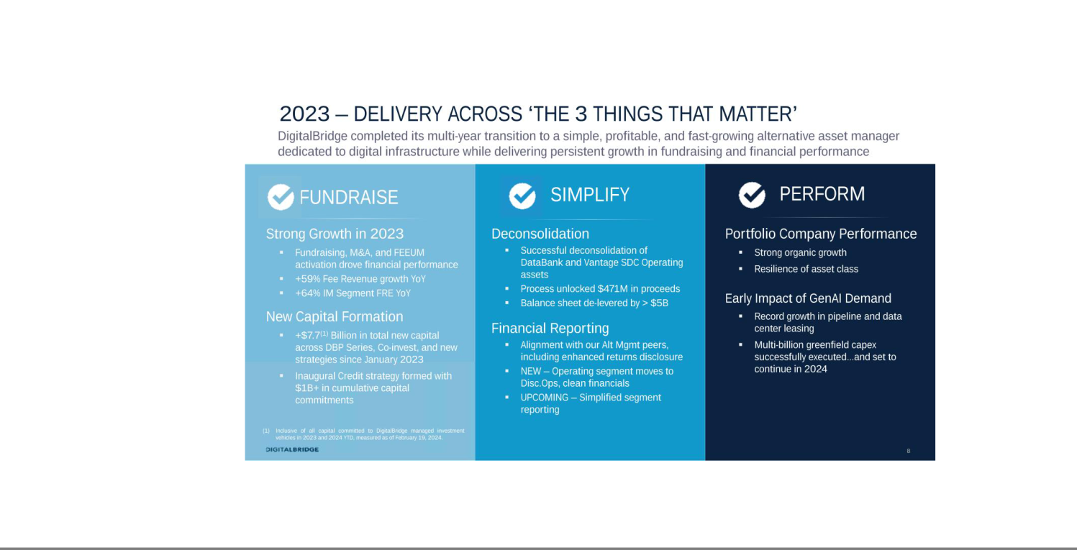

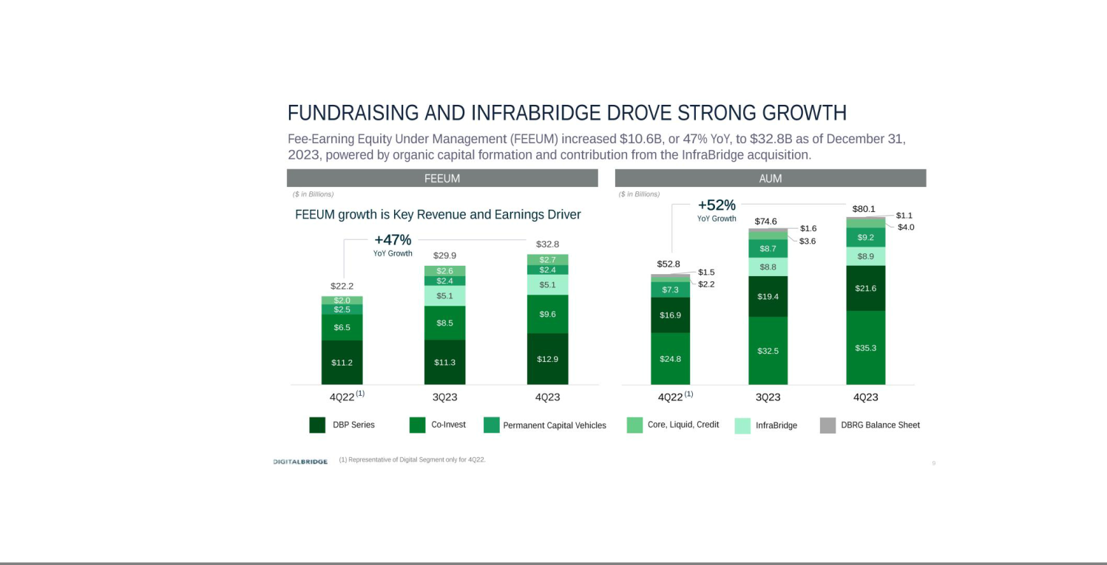

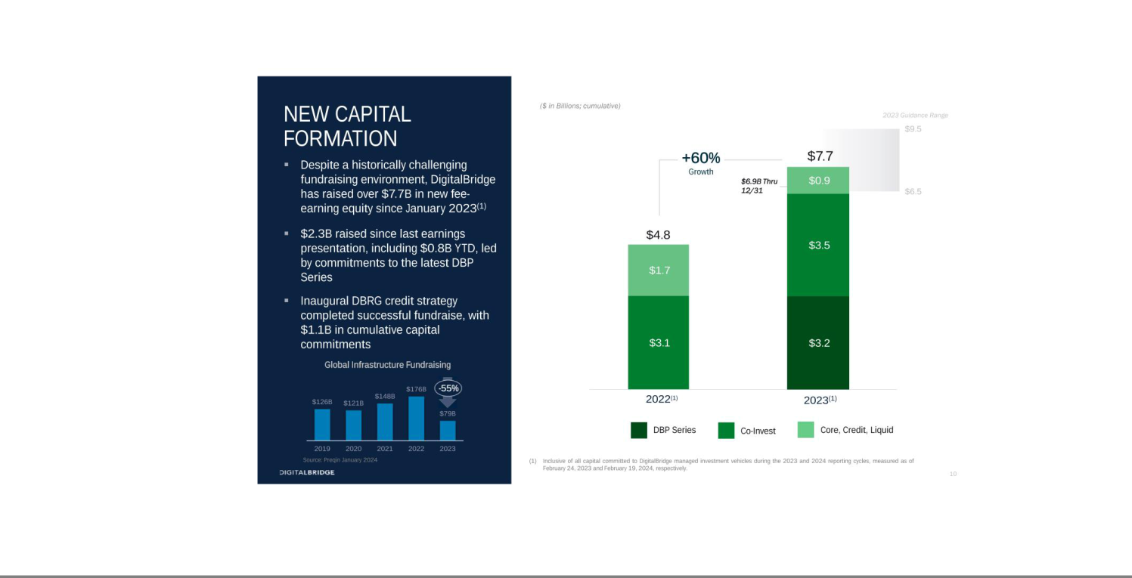

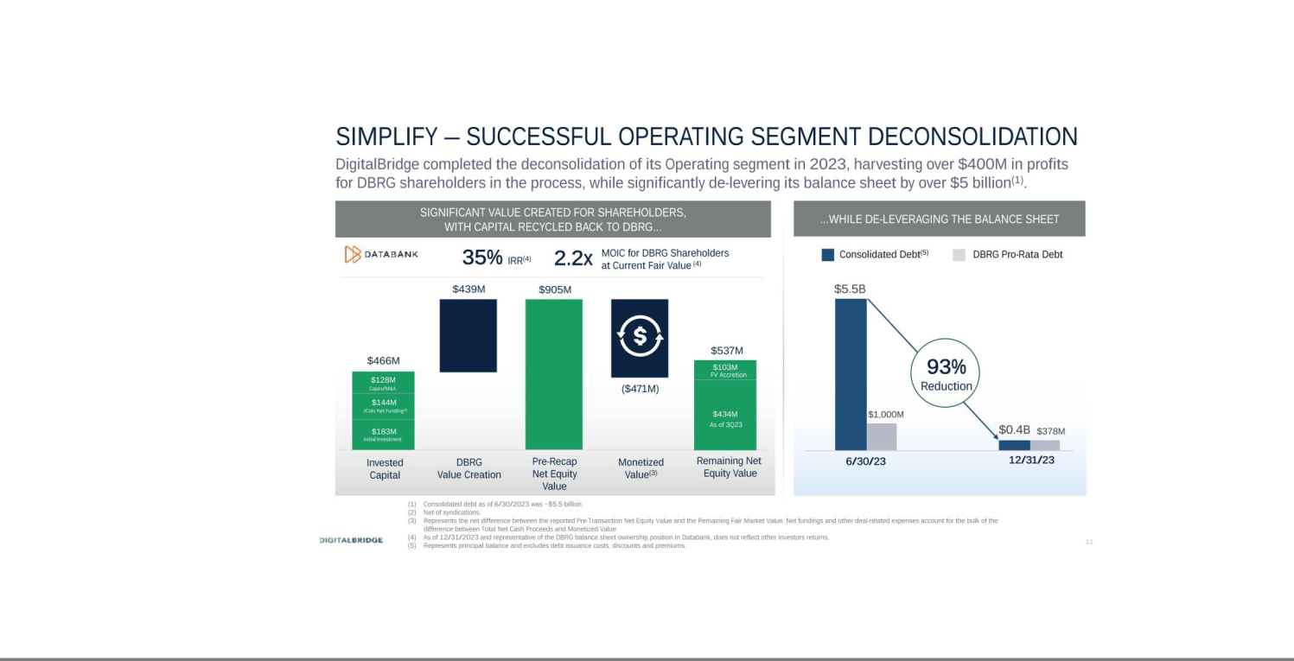

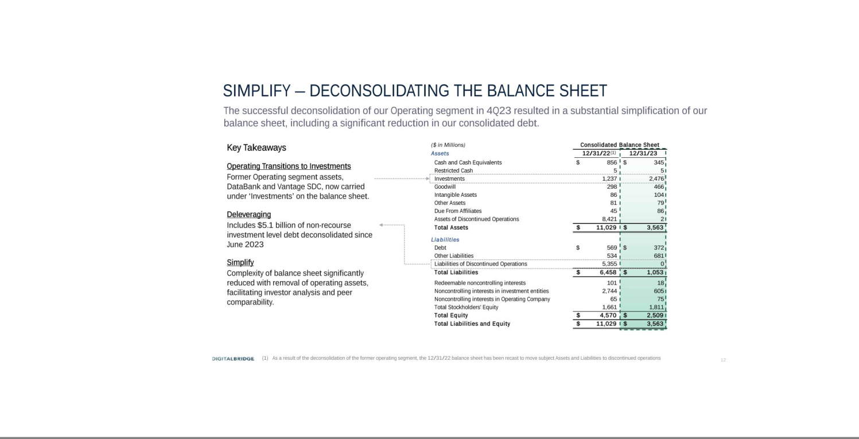

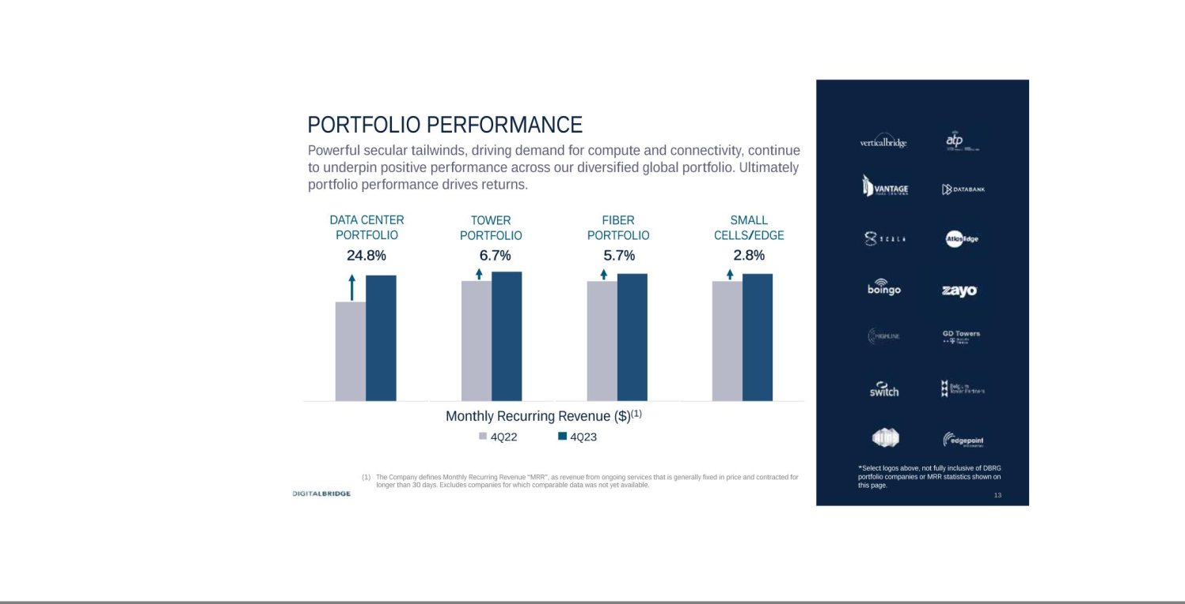



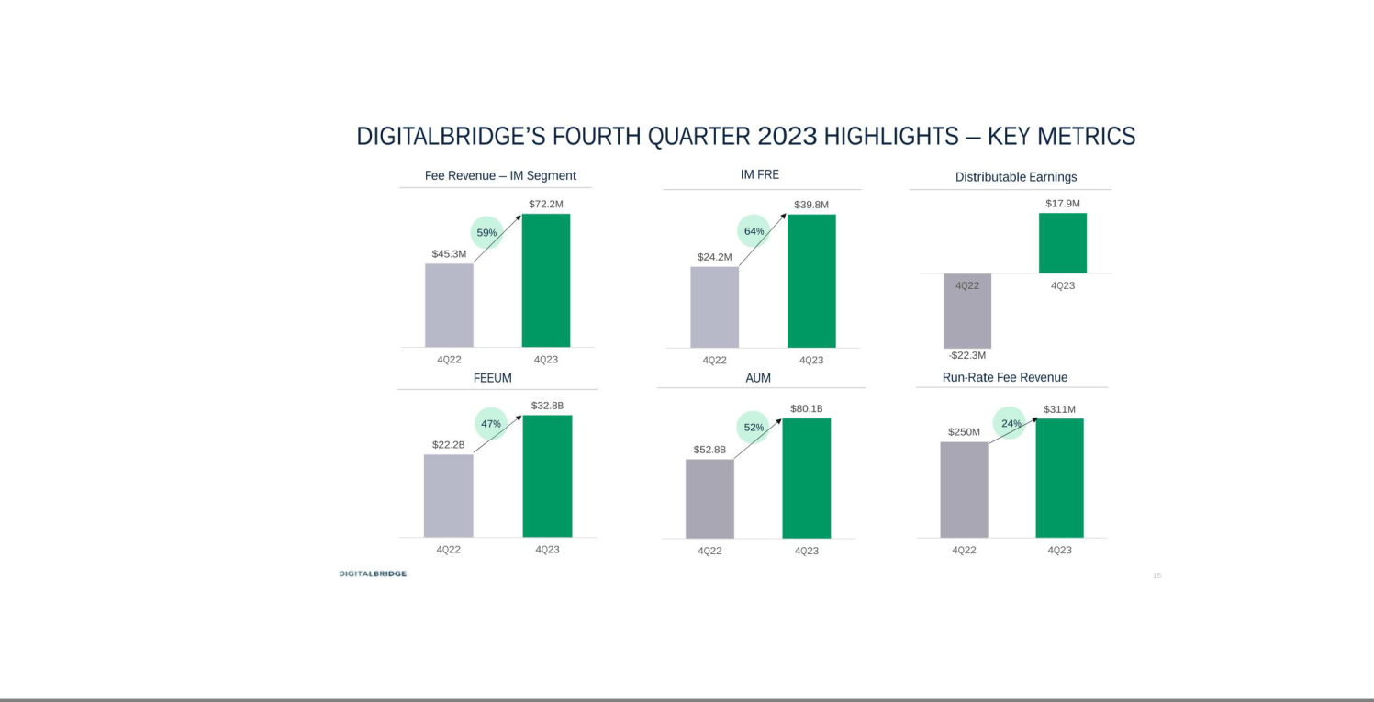

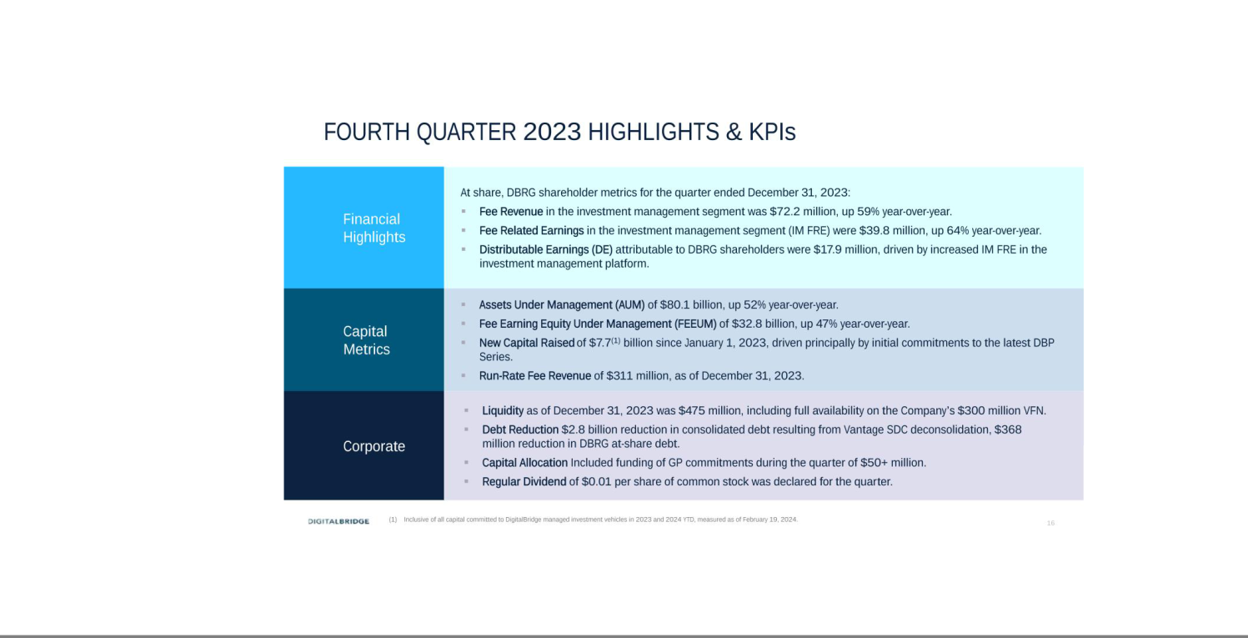

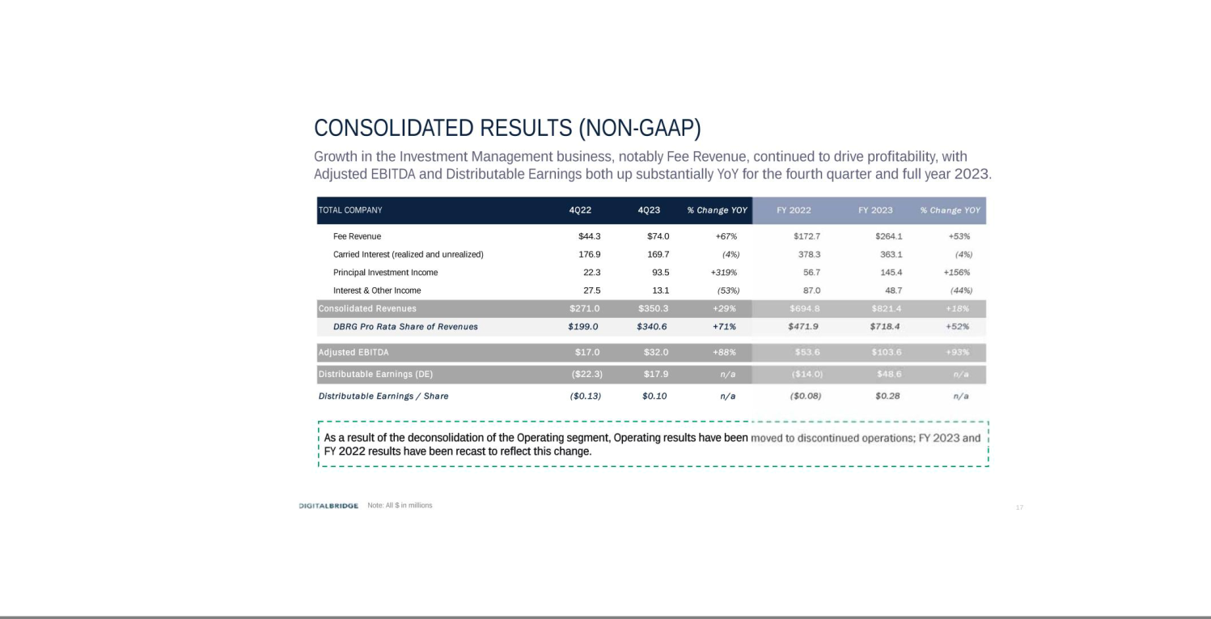

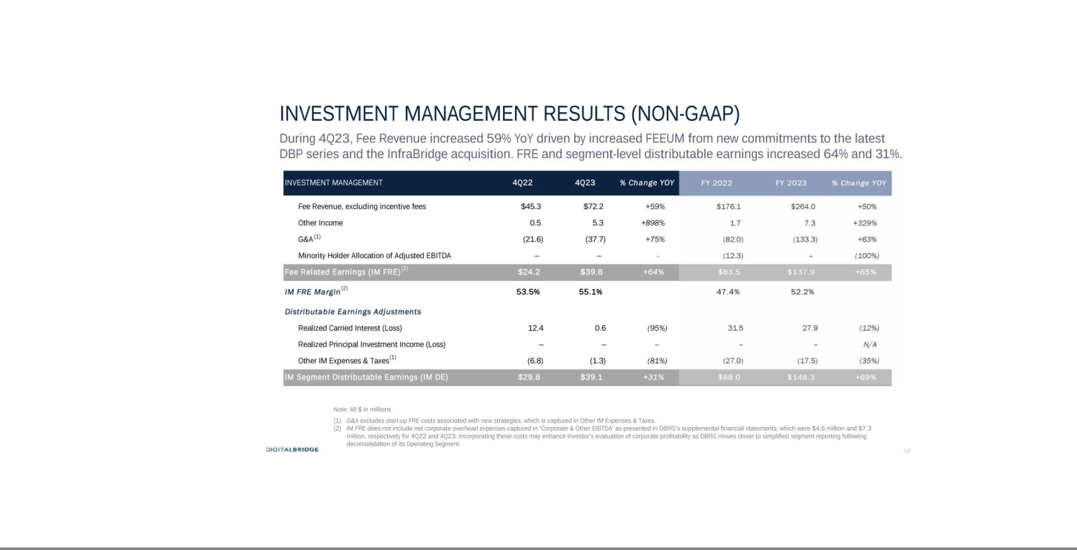

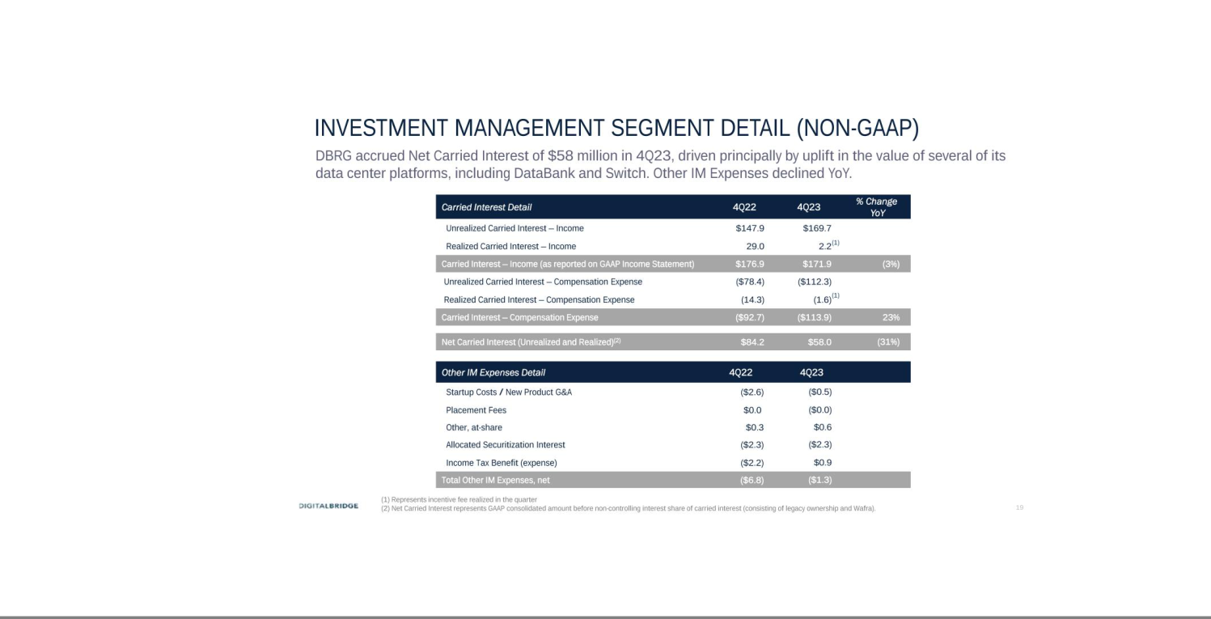

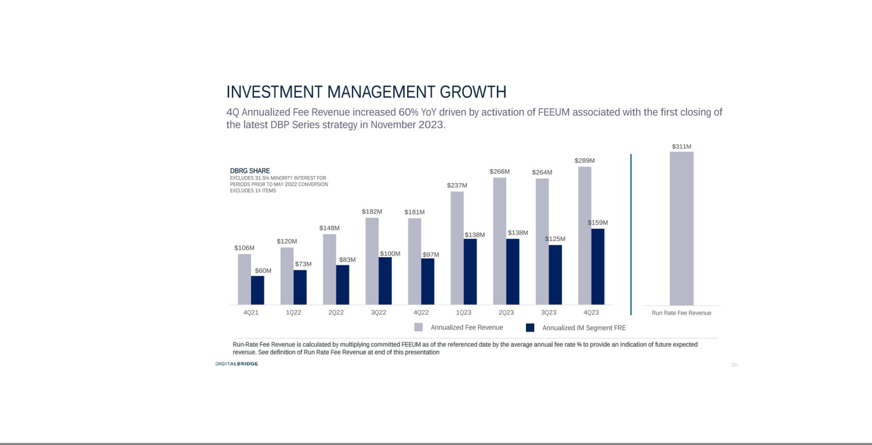

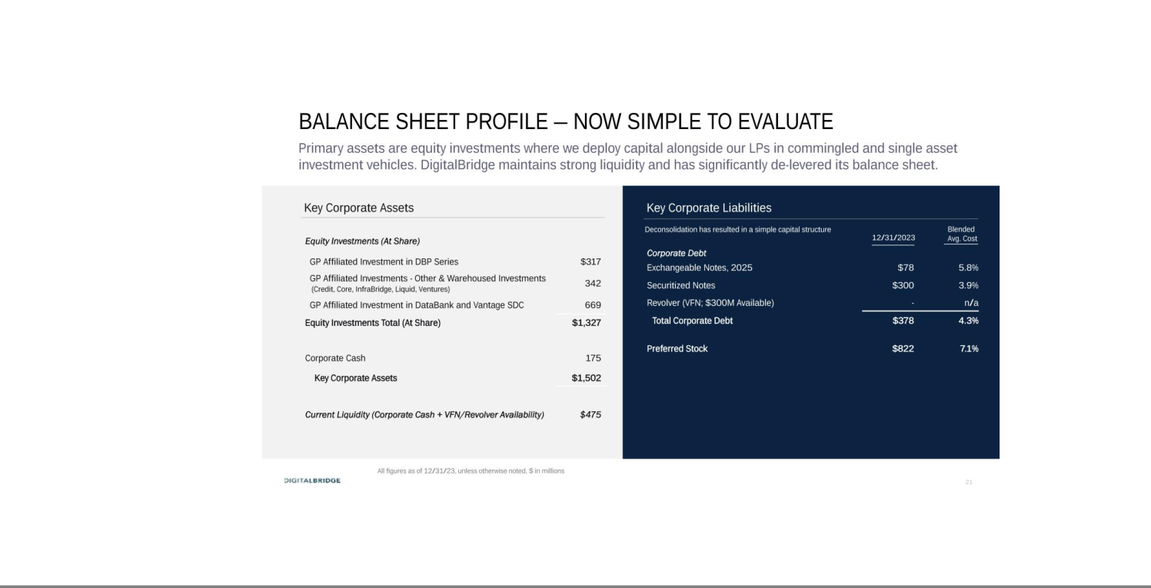

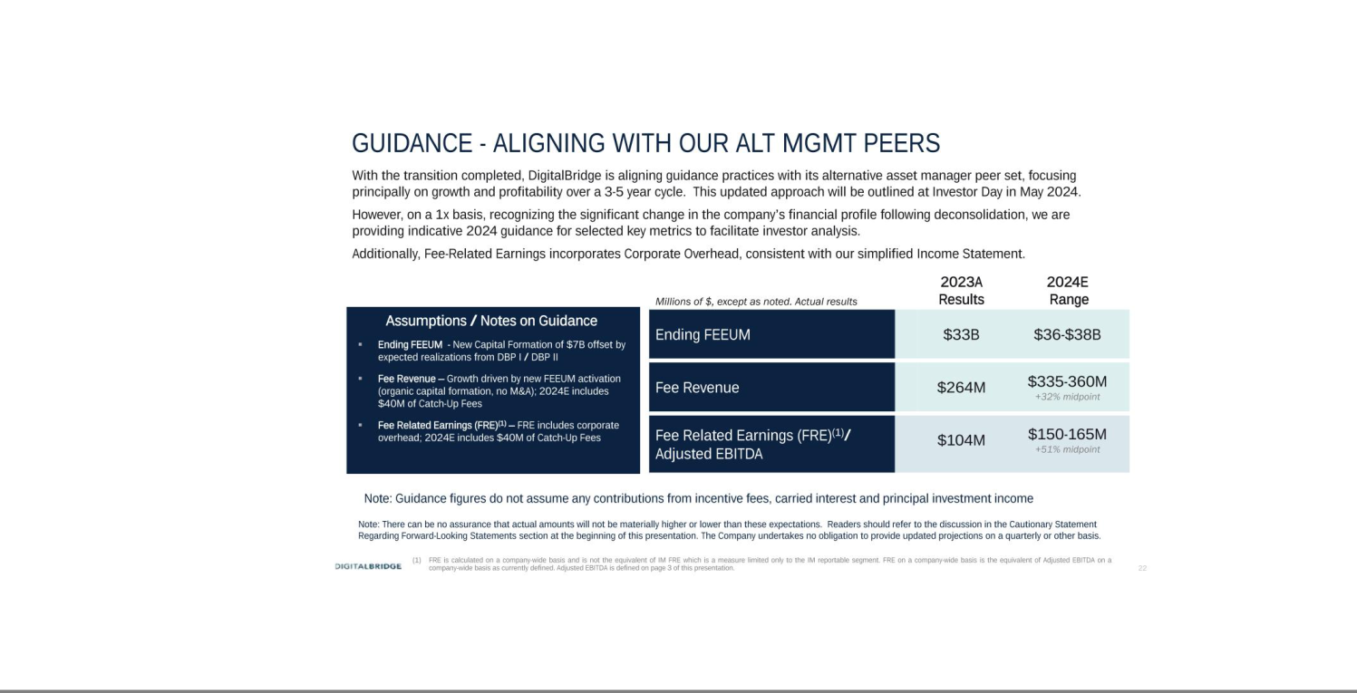

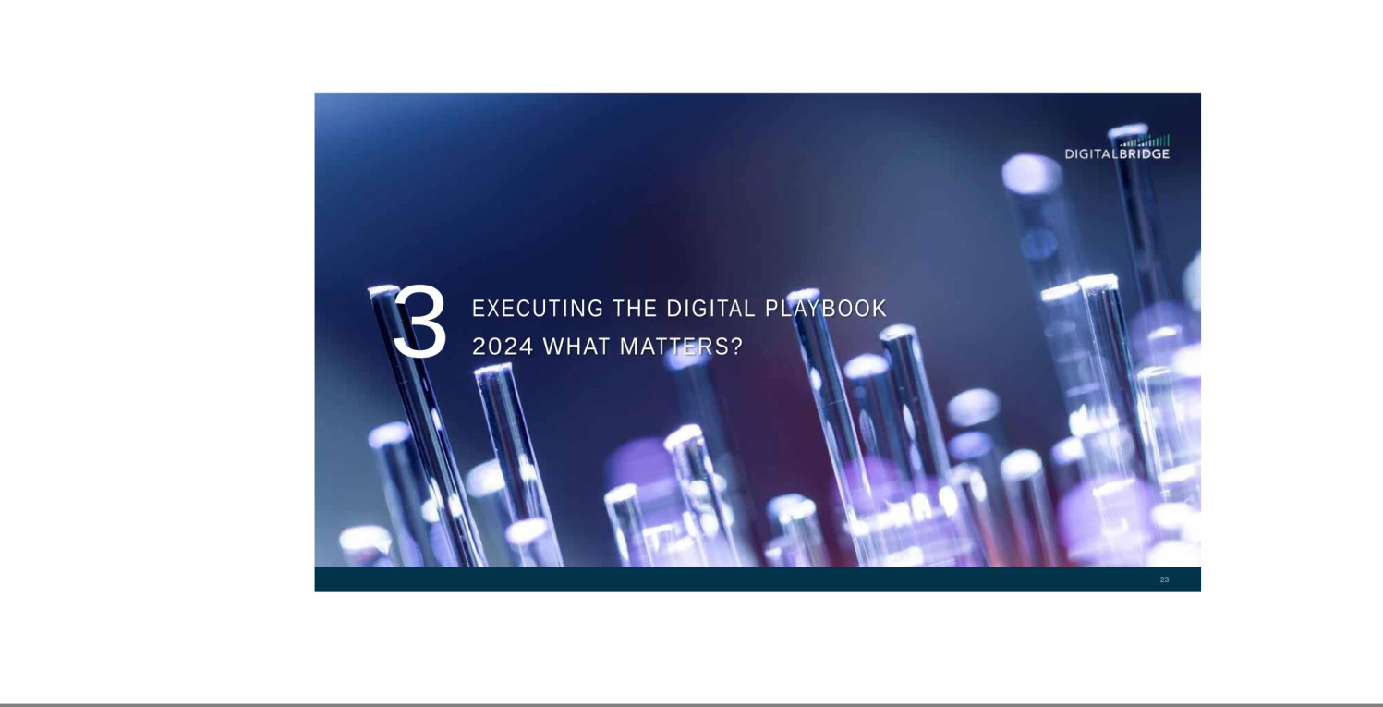

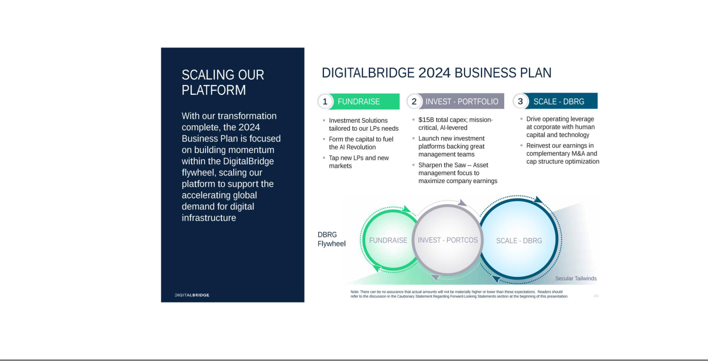

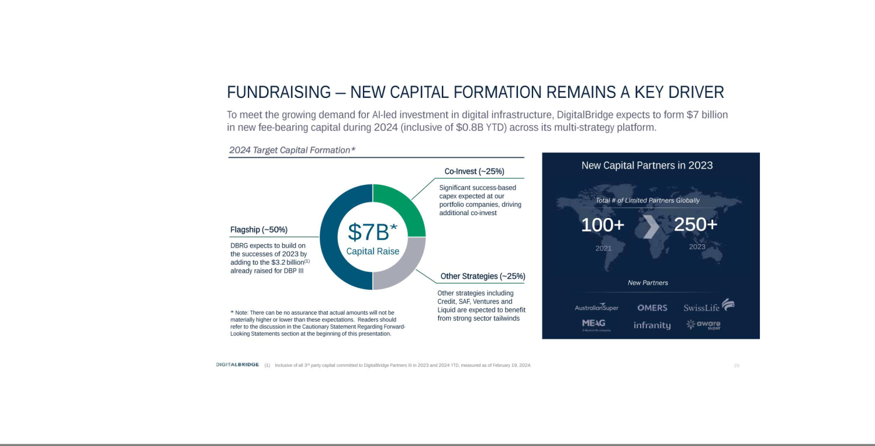

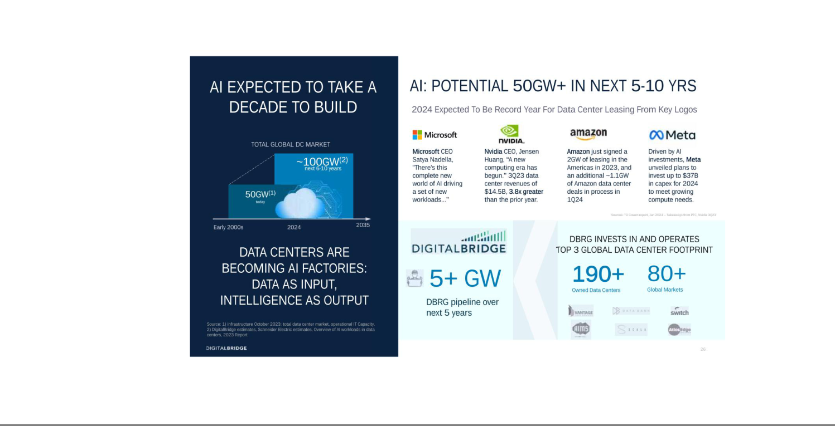

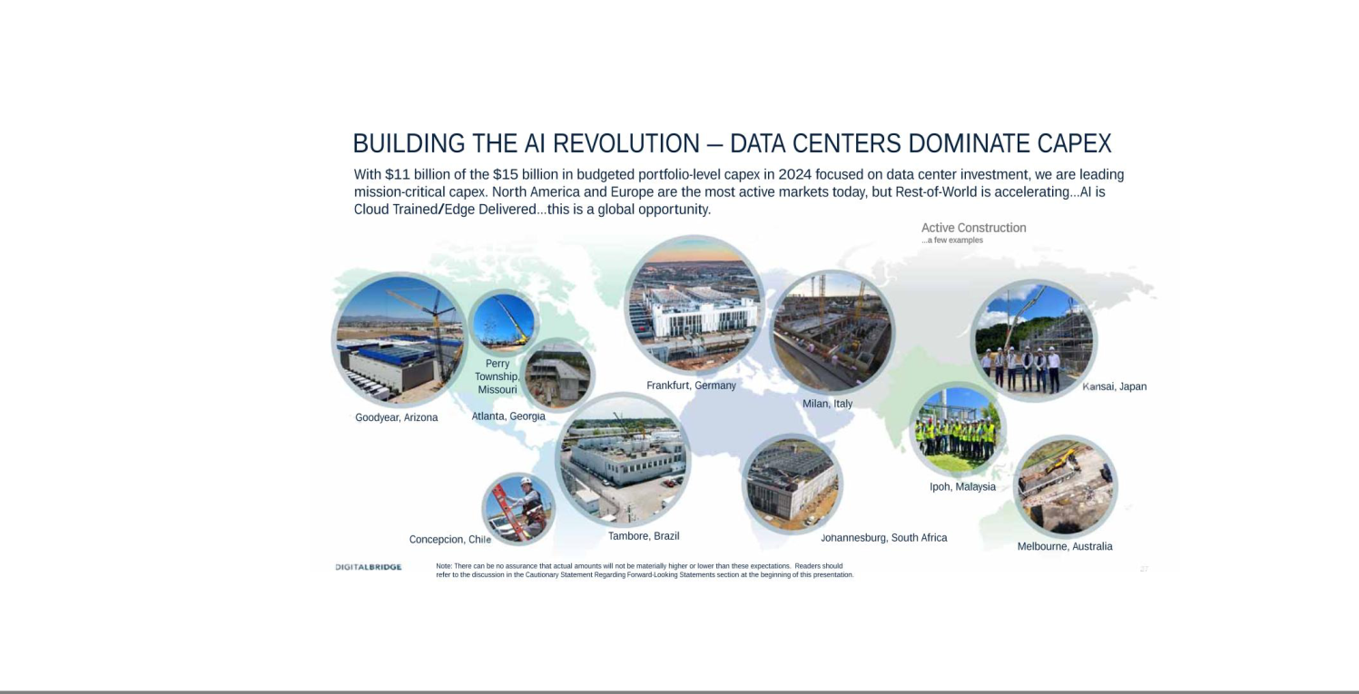

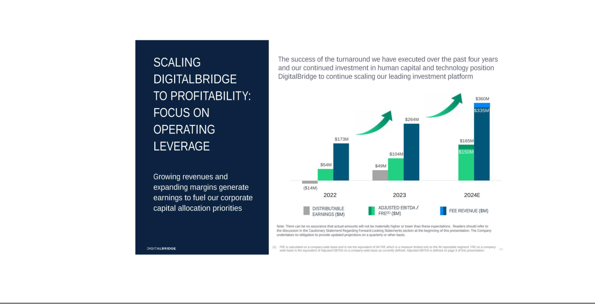

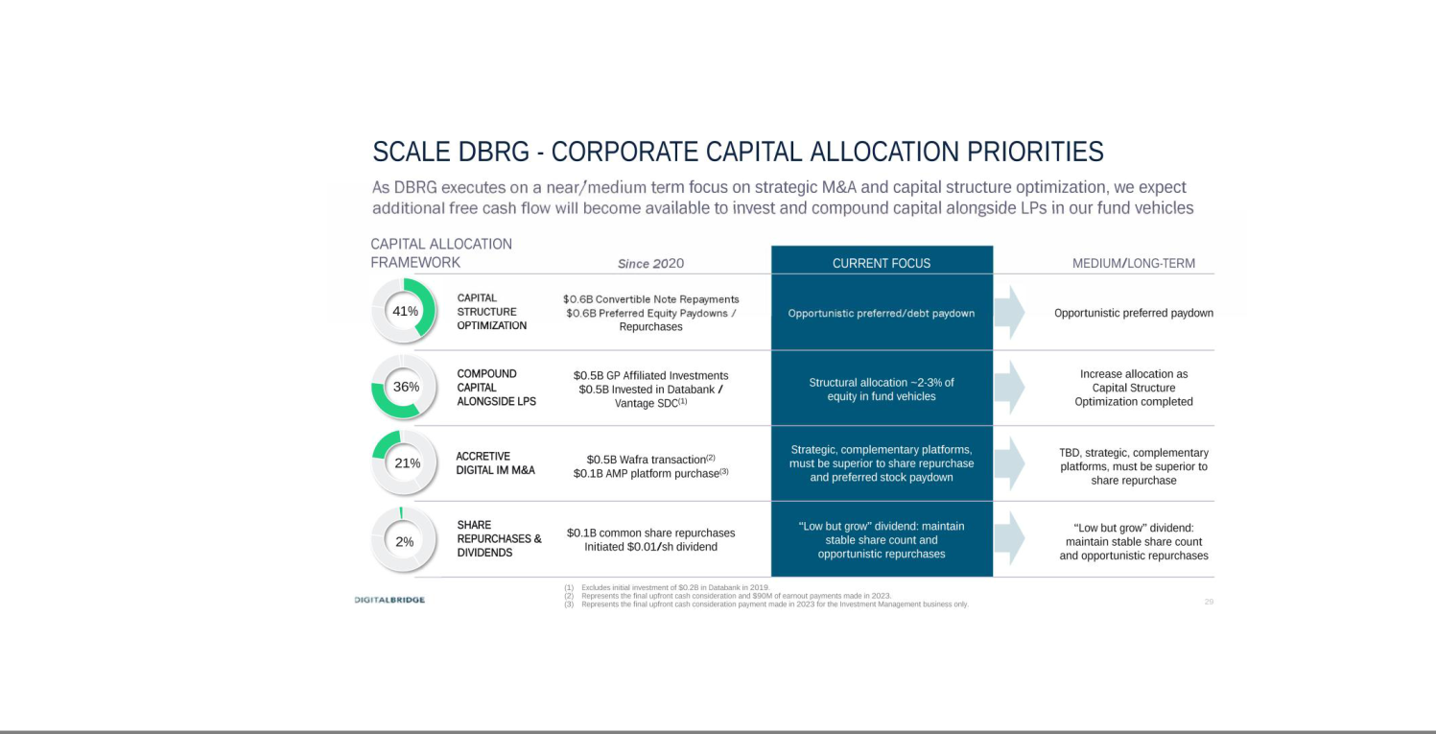

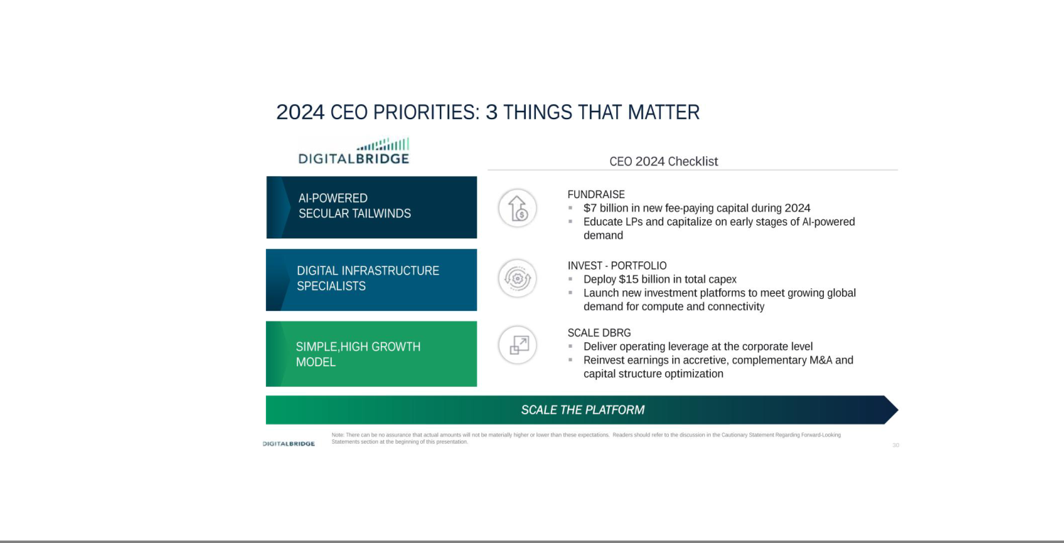

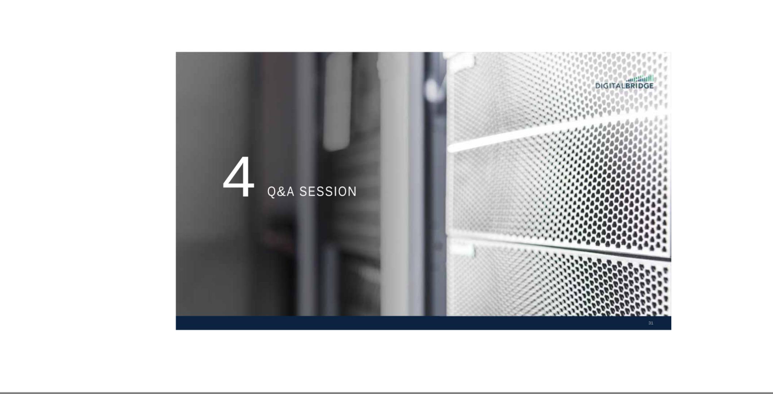



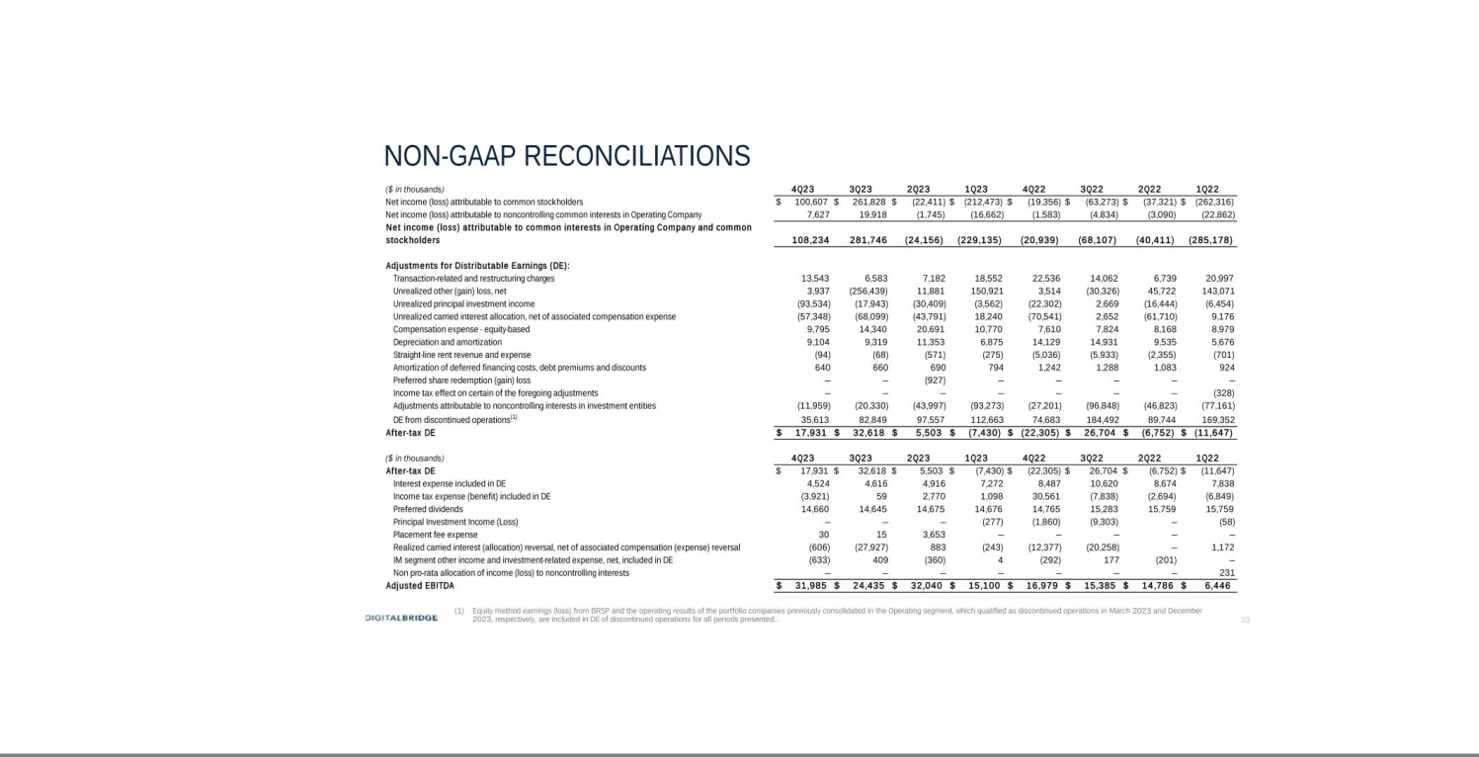

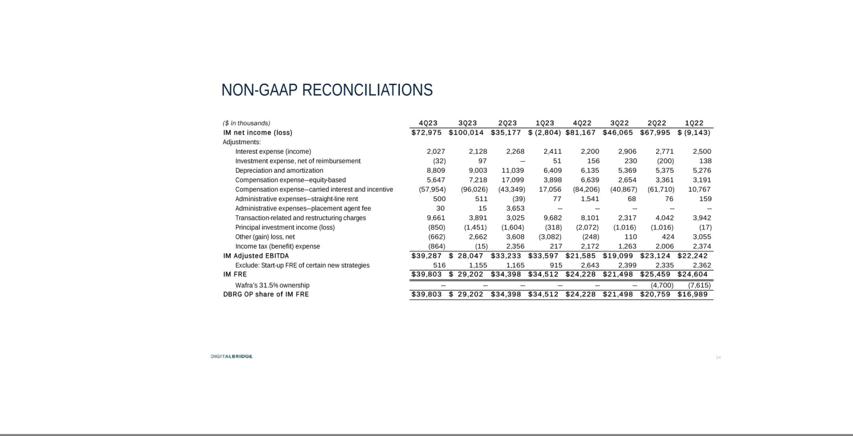

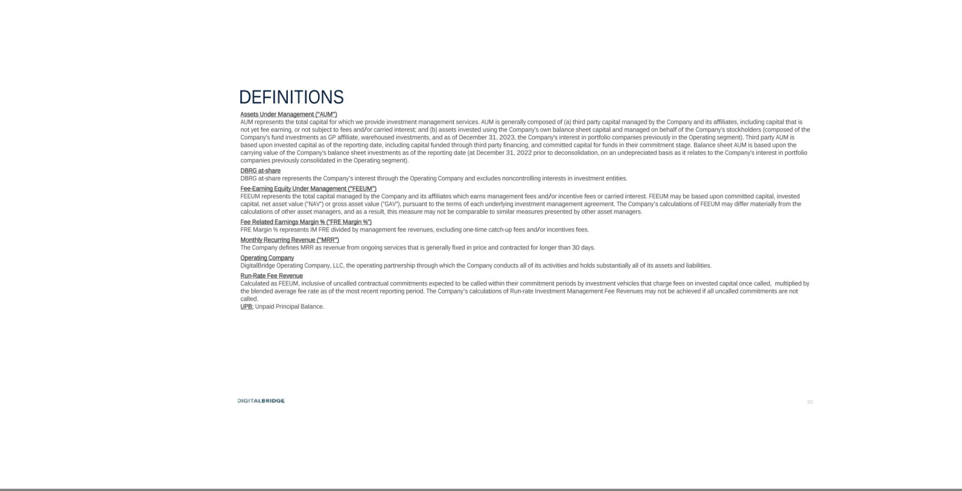



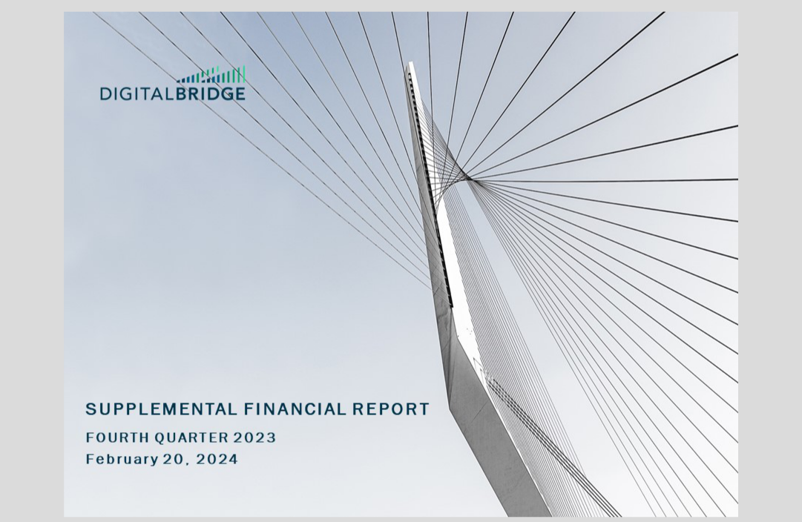

Cautionary Statement Regarding Forward-Looking Statements

This presentation may contain forward-looking statements within the meaning of the federal securities laws. Forward-looking statements relate to expectations, beliefs, projections, future plans and strategies, anticipated events or trends and similar expressions concerning matters that are not historical facts. In some cases, you can identify forward-looking statements by the use of forward-looking terminology such as “may,” “will,” “should,” “expects,” “intends,” “plans,” “anticipates,” “believes,” “estimates,” “predicts,” or “potential” or the negative of these words and phrases or similar words or phrases which are predictions of or indicate future events or trends and which do not relate solely to historical matters. You can also identify forward-looking statements by discussions of strategy, plans or intentions.

Forward-looking statements involve known and unknown risks, uncertainties, assumptions and contingencies, many of which are beyond the Company’s control, and may cause the Company’s actual results to differ significantly from those expressed in any forward-looking statement. Factors that might cause such a difference include, without limitation, difficult market and political conditions, including those resulting from supply chain difficulties, inflation, higher interest rates, a general economic slowdown or a recession; our ability to raise capital from investors for our Company, our funds and the companies that we manage; the performance of our funds and investments relative to our expectations and the highly variable nature of our revenues, earnings and cash flow; our exposure to risks inherent in the ownership and operation of infrastructure and digital infrastructure assets, including our reliance on third-party suppliers to provide power, network connectivity and certain other services to our managed companies; our exposure to business risks in Europe, Asia, Latin America and other foreign markets; our ability to increase assets under management and expand our existing and new investment strategies while maintaining consistent standards and controls; our ability to appropriately manage conflicts of interest; our ability to expand into new investment strategies, geographic markets and businesses, including through acquisitions in the infrastructure and investment management industries; the impact of climate change and regulatory efforts associated with environmental, social and governance matters; our ability to maintain effective information and cybersecurity policies, procedures and capabilities and the impact of any cybersecurity incident affecting our systems or network or the system and network of any of our managed companies or service providers; the ability of our portfolio companies to attract and retain key customers and to provide reliable services without disruption; any litigation and contractual claims against us and our affiliates, including potential settlement and litigation of such claims; our ability to obtain and maintain financing arrangements, including securitizations, on favorable or comparable terms or at all; the general volatility of the securities markets in which we participate; the market value of our assets and effects of hedging instruments on our assets; the impact of legislative, regulatory and competitive changes, including those related to privacy and data protection and new Securities and Exchange Commission (“SEC”) rules governing investment advisers; whether we will be able to utilize existing tax attributes to offset taxable income to the extent contemplated; our ability to maintain our exemption from registration as an investment company under the Investment Company Act of 1940, as amended; changes in our board of directors or management team, and availability of qualified personnel; our ability to make or maintain distributions to our stockholders; our understanding of and ability to successfully navigate the competitive landscape in which we and our managed companies operate and other risks and uncertainties, including those detailed in the Company’s Annual Report on Form 10-K for the fiscal year ended December 31, 2022 under the heading “Risk Factors,” as such factors may be updated from time to time in the Company’s subsequent periodic filings with the U.S. Securities and Exchange Commission (“SEC”). All forward-looking statements reflect the Company’s good faith beliefs, assumptions and expectations, but they are not guarantees of future performance. Additional information about these and other factors can be found in the Company’s reports filed from time to time with the SEC.

The Company cautions investors not to unduly rely on any forward-looking statements. The forward-looking statements speak only as of the date of this presentation. The Company is under no duty to update any of these forward-looking statements after the date of this presentation, nor to conform prior statements to actual results or revised expectations, and the Company does not intend to do so.

This presentation is for informational purposes only and does not constitute an offer to sell or a solicitation of an offer to buy any securities of the Company. This information is not intended to be indicative of future results. Actual performance of the Company may vary materially.
The appendices herein contain important definitions and information that is material to an understanding of this presentation and you should read this presentation only with and in context of the appendices.

DigitalBridge | Supplemental Financial Report

Important Note Regarding Non-GAAP Financial Measures

This financial supplemental package includes certain non-GAAP financial measures and operating metrics that are not defined by generally accepted accounting principles, or GAAP.

The Company conducts its business through its one reportable segment of Investment Management. On December 31, 2023, the Operating segment was discontinued following full deconsolidation of the portfolio companies in the Operating segment, at which time, the activities thereof qualified as discontinued operations. Accordingly, the measures of DE and Adjusted EBITDA exclude the Operating segment for both 2023 and the comparative period of 2022.

The Company reports the following non-GAAP financial measures attributable to the Operating Company: Distributable Earnings (“DE”) and Adjusted Earnings before Interest, Taxes, Depreciation and Amortization (“Adjusted EBITDA”) on a Company-wide basis, and specific to the Company's Investment Management segment, Fee Related Earnings (“FRE”) and FRE before the effects of new investment strategies, as represented by Investment Management Adjusted EBITDA. DE and FRE are the most common metrics utilized in the investment management sector. The Company believes these non-GAAP financial measures supplement and enhance the overall understanding of its underlying financial performance and trends, and facilitate comparison among current, past and future periods and to other companies in similar lines of business. The Company uses these non-GAAP financial measures in evaluating the Company’s ongoing business performance and in making operating decisions. For the same reasons, the Company believes these non-GAAP measures are useful to the Company’s investors and analysts. As the Company evaluates profitability based upon continuing operations, these non-GAAP measures exclude results from discontinued operations. These non-GAAP financial measures should be considered as a supplement to and not an alternative or in lieu of GAAP net income (loss) as measures of operating performance, or to cash flows from operating activities as indicators of liquidity. The Company's calculation of these non-GAAP measures may differ from methodologies utilized by other companies for similarly titled performance measures and, as a result, may not be fully comparable to those calculated by the Company's peers. In evaluating the information presented throughout this supplemental financial report, refer to the appendices to this presentation for definitions and reconciliations of non-GAAP financial measures to GAAP measures. For purposes of comparability, historical information in this presentation may reflect certain adjustments to information reported in prior periods.

DE:

DE generally represents the net realized earnings of the Company and is an indicative measure used by the Company to assess ongoing operating performance and in making decisions related to distributions and reinvestments. Accordingly, we believe DE provides investors and analysts transparency into the measure of performance used by the Company in its decision making.

DE reflects the ongoing operating performance of the Company’s core business by generally excluding non-cash expenses, income (loss) items that are unrealized and items that may not be indicative of core operating results. This allows the Company, and its investors and analysts to assess its operating results on a more comparable basis period-over-period. DE is calculated as an after-tax measure that differs from GAAP net income (loss) from continuing operations as a result of the following adjustments to net income (loss): transaction-related costs; restructuring charges; other gain (loss); unrealized principal investment income (loss); non-cash depreciation and amortization expense, non-cash impairment charges (if any); amortization of deferred financing costs, debt premiums and discounts; our share of unrealized carried interest allocation, net of associated compensation expense; non-cash equity-based compensation costs; preferred stock redemption gain (loss); and straight-line adjustment to lease income and expense. Transaction-related costs are incurred in connection with acquisitions and include costs of unconsummated transactions, while restructuring charges are related primarily to severance and retention costs. These costs, along with other gain (loss) amounts, are excluded from DE as they are related to discrete items, are not considered part of our ongoing operating cost structure, and are not reflective of our core operating performance. Other items excluded from DE are generally non-cash in nature, including income (loss) items that are unrealized, or otherwise do not represent current or future cash obligations such as amortization of deferred financing costs and straight-line lease adjustment. These items are excluded from DE as they do not contribute to the measurement of DE as a net realized earnings measure that is used in decision making related to distributions and reinvestments. Income taxes applied in the determination of DE generally represents GAAP income tax related to continued operations, and includes the benefit of deductions available to the Company on certain expense items excluded from DE (for example, equity-based compensation). As the income tax benefit arising from these excluded expense items do affect actual income tax paid or payable by the Company in any one period, the Company believes their inclusion in DE is appropriate to more accurately reflect amounts available for distribution. The items we have excluded from DE are generally consistent with the exclusions made by our peers, which we believe allows for better comparability to the DE presented by our peers.

DigitalBridge | Supplemental Financial Report

Important Note Regarding Non-GAAP Financial Measures

Adjusted EBITDA:

Adjusted EBITDA is a supplemental measure derived from DE and generally presents the Company’s core operating performance on a pre-tax basis, based upon recurring revenues and independent of our capital structure and leverage. We believe Adjusted EBITDA is useful to investors as an indicative measure of the Company’s profitability that is recurring and sustainable and allows for better comparability of the Company’s performance relative to its peers independent of capital structure and leverage. However, because Adjusted EBITDA is calculated without the effects of certain recurring cash charges, including interest expense, preferred stock dividends, and income taxes, its usefulness as a performance measure may be limited. Adjusted EBITDA is calculated as DE adjusted to generally exclude the following items attributable to the Operating Company that are included in DE: interest expense as included in DE and income tax benefit (expense) as included in DE consistent with an EBITDA measure, preferred stock dividends, placement fee expense, and our share of incentive fees and distributed carried interest net of associated compensation expense. Items excluded from Adjusted EBITDA include preferred stock dividends as Adjusted EBITDA removes the effects to earnings associated with the Company's capital structure, and placement fees as they are inconsistent in amount and frequency depending upon timing of fundraising for our funds. Additionally, Adjusted EBITDA excludes incentive fees and distributed carried interest net of associated compensation expense to be consistent with the FRE measure for our Investment Management segment, as discussed further below.

Investment Management Fee Related Earnings (IM FRE):

Investment Management FRE is presented as Investment Management Adjusted EBITDA, further adjusted to exclude FRE associated with new investment strategies. Investment Management FRE is used to assess the extent to which direct base compensation and core operating expenses are covered by recurring fee revenues in a stabilized investment management business. Investment Management FRE is measured as recurring fee revenue that is not subject to future realization events and other income (inclusive of cost reimbursements associated with administrative expenses), net of the following: compensation expense (excluding non-cash equity-based compensation, and incentive and carried interest compensation expense), administrative expense (excluding placement fee expense and straight-line adjustment to lease expense) and FRE associated with new investment strategies. In reconciling Investment Management FRE to GAAP net income (loss), adjustments are made to first arrive at Investment Management Adjusted EBITDA, which generally excludes the following: our share of incentive fees and carried interest net of associated compensation expense; unrealized principal investment income (loss); other gain (loss); transaction-related and restructuring charges; non-cash equity-based compensation costs; straight-line adjustment to lease expense; placement fee expense; investment expense; and in line with an EBITDA measure, non-cash depreciation and amortization expense, interest expense, and income tax benefit (expense). Consistent with an FRE measure, Investment Management Adjusted EBITDA excludes incentive fees and carried interest net of associated compensation expense, as these are not recurring fee revenue and are subject to variability given that they are performance-based and/or dependent upon future realization events. In calculating Investment Management FRE which reflects the Company’s Investment Management segment as a stabilized business, Investment Management Adjusted EBITDA is further adjusted to exclude Start-Up FRE. Start-Up FRE is FRE associated with new investment strategies that have 1) not yet held a first close raising FEEUM; or 2) not yet achieved break-even Adjusted EBITDA only for investment products that may be terminated solely at the Company’s discretion. The Company evaluates new investment strategies on a regular basis and excludes Start- Up FRE from Investment Management FRE until such time as a new strategy is determined to form part of the Company’s core investment management business. We believe that Investment Management FRE and Investment Management Adjusted EBITDA are useful measures to investors as they reflect the Company’s profitability based upon recurring fee streams that are not subject to future realization events, and without the effects of income taxes, leverage, non-cash expenses, income (loss) items that are unrealized and other items that may not be indicative of core operating results. This allows for better comparability of the profitability of the Company’s investment management business on a recurring and sustainable basis.

DigitalBridge | Supplemental Financial Report

Note Regarding DBRG Reportable Segments / Consolidated and OP Share of Consolidated Amounts

This presentation includes supplemental financial information for the following segments:

Investment Management (IM)

This segment represents the Company's global investment management platform, deploying and managing capital on behalf of a diverse base of global institutional investors. The Company's investment management platform is composed of a growing number of long-duration, private investment funds designed to provide institutional investors access to investments across different segments of the digital infrastructure ecosystem. In addition to its flagship value-add digital infrastructure equity offerings, the Company's investment offerings have expanded to include core equity, credit and liquid securities. The Company earns management fees based upon the assets or capital managed in investment vehicles, and may earn incentive fees and carried interest based upon the performance of such investment vehicles, subject to achievement of minimum return hurdles. The amount of incentive fees and carried interest recognized, a portion of which is allocated to employees and former employees, may be highly variable from period to period. Through the end of May 2022, earnings from the Investment Management segment were attributed 31.5% to Wafra prior to the Company's redemption of Wafra's interest in the investment management business.

Corporate and Other

The Company's remaining investment activities and corporate level activities are presented as Corporate and Other.

Other investment activities are composed primarily of the Company's equity interests as general partner affiliate in its sponsored investment vehicles, the largest of which are the DBP flagship funds, InfraBridge funds, DataBank and Vantage SDC post-deconsolidation, and seed investments in liquid securities and other potential new strategies. With respect to seed investments, these are not intended to be a long-term deployment of capital by the Company and are expected to be warehoused temporarily on the Company's balance sheet until sufficient third party capital has been raised. The Company's remaining non-digital investments consisted, for the most part, of shares in BRSP that were disposed in March 2023. The Company's other investment activities generate largely principal investment income, driven by fair value changes of underlying investments held by its investment vehicles, and to a lesser extent, interest income or dividend income from warehoused investments and investments of consolidated investment vehicles.

Corporate activities include corporate level cash and corresponding interest income, corporate level financing and related interest expense, corporate level transaction costs, costs in connection with unconsummated investments, income and expense related to cost reimbursement arrangements with affiliates, fixed assets for corporate use, compensation expense not directly attributable to reportable segments, and corporate level administrative and overhead costs. Costs which are directly attributable, or otherwise can be subjected to a reasonable and systematic attribution, have been attributed to reportable segments. As segment results are presented before elimination of intercompany fees, elimination adjustment is made with respect to fee income earned by the Investment Management segment from third party capital in managed investment vehicles consolidated in Corporate and Other.

Fund Performance Metrics:

Certain performance metrics for our key investment funds from inception through December 31, 2023 are presented in this financial supplemental presentation. Excluded are funds with less than one year of performance history as of December 31, 2023, funds and separately managed accounts in the liquid strategy, co-investment vehicles and separately capitalized portfolio companies. The historical performance of these funds is not indicative of their future performance nor indicative of the performance of our other existing investment vehicles or of any of our future funds. An investment in DigitalBridge Group, Inc. is not an investment in any of our funds and these fund performance metrics are not indicative of the performance of DigitalBridge Group, Inc.

Throughout this presentation, consolidated figures represent the interest of both the Company (and its subsidiary DigitalBridge Operating Company, LLC (the Operating Company" or “DBRG OP”)) and noncontrolling interests. Figures labeled as DBRG OP share represent the Company’s pro-rata share.

DigitalBridge | Supplemental Financial Report

Table of Contents

- Financial Overview

  - Summary Financial Metrics

  - Investment Management & Fund Performance

- Financial Results

  - Balance Sheet Consolidated & Noncontrolling Interests’ Share

  - Consolidated Segment Operating Results

  - Noncontrolling Interests’ Share Segment Operating Results

  - Segment Reconciliation of Net Income to DE and Adjusted EBITDA

- Capitalization

  - Debt and Preferred Stock Summary

  - Secured Fund Fee Revenue Notes and Variable Funding Notes

IV.Other

- Cash G&A Expense

Appendices

Reconciliation of IM FRE to Net Income (Loss)

Reconciliations of DE and Adjusted EBITDA and to Net Income (Loss)

Definitions

Page

7

8-9

10

11

12

13-14

15

16

17

18

20

21-22

23

DigitalBridge | Supplemental Financial Report | 6

Ia. Summary Financial Metrics

($ and shares in thousands, except per share data and as noted) (Unaudited) | 12/31/2023 - 4Q23 |  |  | 9/30/2023 - 3Q23 |  | 6/30/2023 - 2Q23 |  | 3/31/2023 - 1Q23 | 12/31/2022 - 4Q22 |  |  | 9/30/2022 - 3Q22 |  | 6/30/2022 - 2Q22 |  | 3/31/2022 - 1Q22
Financial Data
Total Company
Net income (loss) attributable to common stockholders | $ | 100,607 | $ | 261,828 | $ | (22,411) | $ | (212,473) | $ | (19,356) | $ | (63,273) | $ | (37,321) | $ | (262,316)
Net income (loss) attributable to common stockholders per basic share⁽¹⁾ |  | 0.61 |  | 1.60 |  | (0.14) |  | (1.34) |  | (0.12) |  | (0.39) |  | (0.24) |  | (1.84)
Distributable Earnings ("DE") |  | 17,931 |  | 32,618 |  | 5,503 |  | (7,430) |  | (22,305) |  | 26,704 |  | (6,752) |  | (11,647)
DE per basic share⁽¹⁾ |  | 0.10 |  | 0.19 |  | 0.03 |  | (0.04) |  | (0.13) |  | 0.15 |  | (0.04) |  | (0.07)
Adjusted EBITDA |  | 31,985 |  | 24,435 |  | 32,040 |  | 15,100 |  | 16,979 |  | 15,385 |  | 14,786 |  | 6,446
Investment Management
Total Assets Under Management ("AUM") (in billions) | $ | 80.1 | $ | 74.6 | $ | 72.2 | $ | 69.3 | $ | 52.8 | $ | 50.3 | $ | 47.9 | $ | 46.6
Fee Earning Equity Under Management ("FEEUM") (in billions) | $ | 32.8 | $ | 29.9 | $ | 29.1 | $ | 27.7 | $ | 22.2 | $ | 20.5 | $ | 19.0 | $ | 18.8
IM management fee revenue - DBRG OP share |  | 72,205 |  | 66,058 |  | 66,460 |  | 59,229 |  | 45,272 |  | 42,039 |  | 36,948 |  | 29,921
IM FRE - DBRG OP share |  | 39,803 |  | 29,202 |  | 34,398 |  | 34,512 |  | 24,228 |  | 21,498 |  | 20,759 |  | 16,989
IM FRE margin % |  | 54.8% |  | 44.2% |  | 51.8% |  | 58.3% |  | 53.5% |  | 51.1% |  | 56.2% |  | 56.8%
Net realized carried interest and incentive fees |  | 606 |  | 27,927 |  | (883) |  | 243 |  | 12,377 |  | 20,258 |  | — |  | (1,172)
Balance Sheet and Capitalization
Consolidated assets | $ | 3,562,550 | $ | 6,872,091 | $ | 10,757,065 | $ | 10,743,429 | $ | 11,028,503 | $ | 11,740,829 | $ | 11,877,288 | $ | 11,232,157
Consolidated debt⁽²⁾ |  | 378,422 |  | 383,082 |  | 404,222 |  | 579,022 |  | 578,922 |  | 888,574 |  | 1,135,156 |  | 708,922
DBRG OP Share:
Total Assets |  | 2,919,643 |  | 2,888,793 |  | 2,868,093 |  | 3,001,644 |  | 3,334,288 |  | 3,755,231 |  | 4,177,806 |  | 3,561,501
Corporate debt |  | 378,422 |  | 378,422 |  | 378,422 |  | 578,422 |  | 578,422 |  | 578,422 |  | 648,422 |  | 578,422
Investment-level debt |  | — |  | 1,351 |  | 7,006 |  | 149 |  | 124 |  | 177,396 |  | 348,196 |  | 130,500
Total Debt⁽²⁾ |  | 378,422 |  | 379,773 |  | 385,428 |  | 578,571 |  | 578,546 |  | 755,818 |  | 996,618 |  | 708,922
Corporate cash |  | 175,195 |  | 230,300 |  | 204,508 |  | 449,368 |  | 733,382 |  | 423,441 |  | 55,628 |  | 813,237
Corporate cash & VFN / Revolver borrowing availability |  | 475,195 |  | 530,300 |  | 504,508 |  | 749,368 |  | 1,033,382 |  | 723,441 |  | 285,628 |  | 1,013,237
Perpetual Preferred Equity, $25 per share liquidation preference |  | 821,899 |  | 821,899 |  | 821,899 |  | 827,711 |  | 827,779 |  | 827,779 |  | 883,500 |  | 883,500
Basic shares and OP units outstanding⁽¹⁾⁽³⁾ |  | 175,751 |  | 175,806 |  | 175,017 |  | 174,630 |  | 172,558 |  | 175,770 |  | 176,733 |  | 162,265
Diluted shares and OP units outstanding⁽¹⁾⁽³⁾ |  | 186,406 |  | 185,943 |  | 185,506 |  | 185,243 |  | 182,907 |  | 188,478 |  | 191,185 |  | 180,758
Common dividend per share | $ | 0.01 | $ | 0.01 | $ | 0.01 | $ | 0.01 | $ | 0.01 | $ | 0.01 | $ | — | $ | —

Notes:

- In August 2022, the Company effectuated a 1-for-4 reverse stock split of its shares of class A and B common stock. All prior period common share and per share information is presented after giving effect to the reverse stock split.

- Represents principal balance and excludes debt issuance costs, discounts and premiums.

- Basic shares and OP units outstanding for the respective quarters represent the shares/units outstanding at quarter end of Class A and Class B common stock, inclusive of unvested restricted stock and OP units. For the purpose of calculating basic DE per share, the basic shares and OP units represent the weighted average number of share/units during the respective quarters and is inclusive of vested deferred stock units. Diluted shares and OP units outstanding for the respective quarters represent the number of basic shares and OP units outstanding at quarter end, adjusted to include the effect of potentially dilutive share equivalents which are common stock issuable in connection with performance stock units, exchangeable senior notes and in-the-money warrants issued to Wafra.

DigitalBridge | Supplemental Financial Report | 7

Ib. Investment Management

($ in millions)
 | 12/31/23
Investment Management FEEUM |  | Annual IM |  |  | 12/31/23 |  | 9/30/23 |  | 6/30/23 |  | 3/31/23 |  | 12/31/22 |  | 9/30/22 |  | 6/30/22 |  | 3/31/22
Investment Management FEEUM |  | Fee Rate |  |  | 12/31/23 |  | 9/30/23 |  | 6/30/23 |  | 3/31/23 |  | 12/31/22 |  | 9/30/22 |  | 6/30/22 |  | 3/31/22
DigitalBridge Partners I (DBP I) |  | 1.10% | $ |  | 3,571 | $ | 3,345 | $ | 3,311 | $ | 3,180 | $ | 3,165 | $ | 2,802 | $ | 3,048 | $ | 3,034
DigitalBridge Partners II (DBP II) | 1.18% |  |  |  | 6,687 |  | 7,996 |  | 7,996 |  | 7,996 |  | 7,996 |  | 7,996 |  | 7,996 |  | 7,996
DigitalBridge Partners III (DBP III) |  | 0.96% | (1) |  | 2,671 |  | — |  | — |  | — |  | — |  | — |  | — |  | —
Separately Capitalized Portfolio Companies | 0.75% |  |  |  | 2,372 |  | 2,402 |  | 2,267 |  | 2,187 |  | 2,512 |  | 2,370 |  | 2,401 |  | 2,372
InfraBridge Global Infrastructure Funds (GIF) |  | 1.16% |  |  | 5,121 |  | 5,083 |  | 5,112 |  | 5,083 |  | — |  | — |  | — |  | —
& Other |  | 1.16% |  |  | 5,121 |  | 5,083 |  | 5,112 |  | 5,083 |  | — |  | — |  | — |  | —
Co-Investment (Sidecar) Capital | 0.44% |  |  |  | 9,646 |  | 8,519 |  | 7,990 |  | 7,000 |  | 6,525 |  | 6,310 |  | 4,651 |  | 4,370
Digital Core, Liquid and Credit Strategies |  | 0.67% |  |  | 2,703 |  | 2,591 |  | 2,383 |  | 2,248 |  | 2,036 |  | 1,021 |  | 933 |  | 1,013
IM FEEUM | 0.86% |  | $ |  | 32,771 | $ | 29,936 | $ | 29,059 | $ | 27,694 | $ | 22,234 | $ | 20,499 | $ | 19,029 | $ | 18,785
($ in thousands)
IM FRE |  |  |  |  | 4Q23 |  | 3Q23 |  | 2Q23 |  | 1Q23 |  | 4Q22 |  | 3Q22 |  | 2Q22 |  | 1Q22
Fee revenue |  |  | $ |  | 70,938 | $ | 65,935 | $ | 65,812 | $ | 58,600 | $ | 44,371 | $ | 41,353 | $ | 44,758 | $ | 43,155
Fee revenue, other ⁽²⁾ |  |  |  |  | 1,267 |  | 123 |  | 648 |  | 629 |  | 901 |  | 686 |  | 355 |  | 523
Other income |  |  |  |  | 5,338 |  | 420 |  | 1,051 |  | 492 |  | 535 |  | 386 |  | 530 |  | 251
Compensation expense—cash |  |  |  |  | (25,989) |  | (29,695) |  | (26,286) |  | (19,795) |  | (17,805) |  | (18,876) |  | (17,725) |  | (17,675)
Administrative expenses |  |  |  |  | (12,267) |  | (8,736) |  | (7,992) |  | (6,329) |  | (6,417) |  | (4,450) |  | (4,794) |  | (4,012)
Exclude: Start-up FRE of certain new |  |  |  |  | 516 |  | 1,155 |  | 1,165 |  | 915 |  | 2,643 |  | 2,399 |  | 2,335 |  | 2,362
strategies |  |  |  |  | 516 |  | 1,155 |  | 1,165 |  | 915 |  | 2,643 |  | 2,399 |  | 2,335 |  | 2,362
IM FRE ⁽³⁾ |  |  | $ |  | 39,803 | $ | 29,202 | $ | 34,398 | $ | 34,512 | $ | 24,228 | $ | 21,498 | $ | 25,459 | $ | 24,604
DBRG OP share of IM FRE ⁽⁴⁾ |  |  | $ |  | 39,803 | $ | 29,202 | $ | 34,398 | $ | 34,512 | $ | 24,228 | $ | 21,498 | $ | 20,759 | $ | 16,989

Notes:

- Annual weighted average IM Fee Rate would be 1.21% excluding rate reductions in effect the twelve months following the first closing date.

- Includes service fee income and one time catch-up fees earned, which are customary fees paid on newly raised 3rd party capital as if it were raised on the first closing date.

- For a reconciliation of net income / (loss) to IM FRE, please refer to the Appendices section of this presentation.

- In May 2022, DigitalBridge acquired Wafra’s 31.5% ownership in the Company's investment management business that Wafra initially acquired in July 2020, which resulted in 100% of the Company's IM FRE becoming entitled to DigitalBridge.

DigitalBridge | Supplemental Financial Report | 8

Ib. Fund Performance

($ in millions) |  |  |  |  |  |  |  |  |  | Invested |  |  | Available |  |  |  |  | Investment Value |  |  |  |  |  | MOIC |  |  |  |  |  | IRR
Fund ⁽¹⁾ |  |  |  |  | Inception date ⁽²⁾ |  | Total Commitments |  |  |  |  |  |  |  |  | Unrealized |  |  | Realized ⁽⁵⁾ |  |  | Total ⁽⁶⁾ |  | Gross ⁽⁷⁾ |  |  | Net ⁽⁸⁾ |  | Gross ⁽⁹⁾ |  |  | _{Net} (10)
 |  |  |  |  |  |  |  |  |  | Capital ⁽³⁾ |  |  | Capital ⁽⁴⁾ |  |  |  |  |  |  |  |  |  |  |  |  |  |  |  |  |  |  | _{Net} (10)
Value-Add
DBP I |  |  |  |  | March-18 |  | $ | 4,059 | $ | 4,668 |  | $ | 228 |  | $ | 6,126 |  | $ | 1,140 |  | $ | 7,266 |  | 1.6x |  |  | 1.4x |  | 16.8% | 12.3%
DBP II |  |  |  |  | November-20 |  |  | 8,286 |  | 7,544 |  |  | 974 |  |  | 8,505 |  |  | 686 |  |  | 9,191 |  | 1.2x |  |  | 1.1x |  | 12.1% | 9.1%
Core
SAF |  |  |  |  | November-22 |  |  | 1,110 |  | 867 |  |  | 476 |  |  | 878 |  |  | 12 |  |  | 890 |  | 1.0x |  |  | 1.0x |  | 3.7% | 0.7%
InfraBridge
GIF I |  |  |  |  | March-15 |  |  | 1,411 |  | 1,488 |  |  | 406 |  |  | 1,279 |  |  | 1,070 |  |  | 2,349 |  | 1.6x |  |  | 1.4x |  | 10.0% | 7.4%
GIF II |  |  |  |  | January-18 |  |  | 3,382 |  | 3,117 |  |  | 26 |  |  | 2,771 |  |  | 95 |  |  | 2,866 |  | 0.92x |  |  | 0.82x |  | <0% | <0%
Credit
Credit I |  |  |  |  | December-22 |  |  | 697 |  | 368 |  |  | 426 |  |  | 324 |  |  | 77 |  |  | 401 |  | 1.1x |  |  | 1.1x |  | 16.8% | 10.1%

Notes:

- Performance metrics are presented in aggregate for main fund vehicle, its parallel vehicles and alternative investment vehicles.

- First close date of the fund, except for Credit I which is the first capital call date. InfraBridge funds were acquired in Feb-2023.

- Invested capital represents the original cost and subsequent fundings to investments. Invested capital includes financing costs and investment related expenses which are capitalized. With respect to InfraBridge funds, such costs are expensed during the period and excluded from their determination of invested capital.
- Available capital represents unfunded commitments, including recallable capital.
- Realized value represents proceeds from dispositions that have closed and all earnings from both realized and unrealized investments, including interest, dividend and ticking fees.
- Total value is the sum of unrealized fair value and realized value of investments.

- Total investment gross multiple of invested capital (MOIC) is calculated as unrealized fair value and realized value of investments divided by invested capital, without giving effect to allocation of management fee expense, other fund expenses and general partner carried interest (both distributed and unrealized). Excludes capital attributable to the general partner, general partner affiliate and any other capital that is not subject to fees and/or carried interest. Gross MOIC is calculated at the fund level and does not reflect gross MOIC at the individual investor level.
- Total investment net MOIC is calculated as total value of investments, that is realized proceeds and unrealized fair value, divided by invested capital, after giving effect to allocation of management fee expense, other fund expenses and general partner carried interest (both distributed and unrealized). Excludes capital not subject to fees and/or carried interest, including general partner and general partner affiliate capital. Net MOIC is calculated at the fund level and does not reflect net MOIC at the individual investor level.
- Gross internal rate of return (IRR) represents annualized time-weighted return on invested capital based upon total value of investments, that is realized proceeds and unrealized fair value, without giving effect to allocation of management fee expense, other fund expenses and general partner carried interest (both distributed and unrealized). Gross IRR is calculated from the date of investment fundings (inclusive of the effect of third-party credit financing) to the date of investment distributions. For unrealized investments, assumes a liquidating distribution equal to the investment fair value, net of third party credit financing. Gross IRR is calculated at the fund level and does not reflect gross IRR at the individual investor level due to timing of investor level inflows and outflows, among other factors.
- Net IRR is gross IRR after giving effect to allocation of management fee expense, other fund expenses and general partner carried interest (both distributed and unrealized). Net IRR is calculated at the individual investor level based upon timing and amount of fee-paying third party investor level inflows and outflows, and excludes syndicated proceeds and capital not subject to fees and/or carried interest, including general partner and general partner affiliate capital.

DigitalBridge | Supplemental Financial Report | 9

IIa. Financial Results - Balance Sheet

($ in thousands, except per share data) (unaudited) |  | As of December 31, 2023
 |  | Consolidated |  | Noncontrolling Interests'
 |  |  |  | Share
Assets
Cash and cash equivalents | $ | 345,335 |  | $ | 25,922
Restricted cash |  | 4,915 |  |  | —
Investments |  | 2,476,093 |  |  | 616,791
Goodwill |  | 465,991 |  |  | —
Intangible assets |  | 103,750 |  |  | —
Other assets |  | 78,953 |  |  | 97
Due from affiliates |  | 85,815 |  |  | —
Assets of discontinued operations |  | 1,698 |  |  | 97
Total assets | $ | 3,562,550 |  | $ | 642,907
Liabilities
Debt | $ | 371,783 |  | $ | —
Other liabilities |  | 681,451 |  |  | 19,734
Liabilities of discontinued operations |  | 153 |  |  | —
Total liabilities |  | 1,053,387 |  |  | 19,734
Commitments and contingencies
Redeemable noncontrolling interests |  | 17,862 |  |  | 17,862
Equity
Stockholders’ equity:
Preferred stock, $0.01 par value per share; $821,899 liquidation preference; 250,000 shares authorized; 32,876 |  | 794,670 |  |  | —
shares issued and outstanding |  | 794,670
Common stock, $0.01 par value per share
Class A, 237,250 shares authorized; 163,209 shares issued and outstanding |  | 1,632 |  |  | —
Class B, 250 shares authorized; 166 shares issued and outstanding |  | 2 |  |  | —
Additional paid-in capital |  | 7,855,842 |  |  | —
Accumulated deficit |  | (6,842,502) |  |  | —
Accumulated other comprehensive income (loss) |  | 1,411 |  |  | —
Total stockholders’ equity |  | 1,811,055 |  |  | —
Noncontrolling interests in investment entities |  | 605,311 |  |  | 605,311
Noncontrolling interests in Operating Company |  | 74,935 |  |  | —
Total equity |  | 2,491,301 |  |  | 605,311
Total liabilities, redeemable noncontrolling interests and equity | $ | 3,562,550 |  | $ | 642,907
DigitalBridge | Supplemental Financial Report |  |  |  |  | 10

IIb. Financial Results - Consolidated Segment Operating Results

 |  |  |  |  | Three Months Ended December 31, 2023
($ in thousands) (unaudited) |  | Investment |  |  | Corporate and Other |  |  | Discontinued |  |  | Total
($ in thousands) (unaudited) |  | Management |  |  |  |  |  | Operations
Revenues
Fee revenue | $ | 74,394 |  | $ | (385) |  | $ | — |  | $ | 74,009
Carried interest allocation |  | 169,686 |  |  | — |  |  | — |  |  | 169,686
Principal investment income (loss) |  | 850 |  |  | 92,684 |  |  | — |  |  | 93,534
Other income |  | 7,377 |  |  | 5,704 |  |  | — |  |  | 13,081
Total revenues |  | 252,307 |  |  | 98,003 |  |  | — |  |  | 350,310
Expenses
Interest expense |  | 2,631 |  |  | 2,595 |  |  | — |  |  | 5,226
Investment-related expense |  | 1,403 |  |  | (95) |  |  | — |  |  | 1,308
Transaction-related costs |  | 287 |  |  | — |  |  | — |  |  | 287
Depreciation and amortization |  | 8,808 |  |  | 296 |  |  | — |  |  | 9,104
Compensation expense
Compensation expense - cash and equity-based |  | 40,702 |  |  | 9,046 |  |  | — |  |  | 49,748
Compensation expense - incentive fee and carried interest allocation |  | 113,920 |  |  | — |  |  | — |  |  | 113,920
Administrative expenses |  | 13,106 |  |  | 12,830 |  |  | — |  |  | 25,936
Total expenses |  | 180,857 |  |  | 24,672 |  |  | — |  |  | 205,529
Other income (loss)
Other gain (loss), net |  | 661 |  |  | (4,586) |  |  | — |  |  | (3,925)
Income (loss) from continuing operations before income taxes |  | 72,111 |  |  | 68,745 |  |  | — |  |  | 140,856
Income tax benefit (expense) |  | 864 |  |  | 3,057 |  |  | — |  |  | 3,921
Income (loss) from continuing operations |  | 72,975 |  |  | 71,802 |  |  | — |  |  | 144,777
Income (loss) from discontinued operations |  | — |  |  | — |  |  | (33,529) |  |  | (33,529)
Net income (loss) |  | 72,975 |  |  | 71,802 |  |  | (33,529) |  |  | 111,248
Net income (loss) attributable to noncontrolling interests:
Redeemable noncontrolling interests |  | (14) |  |  | 1,883 |  |  | — |  |  | 1,869
Investment entities |  | 8,448 |  |  | 1,870 |  |  | (23,833) |  |  | (13,515)
Operating Company |  | 4,560 |  |  | 3,752 |  |  | (685) |  |  | 7,627
Net income (loss) attributable to DigitalBridge Group, Inc. |  | 59,981 |  |  | 64,297 |  |  | (9,011) |  |  | 115,267
Preferred stock dividends |  | — |  |  | 14,660 |  |  | — |  |  | 14,660
Net income (loss) attributable to common stockholders | $ | 59,981 |  | $ | 49,637 |  | $ | (9,011) |  | $ | 100,607
DigitalBridge | Supplemental Financial Report |  |  |  |  |  |  |  |  |  |  | 11

IIc. Financial Results - Noncontrolling Interests’ Share Segment Operating Results

 |  |  |  |  | Three Months Ended December 31, 2023
($ in thousands) (unaudited) |  | Investment |  |  | Corporate and Other |  |  | Discontinued |  |  | Total
($ in thousands) (unaudited) |  | Management |  |  |  |  |  | Operations
Revenues
Fee revenue | $ | — |  | $ | — |  | $ | — |  | $ | —
Carried interest allocation |  | 7,665 |  |  | — |  |  | — |  |  | 7,665
Principal investment income (loss) |  | 782 |  |  | 668 |  |  | — |  |  | 1,450
Other income |  | 4 |  |  | 612 |  |  | — |  |  | 616
Total revenues |  | 8,451 |  |  | 1,280 |  |  | — |  |  | 9,731
Expenses
Interest expense |  | — |  |  | 42 |  |  | — |  |  | 42
Investment-related expense |  | — |  |  | 3 |  |  | — |  |  | 3
Compensation expense
Compensation expense - cash and equity-based |  | — |  |  | — |  |  | — |  |  | —
Compensation expense - incentive fee and carried interest allocation |  | — |  |  | — |  |  | — |  |  | —
Administrative expenses |  | 11 |  |  | 247 |  |  | — |  |  | 258
Total expenses |  | 11 |  |  | 292 |  |  | — |  |  | 303
Other income (loss)
Other gain (loss), net |  | (6) |  |  | 2,765 |  |  | — |  |  | 2,759
Income (loss) from continuing operations before income taxes |  | 8,434 |  |  | 3,753 |  |  | — |  |  | 12,187
Income tax benefit (expense) |  | — |  |  | — |  |  | — |  |  | —
Income (loss) from continuing operations |  | 8,434 |  |  | 3,753 |  |  | — |  |  | 12,187
Income (loss) from discontinued operations |  | — |  |  | — |  |  | (23,833) |  |  | (23,833)
Net income (loss) |  | 8,434 |  |  | 3,753 |  |  | (23,833) |  |  | (11,646)
Net income (loss) attributable to noncontrolling interests | $ | 8,434 |  | $ | 3,753 |  | $ | (23,833) |  | $ | (11,646)
DigitalBridge | Supplemental Financial Report |  |  |  |  |  |  |  |  |  |  | 12

IId. Financial Results - Segment Reconciliation of Net Income to DE and Adjusted EBITDA

 |  | OP pro rata share by segment |  |  |  |  |  |  |  |  | Amounts
 |  | Investment |  | Non-IM Segment |  |  |  | Total OP pro |  |  | attributable to |  |  | DBRG
($ in thousands; for the three months ended December 31, 2023; and unaudited) |  |  |  |  |  |  |  |  |  |  | noncontrolling |  | consolidated as
 |  | Management |  |  | Adjustments |  |  | rata share |  |  | interests |  |  | reported
Net income (loss) attributable to common stockholders | $ | 59,981 |  | $ | 40,626 |  | $ | 100,607 |  | $ | — |  | $ | 100,607
Net income (loss) attributable to noncontrolling common interests in Operating |  | 4,560 |  |  | 3,067 |  |  | 7,627 |  |  | — |  |  | 7,627
Company |  | 4,560 |  |  | 3,067 |  |  | 7,627 |  |  | — |  |  | 7,627
Net income (loss) attributable to common interests in Operating |  | 64,541 |  |  | 43,693 |  |  | 108,234 |  |  | — |  |  | 108,234
Company and common stockholders |  | 64,541 |  |  | 43,693 |  |  | 108,234 |  |  |  |  |  | 108,234
Adjustments for Distributable Earnings (DE):
Transaction-related and restructuring charges⁽¹⁾ |  | 9,661 |  |  | 3,882 |  |  | 13,543 |  |  | — |  |  | 13,543
Unrealized other (gain) loss, net |  | (662) |  |  | 7,352 |  |  | 6,690 |  |  | (2,753) |  |  | 3,937
Unrealized principal investment income |  | (62) |  |  | (92,017) |  |  | (92,079) |  |  | (1,455) |  |  | (93,534)
Unrealized carried interest allocation, net of associated compensation |  | (49,683) |  |  | — |  |  | (49,683) |  |  | (7,665) |  |  | (57,348)
expense allocation |  | (49,683) |  |  |  |  |  | (49,683) |  |  | (7,665) |  |  | (57,348)
Compensation expense - equity-based |  | 5,647 |  |  | 4,148 |  |  | 9,795 |  |  | — |  |  | 9,795
Depreciation and amortization |  | 8,809 |  |  | 295 |  |  | 9,104 |  |  | — |  |  | 9,104
Straight-line rent revenue and expense |  | 500 |  |  | (594) |  |  | (94) |  |  | — |  |  | (94)
Amortization of deferred financing costs, debt premiums and discounts |  | 334 |  |  | 306 |  |  | 640 |  |  | — |  |  | 640
Adjustments attributable to noncontrolling interests in investment entities |  | — |  |  | — |  |  | — |  |  | (11,959) |  |  | (11,959)
DE from discontinued operations⁽²⁾ |  | — |  |  | 11,781 |  |  | 11,781 |  |  | 23,832 |  |  | 35,613
After-tax DE | $ | 39,085 |  | $ | (21,154) |  | $ | 17,931 |  | $ | — |  | $ | 17,931

Notes:

- Restructuring charges primarily represent costs and charges incurred as a result of corporate restructuring and reorganization to implement the digital evolution. These costs and charges include severance, retention, relocation, transition, shareholder settlement and other related restructuring costs, which are not reflective of the Company’s core operating performance.
- Equity method earnings (loss) from BRSP and the operating results of the portfolio companies previously consolidated in the Operating segment, which qualified as discontinued operations in March 2023 and December 2023, respectively, are included in DE of discontinued operations.

DigitalBridge | Supplemental Financial Report | 13

IId. Financial Results - Segment Reconciliation of Net Income to DE and Adjusted EBITDA

 |  |  |  |  | OP pro rata share by segment
($ in thousands; for the three months ended December 31, 2023; and unaudited) |  | Investment Management |  |  | Non-IM Segment Adjustments |  |  | Total OP pro rata share
After-tax DE | $ | 39,085 |  | $ | (21,154) |  | $ | 17,931
Interest expense included in DE |  | 2,275 |  |  | 2,249 |  |  | 4,524
Income tax expense (benefit) included in DE |  | (864) |  |  | (3,057) |  |  | (3,921)
Preferred dividends |  | — |  |  | 14,660 |  |  | 14,660
Placement fee expense |  | 30 |  |  | — |  |  | 30
Realized carried interest allocation, net of associated compensation expense allocation |  | (606) |  |  | — |  |  | (606)
IM segment other income and investment-related expense, net, included in DE |  | (633) |  |  | — |  |  | (633)
Adjusted EBITDA | $ | 39,287 |  | $ | (7,302) |  | $ | 31,985

DigitalBridge | Supplemental Financial Report | 14

IIIa. Capitalization - Debt and Preferred Stock Summary
($ in thousands, except per share data; as of December 31, 2023)
Consolidated & DBRG OP share of |  |  |  |  |  |  |  |  |  |  |  |  |  |  |  |  |  |  |  |  |  |  |  | WA |  |  | WA
debt |  |  |  |  |  |  |  |  |  |  |  |  | (1)
debt |  |  |  |  |  |  |  |  | Payments due by period |  |  |  |  |  |  |  |  |  |  |  |  |  | Interest |  |  |  | Remaining
 |  | 2024 |  |  | 2025 |  |  |  | 2026 |  |  |  | 2027 |  | 2028 and after |  |  |  |  | Total |  | Fixed/Variable |  | Rate |  |  | Term
2021-1, A-1 Variable Funding Notes |  | — |  |  | — |  |  |  | — |  |  |  | — |  |  |  | — |  |  | — |  |  | Variable | n/a |  |  | 2.7
2021-1, Class A-2 Term Notes |  | — |  |  | — |  |  |  | 300,000 |  |  |  | — |  |  |  | — |  |  | 300,000 |  |  | Fixed | 3.9% |  |  | 2.7
Convertible/exchangeable senior notes |  | — |  |  | 78,422 |  |  |  | — |  |  |  | — |  |  |  | — |  |  | 78,422 |  |  | Fixed | 5.8% |  |  | 1.5
Total debt - DBRG OP share | $ | — $ |  |  | 78,422 |  | $ |  | 300,000 |  | $ |  | — |  | $ |  | — $ |  |  | 378,422
Net corporate debt
Cash and cash equivalents - consolidated |  |  |  |  |  |  |  |  |  |  |  |  |  |  |  | $ |  |  |  | 345,335
less: Noncontrolling interests |  |  |  |  |  |  |  |  |  |  |  |  |  |  |  |  |  |  |  | (25,922)
less: Investment level cash - DBRG OP |  |  |  |  |  |  |  |  |  |  |  |  |  |  |  |  |  |  |  | (144,218)
share
Corporate cash - DBRG OP share |  |  |  |  |  |  |  |  |  |  |  |  |  |  |  |  |  |  |  | 175,195
Corporate debt - DBRG OP share |  |  |  |  |  |  |  |  |  |  |  |  |  |  |  |  |  |  |  | (378,422)
Corporate Cash (Debt) Position - DBRG OP |  |  |  |  |  |  |  |  |  |  |  |  |  |  |  | $ |  |  |  | (203,227)
share
Exchangeable debt |  |  |  |  |  |  |  |  |  |  |  |  |  |  |  |  |  |  |  |  |  |  |  |  |  | Conversion price (per
 |  |  |  |  |  |  |  |  |  |  |  |  |  |  |  |  |  |  |  |  |  |  |  |  |  |  |  |  |  |  |  | Conversion
Description |  |  |  |  |  |  |  |  | Outstanding principal |  |  |  |  |  |  | Final due date⁽²⁾ |  |  |  |  |  |  | Interest rate |  |  |  | share of common |  |  | Conversion ratio
Description |  |  |  |  |  |  |  |  |  |  |  |  |  |  |  |  |  |  |  |  |  |  | Interest rate |  |  |  | stock) |  |  | Conversion ratio |  | shares
5.75% Exchangeable senior notes |  |  |  |  |  |  |  | $ |  |  |  |  | 78,422 |  |  |  | July 15, 2025 |  |  |  |  |  | 5.75% fixed |  |  | $ | 9.20 |  |  | 108.6956 |  | 8,524
Total convertible debt |  |  |  |  |  |  | $ |  |  |  |  |  | 78,422
Perpetual preferred stock
Description |  |  |  |  |  |  |  |  |  |  |  |  | Liquidation |  |  |  | Shares outstanding (In |  |  |  |  |  | Callable period
Description |  |  |  |  |  |  |  |  |  |  |  |  | preference |  |  |  |  | thousands)
Series H 7.125% cumulative redeemable perpetual preferred stock |  |  |  |  |  |  |  |  |  |  |  |  | 209,870 |  |  |  |  |  |  | 8,395 |  |  | Callable
Series I 7.15% cumulative redeemable perpetual preferred stock |  |  |  |  |  |  |  |  |  |  |  |  | 321,668 |  |  |  |  |  |  | 12,867 |  |  | Callable
Series J 7.125% cumulative redeemable perpetual preferred stock |  |  |  |  |  |  |  |  |  |  |  |  | 290,361 |  |  |  |  |  |  | 11,614 |  |  | Callable
Total preferred stock |  |  |  |  |  |  |  |  |  |  | $ |  | 821,899 |  |  |  |  |  |  | 32,876

Notes:

- Maturity dates are based on initial maturity dates or extended maturity dates, where applicable, the extension option is at the Company’s discretion and if the criteria to extend have been met as of the reporting date.

- Callable at principal amount only if DBRG common stock has traded at least 130% of the conversion price for 20 of 30 consecutive trading days on or after July 21, 2023.

DigitalBridge | Supplemental Financial Report | 15

IIIb. Capitalization - DBRG Series 2021-1

($ in thousands, as of December 31, 2023)

Class A-2 Term Notes

Amount outstanding | $ | 300,000
Interest rate |  | 3.933 %
Anticipated Repayment Date (ARD) |  | September 25, 2026
Kroll Rating |  | BBB

Class A-1 Variable Funding Notes

Maximum Available | $ | 300,000 | (1)
Amount outstanding | $ | —
Interest Rate |  | 1M Term SOFR + 3.00% ⁽¹⁾
Fully extended Anticipated Repayment Date (ARD)⁽²⁾ |  | September 25, 2026
Financial covenants: |  | Covenant level
Debt Service Coverage Ratio⁽³⁾ |  | Minimum 1.75x
Loan to Value Ratio⁽⁴⁾ |  | Less than 35.0%
Investment Management Expense Ratio⁽⁵⁾ |  | Less than 60.0%
Company status: As of February 19, 2024, DBRG is meeting all required covenant threshold levels.

Notes:

- Effective April 1, 2022, the maximum principal amount of the Series 2021-1 Class A-1 Variable Funding Notes increased to $300 million and Term SOFR replaced LIBOR as the benchmark for accruing interest on the Series 2021-1 Class A-1 Variable Funding Notes. 1 month term SOFR is adjusted to include 0.11448% as defined in the Amendment No.1 to Class A-1 Note Purchase Agreement.
- Anticipated Repayment Date is September 25, 2026 including two 1-year extension options subject to 1) either rating agency confirmation and consent of VFN noteholders are obtained or DSCR exceeding 1.75x, 2) term notes rating not less than BBB- 3) the payment of a 0.05% extension fee and 4) other customary conditions.
- Debt service coverage ratio covenant thresholds: minimum of 1.75x for ability to borrow from the VFN; below 1.75x to 1.50x = 50% cash trap; below 1.50x to 1.20x = 100% cash trap; and below 1.20x = cash sweep.

- 100% cash sweep until LTV is less than 35%.

- 50% cash sweep until ratio is less than 60%.

DigitalBridge | Supplemental Financial Report | 16

IV. Other

($ in thousands)
Consolidated amount |  | 4Q23 |  | 3Q23 |  | 2Q23 |  | 1Q23 |  | 4Q22 |  | 3Q22 |  | 2Q22 |  | 1Q22
GP affiliated investment in DBP Series | $ | 406,039 | $ | 388,169 | $ | 374,139 | $ | 345,719 | $ | 343,137 | $ | 277,450 | $ | 284,282 | $ | 248,663
GP affiliated investment in GIF Series |  | 144,167 |  | 134,011 |  | 135,857 |  | 142,280 |  | — |  | — |  | — |  | —
GP affiliated investment in DataBank and Vantage SDC |  | 930,654 |  | 434,465 |  | — |  | — |  | — |  | — |  | — |  | —
Other GP affiliated investments and warehoused/seed investments (Credit, |  | 232,293 |  | 296,914 |  | 272,564 |  | 346,774 |  | 316,299 |  | 769,431 |  | 906,076 |  | 423,467
Core, Liquid, Ventures) |  | 232,293 |  | 296,914 |  | 272,564 |  | 346,774 |  | 316,299 |  | 769,431 |  | 906,076 |  | 423,467
Total investments | $ | 1,713,153 | $ | 1,253,559 | $ | 782,560 | $ | 834,773 | $ | 659,436 | $ | 1,046,881 | $ | 1,190,358 | $ | 672,130
DBRG OP share of consolidated amount
GP affiliated investment in DBP Series | $ | 316,763 | $ | 303,127 | $ | 294,031 | $ | 272,395 | $ | 270,400 | $ | 215,872 | $ | 217,504 | $ | 187,247
GP affiliated investment in GIF Series |  | 144,167 |  | 134,011 |  | 135,857 |  | 142,280 |  | — |  | — |  | — |  | —
GP affiliated investment in DataBank and Vantage SDC |  | 668,587 |  | 434,465 |  | — |  | — |  | — |  | — |  | — |  | —
Other GP affiliated investments and warehoused/seed investments (Credit, |  | 197,339 |  | 186,444 |  | 188,325 |  | 184,938 |  | 178,379 |  | 467,014 |  | 591,066 |  | 308,578
Core, Liquid, Ventures) |  | 197,339 |  | 186,444 |  | 188,325 |  | 184,938 |  | 178,379 |  | 467,014 |  | 591,066 |  | 308,578
Total investments | $ | 1,326,856 | $ | 1,058,047 | $ | 618,213 | $ | 599,613 | $ | 448,779 | $ | 682,886 | $ | 808,570 | $ | 495,825

DigitalBridge | Supplemental Financial Report | 17

V. Cash G&A Expense

($ in thousands)

Investment Management Cash G&A

Cash and equity-based compensation

Administrative expenses
Compensation expense—equity-based

Administrative expenses—straight-line rent
Transaction-related and restructuring charges

Investment Management Cash G&A

Corporate & Other Cash G&A

Cash and equity-based compensation

Administrative expenses
Compensation expense—equity-based

Administrative expenses—straight-line rent
Administrative expenses—noncontrolling interests

Transaction-related and restructuring charges

Corporate & Other Cash G&A

DBRG Cash G&A excluding Portfolio Company G&A

Corporate & Other Adjusted EBITDA

EBITDA, excluding Cash G&A

Cash G&A

Corporate & Other Adjusted EBITDA

 | 4Q23 |  | 3Q23 |  | 2Q23 |  | 1Q23 |  | 4Q22 |  | 3Q22 |  | 2Q22 |  | 1Q22
$ | 40,702 | $ | 39,760 | $ | 45,798 | $ | 28,182 | $ | 30,829 | $ | 22,566 | $ | 23,230 | $ | 24,808
 | 13,106 |  | 9,410 |  | 7,953 |  | 6,407 |  | 7,958 |  | 4,517 |  | 4,869 |  | 4,171
 | (5,647) |  | (7,218) |  | (17,099) |  | (3,898) |  | (7,939) |  | (2,654) |  | (3,361) |  | (3,190)
 | (500) |  | (511) |  | 39 |  | (77) |  | (66) |  | (68) |  | (76) |  | (159)
 | (9,405) |  | (3,010) |  | (2,413) |  | (4,490) |  | (6,560) |  | (1,035) |  | (2,143) |  | (3,943)
 | 38,256 |  | 38,431 |  | 34,278 |  | 26,124 |  | 24,222 |  | 23,326 |  | 22,519 |  | 21,687
 | 9,046 |  | 13,356 |  | 10,759 |  | 19,289 |  | 10,804 |  | 12,404 |  | 9,333 |  | 20,778
 | 12,830 |  | 7,142 |  | 8,969 |  | 12,859 |  | 23,373 |  | 17,992 |  | 12,574 |  | 16,815
 | (4,148) |  | (7,122) |  | (3,593) |  | (6,872) |  | 329 |  | (5,171) |  | (4,840) |  | (5,878)
 | 594 |  | 579 |  | 532 |  | 352 |  | 485 |  | 660 |  | 741 |  | 856
 | (247) |  | (337) |  | (170) |  | (289) |  | (248) |  | (338) |  | (327) |  | (302)
 | (4,595) |  | (2,950) |  | (4,282) |  | (6,273) |  | (18,443) |  | (10,549) |  | (2,828) |  | (14,352)
 | 13,480 |  | 10,668 |  | 12,215 |  | 19,066 |  | 16,300 |  | 14,998 |  | 14,653 |  | 17,917
$ | 51,736 | $ | 49,099 | $ | 46,493 | $ | 45,190 | $ | 40,522 | $ | 38,324 | $ | 37,172 | $ | 39,604
$ | 6,179 | $ | 7,056 | $ | 11,022 | $ | 569 | $ | 11,694 | $ | 11,285 | $ | 10,925 | $ | 9,611
 | (13,480) |  | (10,668) |  | (12,215) |  | (19,066) |  | (16,300) |  | (14,998) |  | (14,653) |  | (17,917)
$ | (7,301) | $ | (3,612) | $ | (1,193) | $ | (18,497) | $ | (4,606) | $ | (3,713) | $ | (3,728) | $ | (8,306)

DigitalBridge | Supplemental Financial Report | 18

Appendices

DigitalBridge | Supplemental Financial Report | 19

Reconciliation of IM FRE to Net Income (Loss)

($ in thousands) |  | 4Q23 |  | 3Q23 |  | 2Q23 |  | 1Q23 |  | 4Q22 |  | 3Q22 |  | 2Q22 |  | 1Q22
IM net income (loss) |  | 72,975 |  | 100,014 |  | 35,177 |  | (2,804) |  | 81,167 |  | 46,065 |  | 67,995 |  | (9,143)
Adjustments:
Interest expense (income) |  | 2,027 |  | 2,128 |  | 2,268 |  | 2,411 |  | 2,200 |  | 2,906 |  | 2,771 |  | 2,500
Investment-related expense, net of reimbursement |  | (32) |  | 97 |  | — |  | 51 |  | 156 |  | 230 |  | (200) |  | 138
Depreciation and amortization |  | 8,809 |  | 9,003 |  | 11,039 |  | 6,409 |  | 6,135 |  | 5,369 |  | 5,375 |  | 5,276
Compensation expense—equity-based |  | 5,647 |  | 7,218 |  | 17,099 |  | 3,898 |  | 6,639 |  | 2,654 |  | 3,361 |  | 3,191
Compensation expense—carried interest and incentive |  | (57,954) |  | (96,026) |  | (43,349) |  | 17,056 |  | (84,206) |  | (40,867) |  | (61,710) |  | 10,767
Administrative expenses—straight-line rent |  | 500 |  | 511 |  | (39) |  | 77 |  | 1,541 |  | 68 |  | 76 |  | 159
Administrative expenses—placement agent fee |  | 30 |  | 15 |  | 3,653 |  | — |  | — |  | — |  | — |  | —
Transaction-related and restructuring charges |  | 9,661 |  | 3,891 |  | 3,025 |  | 9,682 |  | 8,101 |  | 2,317 |  | 4,042 |  | 3,942
Principal investment income (loss) |  | (850) |  | (1,451) |  | (1,604) |  | (318) |  | (2,072) |  | (1,016) |  | (1,016) |  | (17)
Other (gain) loss, net |  | (662) |  | 2,662 |  | 3,608 |  | (3,082) |  | (248) |  | 110 |  | 424 |  | 3,055
Income tax (benefit) expense |  | (864) |  | (15) |  | 2,356 |  | 217 |  | 2,172 |  | 1,263 |  | 2,006 |  | 2,374
IM Adjusted EBITDA | $ | 39,287 | $ | 28,047 | $ | 33,233 | $ | 33,597 | $ | 21,585 | $ | 19,099 | $ | 23,124 | $ | 22,242
Exclude: Start-up FRE of certain new strategies |  | 516 |  | 1,155 |  | 1,165 |  | 915 |  | 2,643 |  | 2,399 |  | 2,335 |  | 2,362
IM FRE | $ | 39,803 | $ | 29,202 | $ | 34,398 | $ | 34,512 | $ | 24,228 | $ | 21,498 | $ | 25,459 | $ | 24,604
Wafra’s 31.5% ownership |  | — |  | — |  | — |  | — |  | — |  | — |  | (4,700) |  | (7,615)
DBRG OP share of IM FRE | $ | 39,803 | $ | 29,202 | $ | 34,398 | $ | 34,512 | $ | 24,228 | $ | 21,498 | $ | 20,759 | $ | 16,989
DigitalBridge | Supplemental Financial Report |  |  |  |  |  |  |  |  |  |  |  |  |  |  |  | 20

Reconciliations of DE and Adjusted EBITDA to Net Income (Loss)

($ in thousands) |  | 4Q23 |  | 3Q23 |  | 2Q23 |  | 1Q23 |  | 4Q22 |  | 3Q22 |  | 2Q22 |  | 1Q22
Net income (loss) attributable to common stockholders | $ | 100,607 | $ | 261,828 | $ | (22,411) | $ | (212,473) | $ | (19,356) | $ | (63,273) | $ | (37,321) | $ | (262,316)
Net income (loss) attributable to noncontrolling common interests in Operating Company |  | 7,627 |  | 19,918 |  | (1,745) |  | (16,662) |  | (1,583) |  | (4,834) |  | (3,090) |  | (22,862)
Net income (loss) attributable to common interests in Operating Company and |  | 108,234 |  | 281,746 |  | (24,156) |  | (229,135) |  | (20,939) |  | (68,107) |  | (40,411) |  | (285,178)
common stockholders |  | 108,234 |  | 281,746 |  | (24,156) |  | (229,135) |  | (20,939) |  | (68,107) |  | (40,411) |  | (285,178)
Adjustments for Distributable Earnings (DE):
Transaction-related and restructuring charges |  | 13,543 |  | 6,583 |  | 7,182 |  | 18,552 |  | 22,536 |  | 14,062 |  | 6,739 |  | 20,997
Unrealized other (gain) loss, net |  | 3,937 |  | (256,439) |  | 11,881 |  | 150,921 |  | 3,514 |  | (30,326) |  | 45,722 |  | 143,071
Unrealized principal investment income |  | (93,534) |  | (17,943) |  | (30,409) |  | (3,562) |  | (22,302) |  | 2,669 |  | (16,444) |  | (6,454)
Unrealized carried interest allocation, net of associated compensation expense |  | (57,348) |  | (68,099) |  | (43,791) |  | 18,240 |  | (70,541) |  | 2,652 |  | (61,710) |  | 9,176
Compensation expense - equity-based |  | 9,795 |  | 14,340 |  | 20,691 |  | 10,770 |  | 7,610 |  | 7,824 |  | 8,168 |  | 8,979
Depreciation and amortization |  | 9,104 |  | 9,319 |  | 11,353 |  | 6,875 |  | 14,129 |  | 14,931 |  | 9,535 |  | 5,676
Straight-line rent revenue and expense |  | (94) |  | (68) |  | (571) |  | (275) |  | (5,036) |  | (5,933) |  | (2,355) |  | (701)
Amortization of deferred financing costs, debt premiums and discounts |  | 640 |  | 660 |  | 690 |  | 794 |  | 1,242 |  | 1,288 |  | 1,083 |  | 924
Preferred share redemption (gain) loss |  | — |  | — |  | (927) |  | — |  | — |  | — |  | — |  | —
Income tax effect on certain of the foregoing adjustments |  | — |  | — |  | — |  | — |  | — |  | — |  | — |  | (328)
Adjustments attributable to noncontrolling interests in investment entities |  | (11,959) |  | (20,330) |  | (43,997) |  | (93,273) |  | (27,201) |  | (96,848) |  | (46,823) |  | (77,161)
DE from discontinued operations ⁽¹⁾ |  | 35,613 |  | 82,849 |  | 97,557 |  | 112,663 |  | 74,683 |  | 184,492 |  | 89,744 |  | 169,352
After-tax DE | $ | 17,931 | $ | 32,618 | $ | 5,503 | $ | (7,430) | $ | (22,305) | $ | 26,704 | $ | (6,752) | $ | (11,647)

Notes:

- Equity method earnings (loss) from BRSP and the operating results of the portfolio companies previously consolidated in the Operating segment, which qualified as discontinued operations in March 2023 and December 2023, respectively, are included in DE of discontinued operations for all periods presented.

DigitalBridge | Supplemental Financial Report | 21

Reconciliations of DE and Adjusted EBITDA to Net Income (Loss)

($ in thousands) |  | 4Q23 |  | 3Q23 |  | 2Q23 |  | 1Q23 |  | 4Q22 |  | 3Q22 |  | 2Q22 |  | 1Q22
After-tax DE | $ | 17,931 | $ | 32,618 | $ | 5,503 | $ | (7,430) | $ | (22,305) | $ | 26,704 | $ | (6,752) | $ | (11,647)
Interest expense included in DE |  | 4,524 |  | 4,616 |  | 4,916 |  | 7,272 |  | 8,487 |  | 10,620 |  | 8,674 |  | 7,838
Income tax expense (benefit) included in DE |  | (3,921) |  | 59 |  | 2,770 |  | 1,098 |  | 30,561 |  | (7,838) |  | (2,694) |  | (6,849)
Preferred dividends |  | 14,660 |  | 14,645 |  | 14,675 |  | 14,676 |  | 14,765 |  | 15,283 |  | 15,759 |  | 15,759
Principal Investment Income (Loss) |  | — |  | — |  | — |  | (277) |  | (1,860) |  | (9,303) |  | — |  | (58)
Placement fee expense |  | 30 |  | 15 |  | 3,653 |  | — |  | — |  | — |  | — |  | —
Realized carried interest (allocation) reversal, net of associated compensation |  | (606) |  | (27,927) |  | 883 |  | (243) |  | (12,377) |  | (20,258) |  | — |  | 1,172
(expense) reversal |  | (606) |  | (27,927) |  | 883 |  | (243) |  | (12,377) |  | (20,258) |  | — |  | 1,172
IM segment other income and investment-related expense, net, included in DE |  | (633) |  | 409 |  | (360) |  | 4 |  | (292) |  | 177 |  | (201) |  | —
Non pro-rata allocation of income (loss) to noncontrolling interests |  | — |  | — |  | — |  | — |  | — |  | — |  | — |  | 231
Adjusted EBITDA | $ | 31,985 | $ | 24,435 | $ | 32,040 | $ | 15,100 | $ | 16,979 | $ | 15,385 | $ | 14,786 | $ | 6,446

DigitalBridge | Supplemental Financial Report | 22

Definitions

Assets Under Management (“AUM”)

AUM represents the total capital for which we provide investment management services. AUM is generally composed of (a) third party capital managed by the Company and its affiliates, including capital that is not yet fee earning, or not subject to fees and/or carried interest; and (b) assets invested using the Company's own balance sheet capital and managed on behalf of the Company's stockholders (composed of the Company's fund investments as GP affiliate, warehoused investments, and as of December 31, 2023, the Company's interest in portfolio companies previously in the Operating segment). Third party AUM is based upon invested capital as of the reporting date, including capital funded through third party financing, and committed capital for funds in their commitment stage. Balance sheet AUM is based upon the carrying value of the Company's balance sheet investments as of the reporting date (at December 31, 2022 prior to deconsolidation, on an undepreciated basis as it relates to the Company's interest in portfolio companies previously consolidated in the Operating segment).

Fee-Earning Equity Under Management (“FEEUM”)

FEEUM represents the total capital managed by the Company and its affiliates which earns management fees and/or incentive fees or carried interest. FEEUM may be based upon committed capital, invested capital, net asset value ("NAV") or gross asset value ("GAV"), pursuant to the terms of each underlying investment management agreement.The Company's calculations of FEEUM may differ materially from the calculations of other asset managers, and as a result, this measure may not be comparable to similar measures presented by other asset managers.

IM Fee Related Earnings Margin % ("IM FRE Margin %")

IM FRE Margin % represents IM FRE divided by management fee revenues, excluding one-time catch-up fees and/or incentives fees.

Operating Company ("DBRG OP")

DigitalBridge Operating Company, LLC, the operating partnership through which the Company conducts all of its activities and holds substantially all of its assets and liabilities. DBRG OP share excludes noncontrolling interests in investment entities.

UPB: Unpaid Principal Balance

DigitalBridge | Supplemental Financial Report | 23

