UNITED STATES
SECURITIES AND EXCHANGE COMMISSION
Washington, D.C. 20549
FORM 8-K
CURRENT REPORT
Pursuant to Section 13 or 15(d)
of the Securities Exchange Act of 1934
Date of Report (Date of earliest event reported): May 1, 2025
DIGITALBRIDGE GROUP, INC.
(Exact Name of Registrant as Specified in Its Charter)
Maryland |  |  |  |  |  | 001-37980 |  |  |  |  |  | 46-4591526
(State or Other Jurisdiction of  Incorporation or Organization) |  |  |  |  |  | (Commission  File Number) |  |  |  |  |  | (I.R.S. Employer  Identification No.)
750 Park of Commerce Drive, Suite 210
Boca Raton, Florida 33487
(Address of Principal Executive Offices, Including Zip Code)
(561) 570-4644
Registrant’s telephone number, including area code:
N/A
(Former name or former address, if changed since last report.)
Check the appropriate box below if the Form 8-K filing is intended to simultaneously satisfy the filing obligation of the registrant under any of the following provisions (see General Instruction A.2. below):
☐ |  |  | Written communications pursuant to Rule 425 under the Securities Act (17 CFR 230.425)
☐ |  |  | Soliciting material pursuant to Rule 14a-12 under the Exchange Act (17 CFR 240.14a-12)
☐ |  |  | Pre-commencement communications pursuant to Rule 14d-2(b) under the Exchange Act (17 CFR 240.14d-2(b))
☐ |  |  | Pre-commencement communications pursuant to Rule 13e-4(c) under the Exchange Act (17 CFR 240.13e-4(c))
Securities registered pursuant to Section 12(b) of the Act:
Title of Class |  |  |  |  |  | Trading Symbol(s) |  |  |  |  |  | Name of Each Exchange on Which Registered
Class A Common Stock, $0.01 par value |  |  |  |  |  | DBRG |  |  |  |  |  | New York Stock Exchange
Preferred Stock, 7.125% Series H Cumulative Redeemable, $0.01 par value |  |  |  |  |  | DBRG.PRH |  |  |  |  |  | New York Stock Exchange
Preferred Stock, 7.15% Series I Cumulative Redeemable, $0.01 par value |  |  |  |  |  | DBRG.PRI |  |  |  |  |  | New York Stock Exchange
Preferred Stock, 7.125% Series J Cumulative Redeemable, $0.01 par value |  |  |  |  |  | DBRG.PRJ |  |  |  |  |  | New York Stock Exchange
Indicate by check mark whether the registrant is an emerging growth company as defined in Rule 405 of the Securities Act of 1933 (§230.405 of this chapter) or Rule 12b-2 of the Securities Exchange Act of 1934 (§240.12b-2 of this chapter).
 |  |  | Emerging growth company |  |  | ☐
 |  |  | If an emerging growth company, indicate by check mark if the registrant has elected not to use the extended transition period for complying with any new or revised financial accounting standards provided pursuant to Section 13(a) of the Exchange Act. |  |  | ☐

Item 2.02 Results of Operations and Financial Condition.
On May 1, 2025, DigitalBridge Group, Inc. (the “Company”) issued an earnings release and detailed presentation announcing its financial position as of March 31, 2025 and its financial results for the quarter ended March 31, 2025. A copy of the earnings release is attached as Exhibit 99.1 to this Current Report on Form 8-K.
The information included in this Current Report on Form 8-K, including Exhibit 99.1 hereto, shall not be deemed “filed” for the purposes of Section 18 of the Securities Exchange Act of 1934, as amended (the “Exchange Act”), or otherwise subject to the liabilities of that section, nor shall it be deemed incorporated by reference into any filing made by the Company under the Exchange Act or the Securities Act of 1933, as amended, except as shall be expressly set forth by specific reference in such a filing.
Use of Website to Distribute Material Company Information
The Company’s website address is www.digitalbridge.com. The Company uses its website as a channel of distribution for important company information. Important information, including press releases, analyst presentations and financial information regarding the Company, is routinely posted on and accessible on the Shareholders subpage of its website, which is accessible by clicking on the tab labeled “Shareholders” on the website home page. The Company also uses its website to expedite public access to time-critical information regarding the Company in advance of or in lieu of distributing a press release or a filing with the U.S. Securities and Exchange Commission disclosing the same information. Therefore, investors should look to the Shareholders subpage of the Company’s website for important and time-critical information. Visitors to the Company’s website can also register to receive automatic e-mail and other notifications alerting them when new information is made available on the Shareholders subpage of the website.
Item 9.01 Financial Statements and Exhibits.
(d) Exhibits. The following exhibits are being furnished herewith to this Current Report on Form 8-K.
Exhibit No. |  |  |  |  |  | Description
99.1 |  |  |  |  |  | Earnings Release dated May 1, 2025
104 |  |  |  |  |  | Cover Page Interactive Data File (embedded within the Inline XBRL document)

SIGNATURES
Pursuant to the requirements of the Securities Exchange Act of 1934, as amended, the registrant has duly caused this report to be signed on its behalf by the undersigned hereunto duly authorized.
Date: |  |  | May 1, 2025 |  |  | DIGITALBRIDGE GROUP, INC.
 |  |  |  |  |  | By: |  |  | /s/ Thomas Mayrhofer
 |  |  |  |  |  |  |  |  | Thomas Mayrhofer
 |  |  |  |  |  |  |  |  | Executive Vice President, Chief Financial Officer and Treasurer



1 EARNINGS PRESENTATION 1Q 2025 May 1, 2025

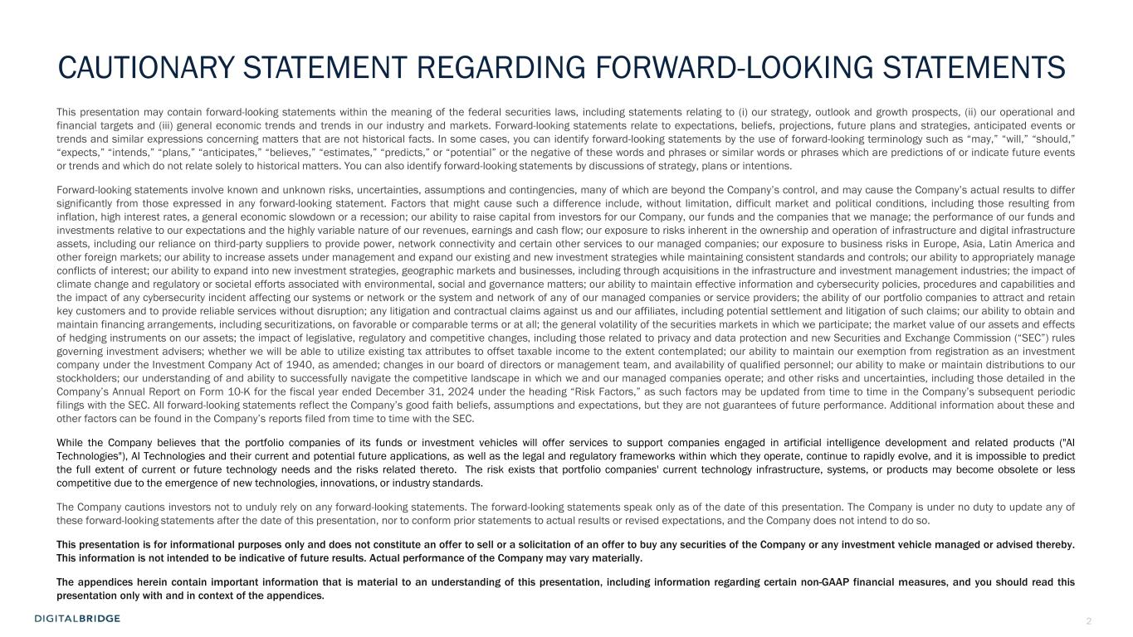
2 CAUTIONARY STATEMENT REGARDING FORWARD-LOOKING STATEMENTS This presentation may contain forward-looking statements within the meaning of the federal securities laws, including statements relating to (i) our strategy, outlook and growth prospects, (ii) our operational and financial targets and (iii) general economic trends and trends in our industry and markets. Forward-looking statements relate to expectations, beliefs, projections, future plans and strategies, anticipated events or trends and similar expressions concerning matters that are not historical facts. In some cases, you can identify forward-looking statements by the use of forward-looking terminology such as “may,” “will,” “should,” “expects,” “intends,” “plans,” “anticipates,” “believes,” “estimates,” “predicts,” or “potential” or the negative of these words and phrases or similar words or phrases which are predictions of or indicate future events or trends and which do not relate solely to historical matters. You can also identify forward-looking statements by discussions of strategy, plans or intentions. Forward-looking statements involve known and unknown risks, uncertainties, assumptions and contingencies, many of which are beyond the Company’s control, and may cause the Company’s actual results to differ significantly from those expressed in any forward-looking statement. Factors that might cause such a difference include, without limitation, difficult market and political conditions, including those resulting from inflation, high interest rates, a general economic slowdown or a recession; our ability to raise capital from investors for our Company, our funds and the companies that we manage; the performance of our funds and investments relative to our expectations and the highly variable nature of our revenues, earnings and cash flow; our exposure to risks inherent in the ownership and operation of infrastructure and digital infrastructure assets, including our reliance on third-party suppliers to provide power, network connectivity and certain other services to our managed companies; our exposure to business risks in Europe, Asia, Latin America and other foreign markets; our ability to increase assets under management and expand our existing and new investment strategies while maintaining consistent standards and controls; our ability to appropriately manage conflicts of interest; our ability to expand into new investment strategies, geographic markets and businesses, including through acquisitions in the infrastructure and investment management industries; the impact of climate change and regulatory or societal efforts associated with environmental, social and governance matters; our ability to maintain effective information and cybersecurity policies, procedures and capabilities and the impact of any cybersecurity incident affecting our systems or network or the system and network of any of our managed companies or service providers; the ability of our portfolio companies to attract and retain key customers and to provide reliable services without disruption; any litigation and contractual claims against us and our affiliates, including potential settlement and litigation of such claims; our ability to obtain and maintain financing arrangements, including securitizations, on favorable or comparable terms or at all; the general volatility of the securities markets in which we participate; the market value of our assets and effects of hedging instruments on our assets; the impact of legislative, regulatory and competitive changes, including those related to privacy and data protection and new Securities and Exchange Commission (“SEC”) rules governing investment advisers; whether we will be able to utilize existing tax attributes to offset taxable income to the extent contemplated; our ability to maintain our exemption from registration as an investment company under the Investment Company Act of 1940, as amended; changes in our board of directors or management team, and availability of qualified personnel; our ability to make or maintain distributions to our stockholders; our understanding of and ability to successfully navigate the competitive landscape in which we and our managed companies operate; and other risks and uncertainties, including those detailed in the Company’s Annual Report on Form 10-K for the fiscal year ended December 31, 2024 under the heading “Risk Factors,” as such factors may be updated from time to time in the Company’s subsequent periodic filings with the SEC. All forward-looking statements reflect the Company’s good faith beliefs, assumptions and expectations, but they are not guarantees of future performance. Additional information about these and other factors can be found in the Company’s reports filed from time to time with the SEC. While the Company believes that the portfolio companies of its funds or investment vehicles will offer services to support companies engaged in artificial intelligence development and related products ("AI Technologies"), AI Technologies and their current and potential future applications, as well as the legal and regulatory frameworks within which they operate, continue to rapidly evolve, and it is impossible to predict the full extent of current or future technology needs and the risks related thereto. The risk exists that portfolio companies' current technology infrastructure, systems, or products may become obsolete or less competitive due to the emergence of new technologies, innovations, or industry standards. The Company cautions investors not to unduly rely on any forward-looking statements. The forward-looking statements speak only as of the date of this presentation. The Company is under no duty to update any of these forward-looking statements after the date of this presentation, nor to conform prior statements to actual results or revised expectations, and the Company does not intend to do so. This presentation is for informational purposes only and does not constitute an offer to sell or a solicitation of an offer to buy any securities of the Company or any investment vehicle managed or advised thereby. This information is not intended to be indicative of future results. Actual performance of the Company may vary materially. The appendices herein contain important information that is material to an understanding of this presentation, including information regarding certain non-GAAP financial measures, and you should read this presentation only with and in context of the appendices.

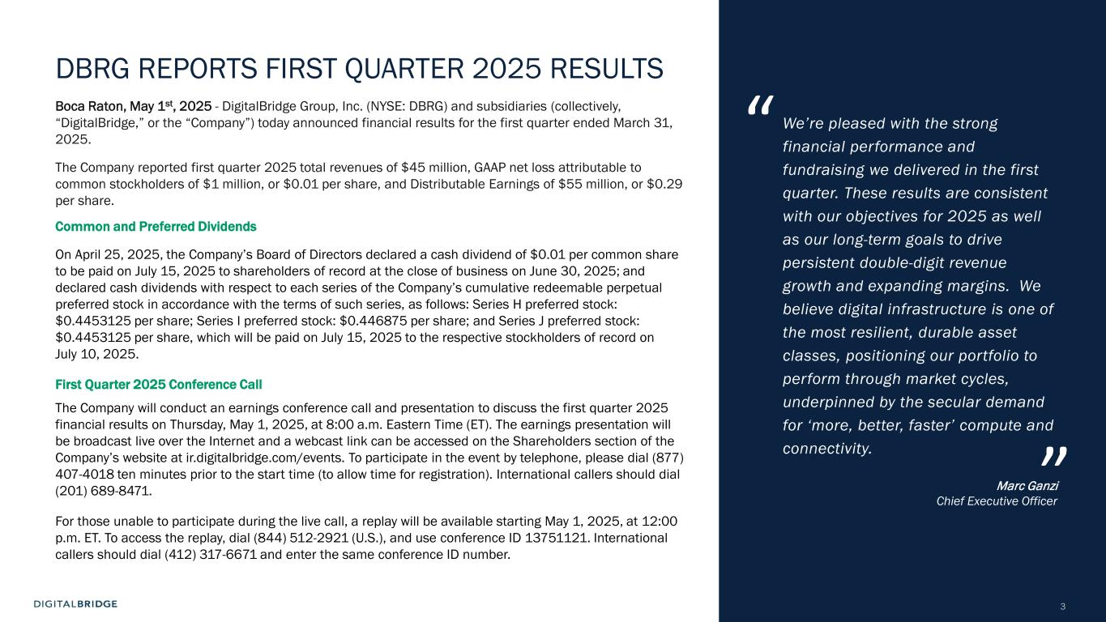
3 DBRG REPORTS FIRST QUARTER 2025 RESULTS Boca Raton, May 1st, 2025 - DigitalBridge Group, Inc. (NYSE: DBRG) and subsidiaries (collectively, “DigitalBridge,” or the “Company”) today announced financial results for the first quarter ended March 31, 2025. The Company reported first quarter 2025 total revenues of $45 million, GAAP net loss attributable to common stockholders of $1 million, or $0.01 per share, and Distributable Earnings of $55 million, or $0.29 per share. Common and Preferred Dividends On April 25, 2025, the Company’s Board of Directors declared a cash dividend of $0.01 per common share to be paid on July 15, 2025 to shareholders of record at the close of business on June 30, 2025; and declared cash dividends with respect to each series of the Company’s cumulative redeemable perpetual preferred stock in accordance with the terms of such series, as follows: Series H preferred stock: $0.4453125 per share; Series I preferred stock: $0.446875 per share; and Series J preferred stock: $0.4453125 per share, which will be paid on July 15, 2025 to the respective stockholders of record on July 10, 2025. First Quarter 2025 Conference Call The Company will conduct an earnings conference call and presentation to discuss the first quarter 2025 financial results on Thursday, May 1, 2025, at 8:00 a.m. Eastern Time (ET). The earnings presentation will be broadcast live over the Internet and a webcast link can be accessed on the Shareholders section of the Company’s website at ir.digitalbridge.com/events. To participate in the event by telephone, please dial (877) 407-4018 ten minutes prior to the start time (to allow time for registration). International callers should dial (201) 689-8471. For those unable to participate during the live call, a replay will be available starting May 1, 2025, at 12:00 p.m. ET. To access the replay, dial (844) 512-2921 (U.S.), and use conference ID 13751121. International callers should dial (412) 317-6671 and enter the same conference ID number. We’re pleased with the strong financial performance and fundraising we delivered in the first quarter. These results are consistent with our objectives for 2025 as well as our long-term goals to drive persistent double-digit revenue growth and expanding margins. We believe digital infrastructure is one of the most resilient, durable asset classes, positioning our portfolio to perform through market cycles, underpinned by the secular demand for ‘more, better, faster’ compute and connectivity. Marc Ganzi Chief Executive Officer “ ”

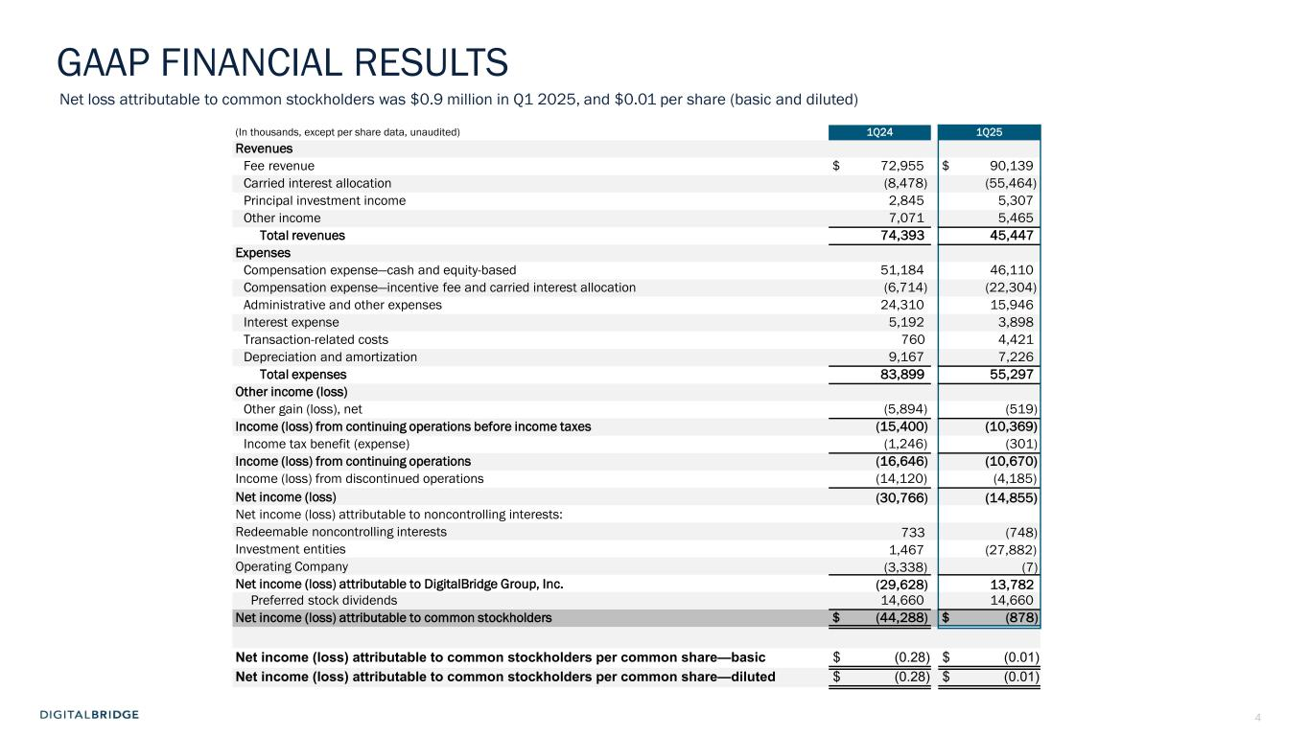
4 (In thousands, except per share data, unaudited) 1Q24 1Q25 Revenues Fee revenue $ 72,955 $ 90,139 Carried interest allocation (8,478) (55,464) Principal investment income 2,845 5,307 Other income 7,071 5,465 Total revenues 74,393 45,447 Expenses Compensation expense—cash and equity-based 51,184 46,110 Compensation expense—incentive fee and carried interest allocation (6,714) (22,304) Administrative and other expenses 24,310 15,946 Interest expense 5,192 3,898 Transaction-related costs 760 4,421 Depreciation and amortization 9,167 7,226 Total expenses 83,899 55,297 Other income (loss) Other gain (loss), net (5,894) (519) Income (loss) from continuing operations before income taxes (15,400) (10,369) Income tax benefit (expense) (1,246) (301) Income (loss) from continuing operations (16,646) (10,670) Income (loss) from discontinued operations (14,120) (4,185) Net income (loss) (30,766) (14,855) Net income (loss) attributable to noncontrolling interests: Redeemable noncontrolling interests 733 (748) Investment entities 1,467 (27,882) Operating Company (3,338) (7) Net income (loss) attributable to DigitalBridge Group, Inc. (29,628) 13,782 Preferred stock dividends 14,660 14,660 Net income (loss) attributable to common stockholders $ (44,288) $ (878) Net income (loss) attributable to common stockholders per common share—basic $ (0.28) $ (0.01) Net income (loss) attributable to common stockholders per common share—diluted $ (0.28) $ (0.01) GAAP FINANCIAL RESULTS Net loss attributable to common stockholders was $0.9 million in Q1 2025, and $0.01 per share (basic and diluted)


5 AGENDA BUSINESS UPDATESE CT IO N 1 FINANCIAL RESULTSSE CT IO N 2 EXECUTING THE DIGITAL PLAYBOOKSE CT IO N 3

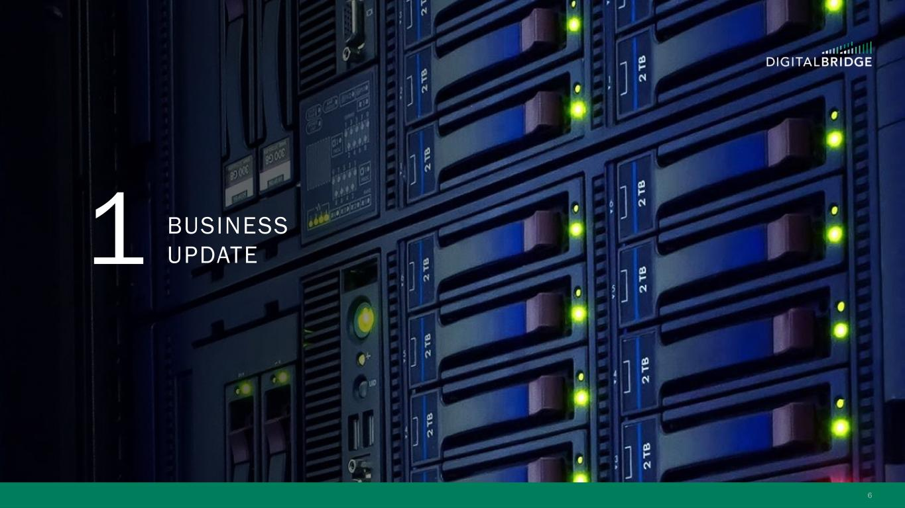
6 1 BUSINESS UPDATE

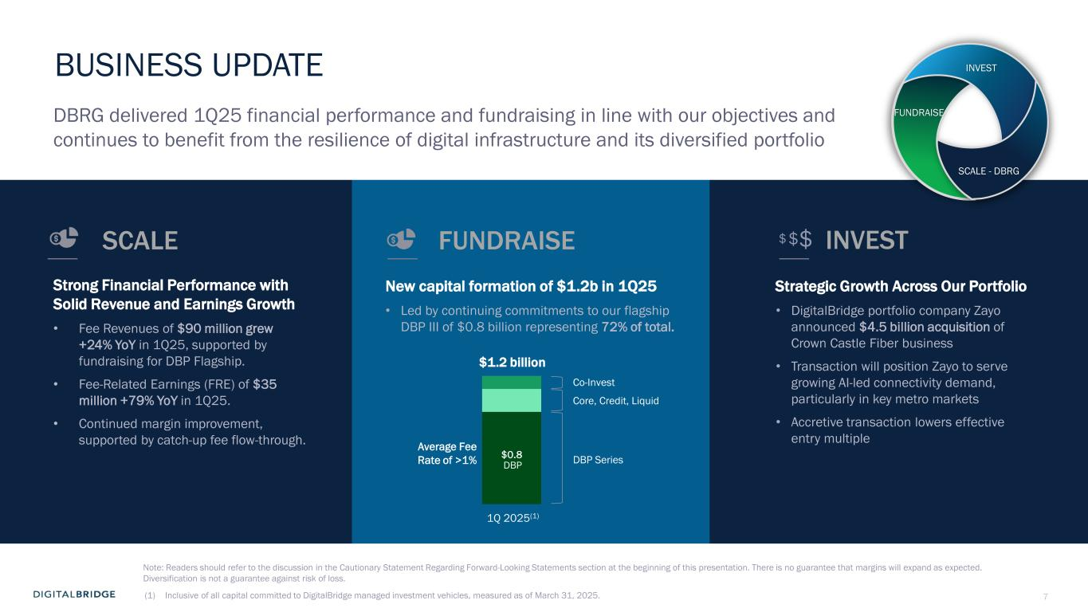
7 BUSINESS UPDATE (1) Inclusive of all capital committed to DigitalBridge managed investment vehicles, measured as of March 31, 2025. Strategic Growth Across Our Portfolio • DigitalBridge portfolio company Zayo announced $4.5 billion acquisition of Crown Castle Fiber business • Transaction will position Zayo to serve growing AI-led connectivity demand, particularly in key metro markets • Accretive transaction lowers effective entry multiple Strong Financial Performance with Solid Revenue and Earnings Growth • Fee Revenues of $90 million grew +24% YoY in 1Q25, supported by fundraising for DBP Flagship. • Fee-Related Earnings (FRE) of $35 million +79% YoY in 1Q25. • Continued margin improvement, supported by catch-up fee flow-through. $$$ DBRG delivered 1Q25 financial performance and fundraising in line with our objectives and continues to benefit from the resilience of digital infrastructure and its diversified portfolio Note: Readers should refer to the discussion in the Cautionary Statement Regarding Forward-Looking Statements section at the beginning of this presentation. There is no guarantee that margins will expand as expected. Diversification is not a guarantee against risk of loss. New capital formation of $1.2b in 1Q25 • Led by continuing commitments to our flagship DBP III of $0.8 billion representing 72% of total. INVESTSCALE FUNDRAISE INVEST FUNDRAISE SCALE - DBRG $0.8 DBP Series Co-Invest Core, Credit, Liquid 1Q 2025(1) Average Fee Rate of >1% DBP $1.2 billion

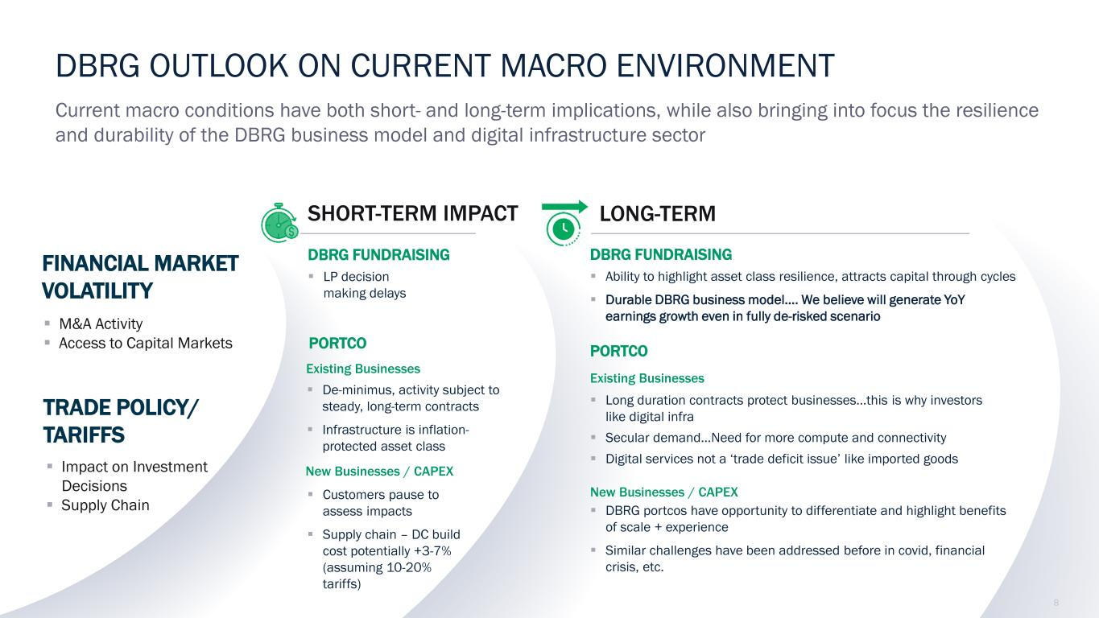
8 LONG-TERM DBRG OUTLOOK ON CURRENT MACRO ENVIRONMENT SHORT-TERM IMPACT Current macro conditions have both short- and long-term implications, while also bringing into focus the resilience and durability of the DBRG business model and digital infrastructure sector TRADE POLICY/ TARIFFS FINANCIAL MARKET VOLATILITY ▪ Impact on Investment Decisions ▪ Supply Chain ▪ M&A Activity ▪ Access to Capital Markets ▪ Customers pause to assess impacts ▪ Supply chain – DC build cost potentially +3-7% (assuming 10-20% tariffs) PORTCO New Businesses / CAPEX DBRG FUNDRAISING ▪ LP decision making delays ▪ De-minimus, activity subject to steady, long-term contracts ▪ Infrastructure is inflation- protected asset class Existing Businesses PORTCO DBRG FUNDRAISING ▪ Ability to highlight asset class resilience, attracts capital through cycles ▪ Durable DBRG business model…. We believe will generate YoY earnings growth even in fully de-risked scenario ▪ Long duration contracts protect businesses...this is why investors like digital infra ▪ Secular demand…Need for more compute and connectivity ▪ Digital services not a ‘trade deficit issue’ like imported goods ▪ DBRG portcos have opportunity to differentiate and highlight benefits of scale + experience ▪ Similar challenges have been addressed before in covid, financial crisis, etc. New Businesses / CAPEX Existing Businesses

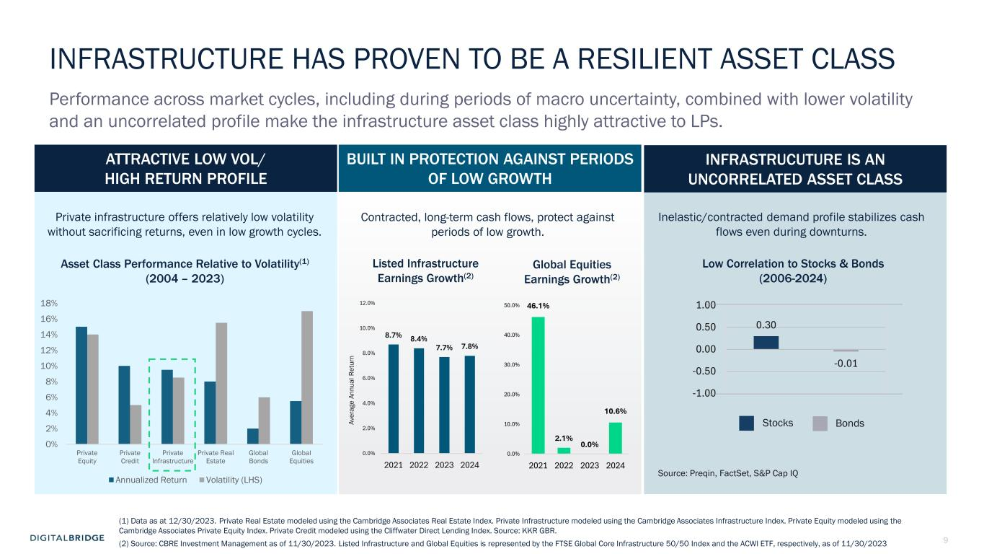
9 0% 2% 4% 6% 8% 10% 12% 14% 16% 18% Private Equity Private Credit Private Infrastructure Private Real Estate Global Bonds Global Equities Annualized Return Volatility (LHS) Asset Class Performance Relative to Volatility(1) (2004 – 2023) INFRASTRUCTURE HAS PROVEN TO BE A RESILIENT ASSET CLASS Performance across market cycles, including during periods of macro uncertainty, combined with lower volatility and an uncorrelated profile make the infrastructure asset class highly attractive to LPs. BUILT IN PROTECTION AGAINST PERIODS OF LOW GROWTH Contracted, long-term cash flows, protect against periods of low growth. ATTRACTIVE LOW VOL/ HIGH RETURN PROFILE INFRASTRUCUTURE IS AN UNCORRELATED ASSET CLASS Inelastic/contracted demand profile stabilizes cash flows even during downturns. 0.30 -0.01 -1.00 -0.50 0.00 0.50 1.00 Listed Infrastructure Earnings Growth(2) Stocks Bonds Low Correlation to Stocks & Bonds (2006-2024) Source: Preqin, FactSet, S&P Cap IQ Global Equities Earnings Growth(2) (1) Data as at 12/30/2023. Private Real Estate modeled using the Cambridge Associates Real Estate Index. Private Infrastructure modeled using the Cambridge Associates Infrastructure Index. Private Equity modeled using the Cambridge Associates Private Equity Index. Private Credit modeled using the Cliffwater Direct Lending Index. Source: KKR GBR. (2) Source: CBRE Investment Management as of 11/30/2023. Listed Infrastructure and Global Equities is represented by the FTSE Global Core Infrastructure 50/50 Index and the ACWI ETF, respectively, as of 11/30/2023 Private infrastructure offers relatively low volatility without sacrificing returns, even in low growth cycles. Av er ag e An nu al R et ur n 8.7% 8.4% 7.7% 7.8% 0.0% 2.0% 4.0% 6.0% 8.0% 10.0% 12.0% 2021 2022 2023 2024 46.1% 2.1% 0.0% 10.6% 0.0% 10.0% 20.0% 30.0% 40.0% 50.0% 2021 2022 2023 2024

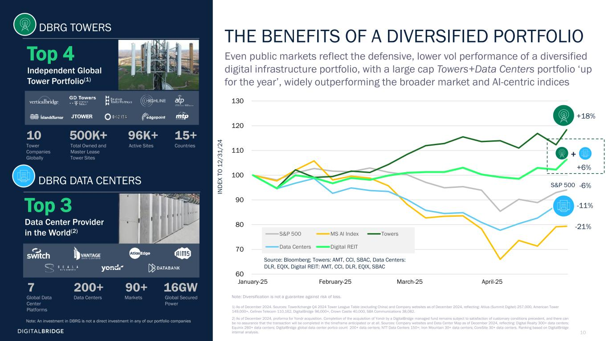
10 60 70 80 90 100 110 120 130 January-25 February-25 March-25 April-25 S&P 500 MS AI Index Towers Data Centers Digital REIT THE BENEFITS OF A DIVERSIFIED PORTFOLIO Even public markets reflect the defensive, lower vol performance of a diversified digital infrastructure portfolio, with a large cap Towers+Data Centers portfolio ‘up for the year’, widely outperforming the broader market and AI-centric indices 1) As of December 2024. Sources: TowerXchange Q4 2024 Tower League Table (excluding China) and Company websites as of December 2024, reflecting: Altius (Summit Digitel) 257,000, American Tower 149,000+, Cellnex Telecom 110,162, DigitalBridge 96,000+, Crown Castle 40,000, SBA Communications 38,082. 2) As of December 2024, proforma for Yondr acquisition. Completion of the acquisition of Yondr by a DigitalBridge managed fund remains subject to satisfaction of customary conditions precedent, and there can be no assurance that the transaction will be completed in the timeframe anticipated or at all. Sources: Company websites and Data Center Map as of December 2024, reflecting: Digital Realty 300+ data centers; Equinix 260+ data centers; DigitalBridge global data center portco count 200+ data centers; NTT Data Centers 150+; Iron Mountain 30+ data centers; CoreSite 30+ data centers. Ranking based on DigitalBridge internal analysis. +18% -6% -11% -21% S&P 500 +6% + IN D EX T O 12 /3 1/ 24 Global Data Center Platforms Data Centers Markets 7 200+ 90+ 16GW Global Secured Power DBRG TOWERS DBRG DATA CENTERS Tower Companies Globally Active Sites CountriesTotal Owned and Master Lease Tower Sites 10 500K+ 96K+ 15+ Top 4 Independent Global Tower Portfolio(1) Top 3 Data Center Provider in the World(2) Source: Bloomberg; Towers: AMT, CCI, SBAC, Data Centers: DLR, EQIX, Digital REIT: AMT, CCI, DLR, EQIX, SBAC Note: An investment in DBRG is not a direct investment in any of our portfolio companies Note: Diversification is not a guarantee against risk of loss.

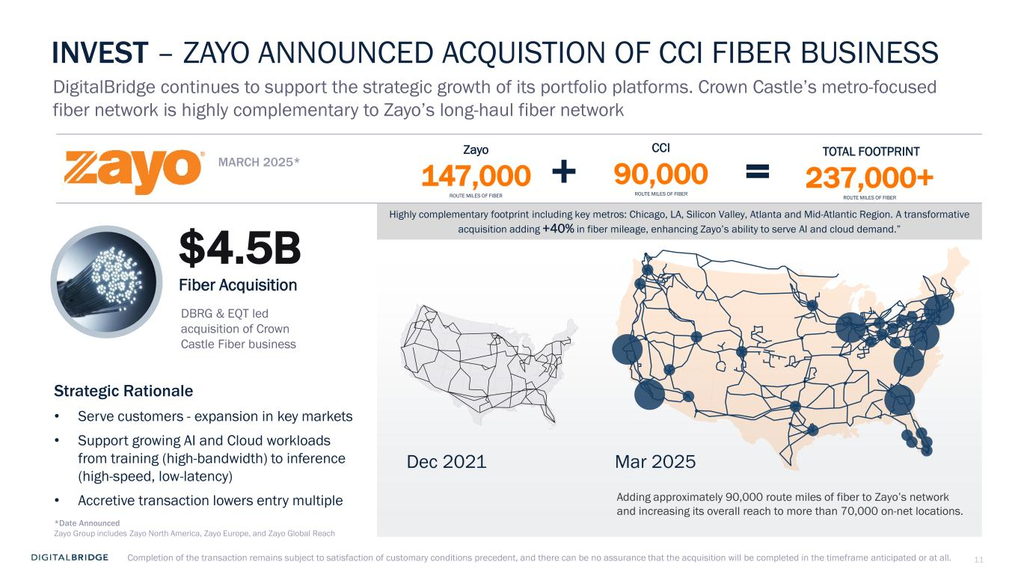
11 INVEST – ZAYO ANNOUNCED ACQUISTION OF CCI FIBER BUSINESS DigitalBridge continues to support the strategic growth of its portfolio platforms. Crown Castle’s metro-focused fiber network is highly complementary to Zayo’s long-haul fiber network Dec 2021 Mar 2025 DBRG & EQT led acquisition of Crown Castle Fiber business MARCH 2025* $4.5B Fiber Acquisition Strategic Rationale • Serve customers - expansion in key markets • Support growing AI and Cloud workloads from training (high-bandwidth) to inference (high-speed, low-latency) • Accretive transaction lowers entry multiple Highly complementary footprint including key metros: Chicago, LA, Silicon Valley, Atlanta and Mid-Atlantic Region. A transformative acquisition adding +40% in fiber mileage, enhancing Zayo’s ability to serve AI and cloud demand.” Adding approximately 90,000 route miles of fiber to Zayo’s network and increasing its overall reach to more than 70,000 on-net locations. Zayo 147,000 ROUTE MILES OF FIBER CCI 90,000 ROUTE MILES OF FIBER TOTAL FOOTPRINT 237,000+ ROUTE MILES OF FIBER *Date Announced Zayo Group includes Zayo North America, Zayo Europe, and Zayo Global Reach Completion of the transaction remains subject to satisfaction of customary conditions precedent, and there can be no assurance that the acquisition will be completed in the timeframe anticipated or at all.


12 2 FINANCIAL UPDATE

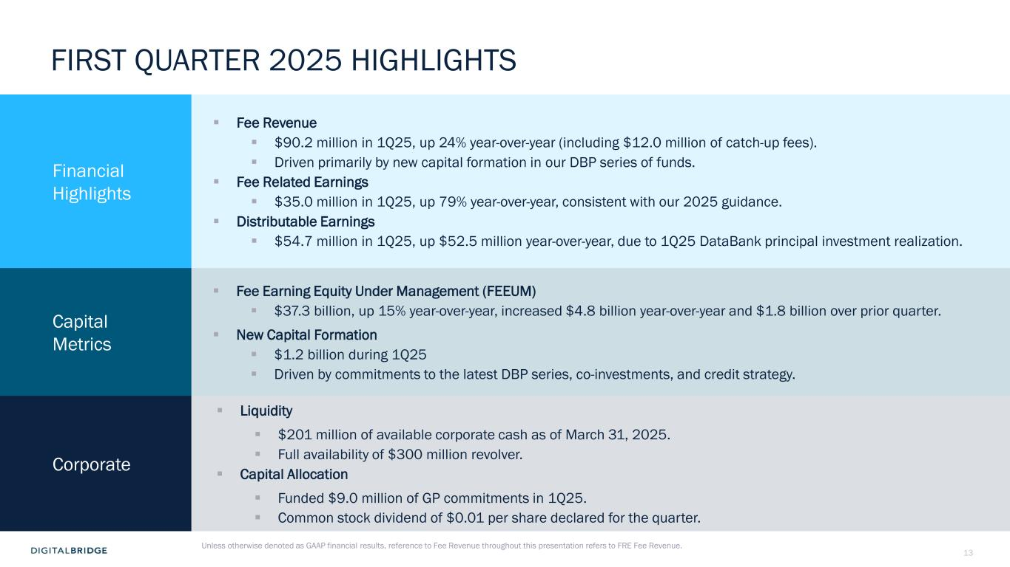
13 FIRST QUARTER 2025 HIGHLIGHTS Financial Highlights ▪ Fee Revenue ▪ $90.2 million in 1Q25, up 24% year-over-year (including $12.0 million of catch-up fees). ▪ Driven primarily by new capital formation in our DBP series of funds. ▪ Fee Related Earnings ▪ $35.0 million in 1Q25, up 79% year-over-year, consistent with our 2025 guidance. ▪ Distributable Earnings ▪ $54.7 million in 1Q25, up $52.5 million year-over-year, due to 1Q25 DataBank principal investment realization. Capital Metrics ▪ Fee Earning Equity Under Management (FEEUM) ▪ $37.3 billion, up 15% year-over-year, increased $4.8 billion year-over-year and $1.8 billion over prior quarter. ▪ New Capital Formation ▪ $1.2 billion during 1Q25 ▪ Driven by commitments to the latest DBP series, co-investments, and credit strategy. Corporate ▪ Liquidity ▪ $201 million of available corporate cash as of March 31, 2025. ▪ Full availability of $300 million revolver. ▪ Capital Allocation ▪ Funded $9.0 million of GP commitments in 1Q25. ▪ Common stock dividend of $0.01 per share declared for the quarter. Unless otherwise denoted as GAAP financial results, reference to Fee Revenue throughout this presentation refers to FRE Fee Revenue.

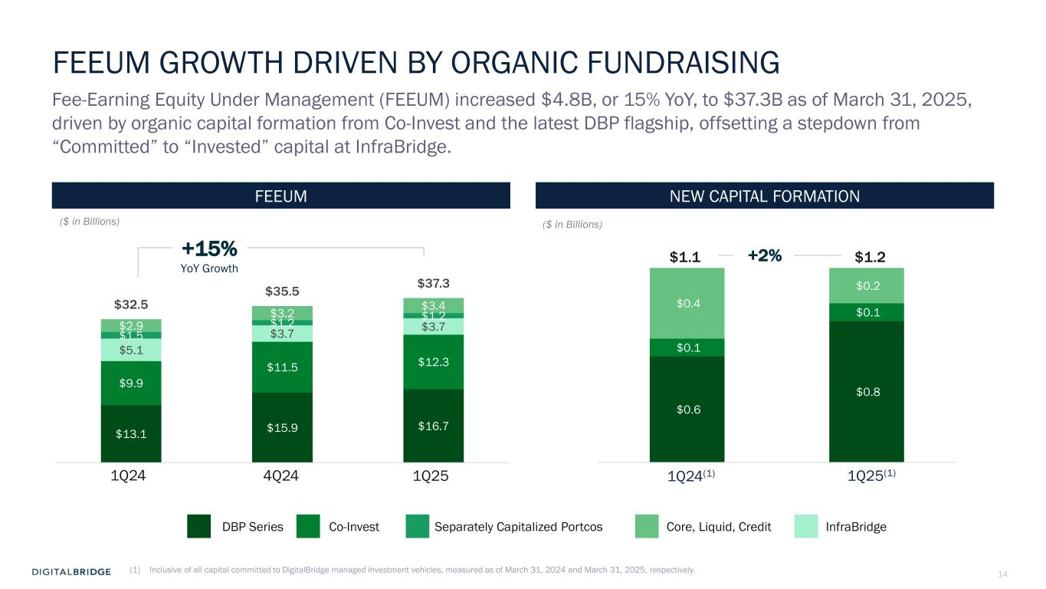
14 $0.6 $0.8 $0.1 $0.1 $0.4 $0.2 FEEUM GROWTH DRIVEN BY ORGANIC FUNDRAISING Fee-Earning Equity Under Management (FEEUM) increased $4.8B, or 15% YoY, to $37.3B as of March 31, 2025, driven by organic capital formation from Co-Invest and the latest DBP flagship, offsetting a stepdown from “Committed” to “Invested” capital at InfraBridge. DBP Series Co-Invest Separately Capitalized Portcos Core, Liquid, Credit NEW CAPITAL FORMATIONFEEUM InfraBridge +15% YoY Growth ($ in Billions) ($ in Billions) (1) Inclusive of all capital committed to DigitalBridge managed investment vehicles, measured as of March 31, 2024 and March 31, 2025, respectively. 1Q25(1) $1.2 1Q24(1) $1.1 +2% 4Q24 1Q251Q24 $13.1 $15.9 $16.7 $9.9 $11.5 $12.3 $5.1 $3.7 $3.7 $1.5 $1.2 $1.2 $2.9 $3.2 $3.4 $32.5 $35.5 $37.3

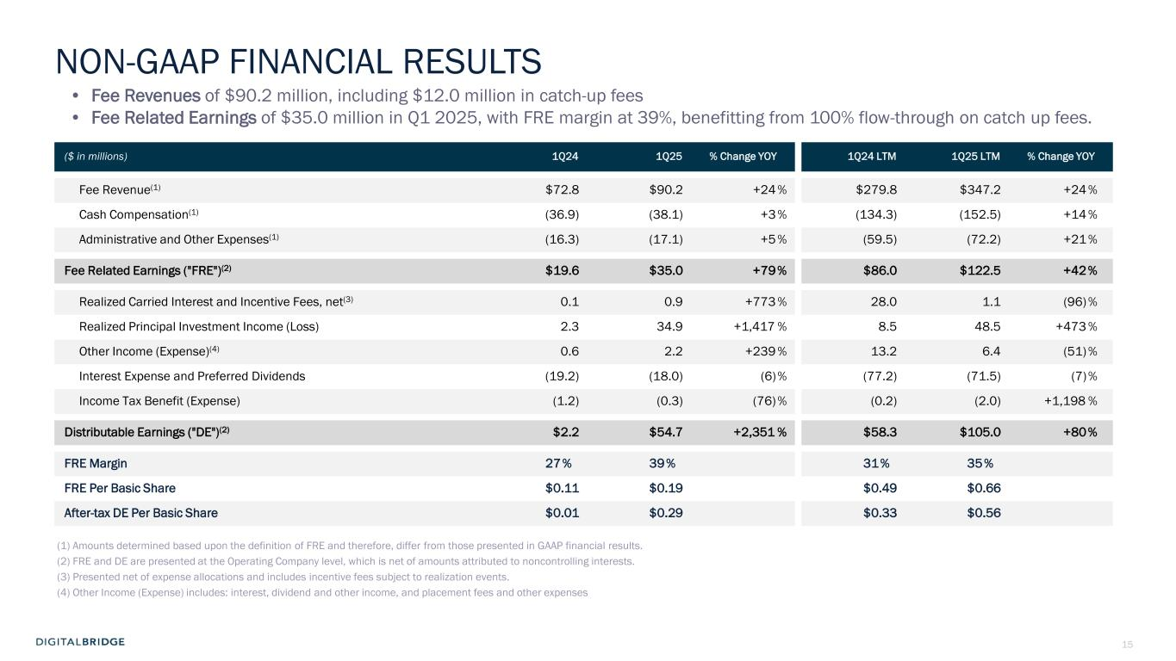
15 NON-GAAP FINANCIAL RESULTS ($ in millions) 1Q24 1Q25 % Change YOY 1Q24 LTM 1Q25 LTM % Change YOY Fee Revenue(1) $72.8 $90.2 +24 % $279.8 $347.2 +24 % Cash Compensation(1) (36.9) (38.1) +3 % (134.3) (152.5) +14 % Administrative and Other Expenses(1) (16.3) (17.1) +5 % (59.5) (72.2) +21 % Fee Related Earnings ("FRE")(2) $19.6 $35.0 +79% $86.0 $122.5 +42% Realized Carried Interest and Incentive Fees, net(3) 0.1 0.9 +773 % 28.0 1.1 (96) % Realized Principal Investment Income (Loss) 2.3 34.9 +1,417 % 8.5 48.5 +473 % Other Income (Expense)(4) 0.6 2.2 +239 % 13.2 6.4 (51) % Interest Expense and Preferred Dividends (19.2) (18.0) (6)% (77.2) (71.5) (7)% Income Tax Benefit (Expense) (1.2) (0.3) (76) % (0.2) (2.0) +1,198 % Distributable Earnings ("DE")(2) $2.2 $54.7 +2,351 % $58.3 $105.0 +80% FRE Margin 27% 39% 31% 35% FRE Per Basic Share $0.11 $0.19 $0.49 $0.66 After-tax DE Per Basic Share $0.01 $0.29 $0.33 $0.56 (1) Amounts determined based upon the definition of FRE and therefore, differ from those presented in GAAP financial results. (2) FRE and DE are presented at the Operating Company level, which is net of amounts attributed to noncontrolling interests. (3) Presented net of expense allocations and includes incentive fees subject to realization events. (4) Other Income (Expense) includes: interest, dividend and other income, and placement fees and other expenses • Fee Revenues of $90.2 million, including $12.0 million in catch-up fees • Fee Related Earnings of $35.0 million in Q1 2025, with FRE margin at 39%, benefitting from 100% flow-through on catch up fees.

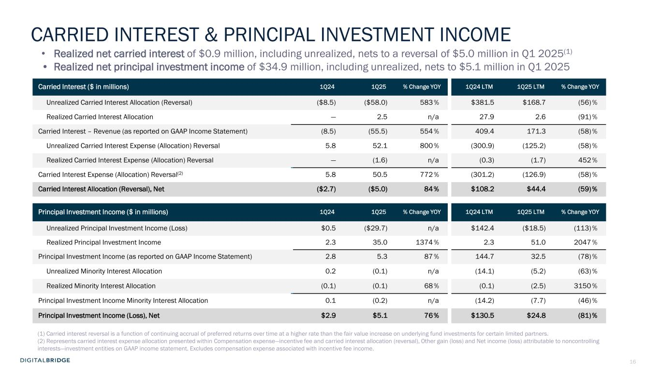
16 Carried Interest ($ in millions) 1Q24 1Q25 % Change YOY 1Q24 LTM 1Q25 LTM % Change YOY Unrealized Carried Interest Allocation (Reversal) ($8.5) ($58.0) 583 % $381.5 $168.7 (56) % Realized Carried Interest Allocation — 2.5 n/a 27.9 2.6 (91) % Carried Interest – Revenue (as reported on GAAP Income Statement) (8.5) (55.5) 554 % 409.4 171.3 (58) % Unrealized Carried Interest Expense (Allocation) Reversal 5.8 52.1 800 % (300.9) (125.2) (58) % Realized Carried Interest Expense (Allocation) Reversal — (1.6) n/a (0.3) (1.7) 452 % Carried Interest Expense (Allocation) Reversal(2) 5.8 50.5 772 % (301.2) (126.9) (58) % Carried Interest Allocation (Reversal), Net ($2.7) ($5.0) 84% $108.2 $44.4 (59)% Principal Investment Income ($ in millions) 1Q24 1Q25 % Change YOY 1Q24 LTM 1Q25 LTM % Change YOY Unrealized Principal Investment Income (Loss) $0.5 ($29.7) n/a $142.4 ($18.5) (113) % Realized Principal Investment Income 2.3 35.0 1374 % 2.3 51.0 2047 % Principal Investment Income (as reported on GAAP Income Statement) 2.8 5.3 87 % 144.7 32.5 (78) % Unrealized Minority Interest Allocation 0.2 (0.1) n/a (14.1) (5.2) (63) % Realized Minority Interest Allocation (0.1) (0.1) 68 % (0.1) (2.5) 3150 % Principal Investment Income Minority Interest Allocation 0.1 (0.2) n/a (14.2) (7.7) (46) % Principal Investment Income (Loss), Net $2.9 $5.1 76% $130.5 $24.8 (81)% (1) Carried interest reversal is a function of continuing accrual of preferred returns over time at a higher rate than the fair value increase on underlying fund investments for certain limited partners. (2) Represents carried interest expense allocation presented within Compensation expense—incentive fee and carried interest allocation (reversal), Other gain (loss) and Net income (loss) attributable to noncontrolling interests—investment entities on GAAP income statement. Excludes compensation expense associated with incentive fee income. CARRIED INTEREST & PRINCIPAL INVESTMENT INCOME • Realized net carried interest of $0.9 million, including unrealized, nets to a reversal of $5.0 million in Q1 2025(1) • Realized net principal investment income of $34.9 million, including unrealized, nets to $5.1 million in Q1 2025

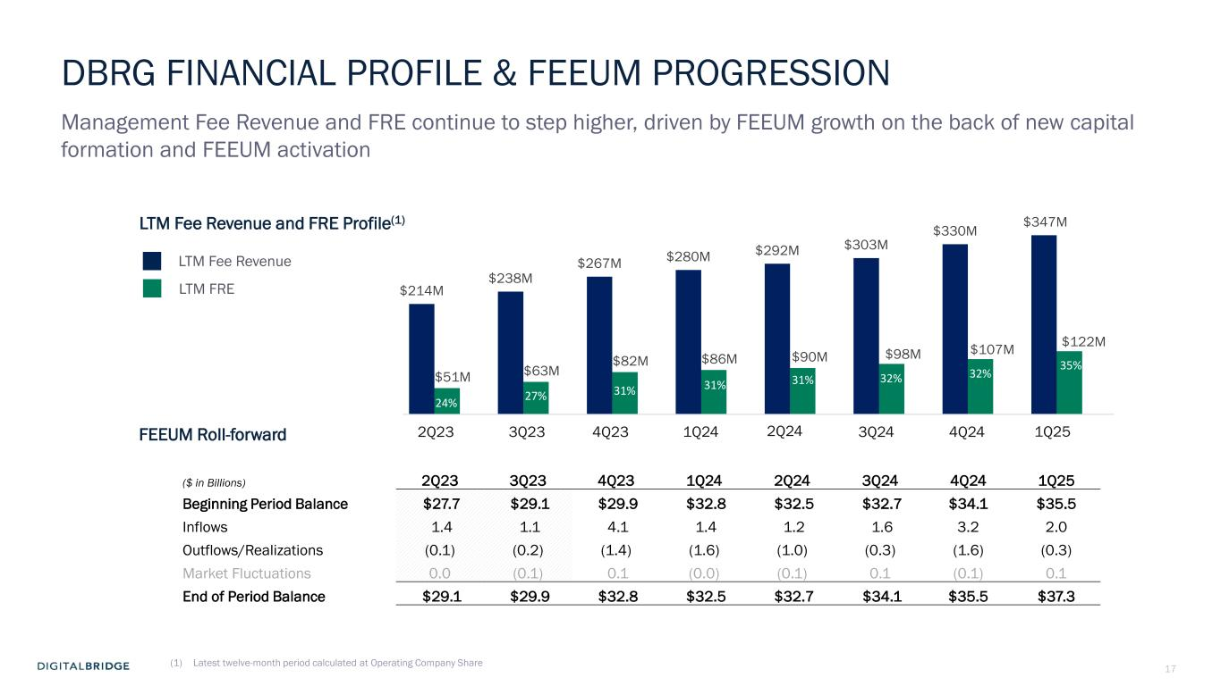
17 DBRG FINANCIAL PROFILE & FEEUM PROGRESSION Management Fee Revenue and FRE continue to step higher, driven by FEEUM growth on the back of new capital formation and FEEUM activation LTM Fee Revenue LTM FRE ($ in Billions) 2Q23 3Q23 4Q23 1Q24 2Q24 3Q24 4Q24 1Q25 Beginning Period Balance $27.7 $29.1 $29.9 $32.8 $32.5 $32.7 $34.1 $35.5 Inflows 1.4 1.1 4.1 1.4 1.2 1.6 3.2 2.0 Outflows/Realizations (0.1) (0.2) (1.4) (1.6) (1.0) (0.3) (1.6) (0.3) Market Fluctuations 0.0 (0.1) 0.1 (0.0) (0.1) 0.1 (0.1) 0.1 End of Period Balance $29.1 $29.9 $32.8 $32.5 $32.7 $34.1 $35.5 $37.3 LTM Fee Revenue and FRE Profile(1) FEEUM Roll-forward (1) Latest twelve-month period calculated at Operating Company Share $214M $238M $267M $280M $292M $303M $330M $347M $51M $63M $82M $86M $90M $98M $107M $122M 1Q254Q243Q242Q241Q244Q233Q23 35% 32%32%31%31%31%27%24% 2Q23

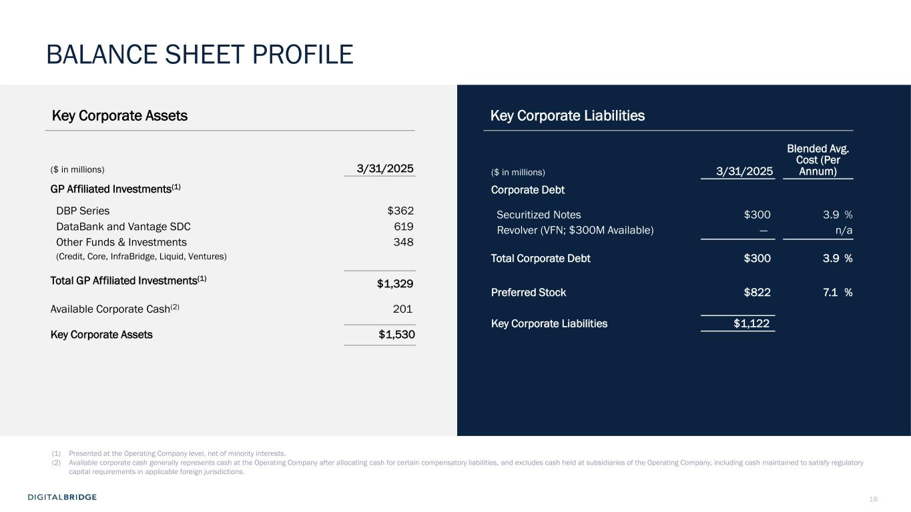
18 Key Corporate Assets Key Corporate Liabilities ($ in millions) 3/31/2025 GP Affiliated Investments(1) DBP Series $362 DataBank and Vantage SDC 619 Other Funds & Investments 348 (Credit, Core, InfraBridge, Liquid, Ventures) Total GP Affiliated Investments(1) $1,329 Available Corporate Cash(2) 201 Key Corporate Assets $1,530 ($ in millions) 3/31/2025 Blended Avg. Cost (Per Annum) Corporate Debt Securitized Notes $300 3.9 % Revolver (VFN; $300M Available) — n/a Total Corporate Debt $300 3.9 % Preferred Stock $822 7.1 % Key Corporate Liabilities $1,122 (1) Presented at the Operating Company level, net of minority interests. (2) Available corporate cash generally represents cash at the Operating Company after allocating cash for certain compensatory liabilities, and excludes cash held at subsidiaries of the Operating Company, including cash maintained to satisfy regulatory capital requirements in applicable foreign jurisdictions. BALANCE SHEET PROFILE


19 3 EXECUTING THE DIGITAL PLAYBOOK

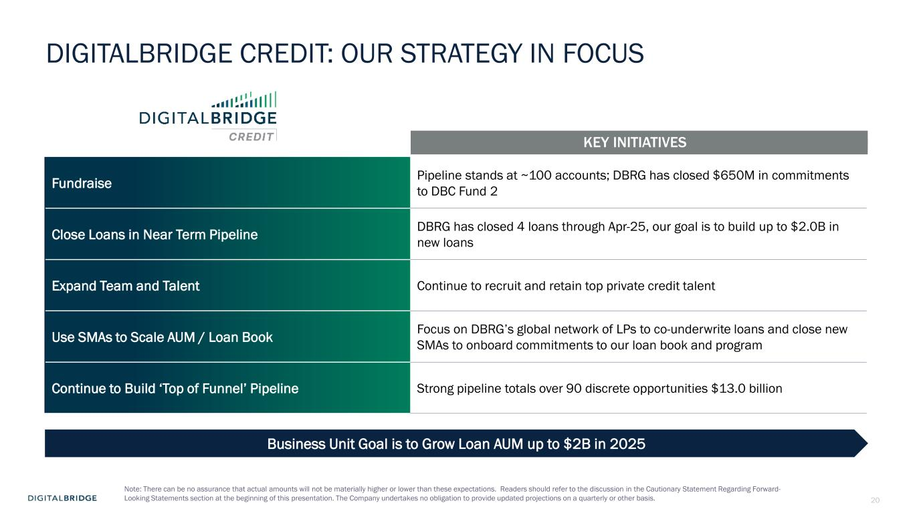
20 DIGITALBRIDGE CREDIT: OUR STRATEGY IN FOCUS Fundraise Pipeline stands at ~100 accounts; DBRG has closed $650M in commitments to DBC Fund 2 Close Loans in Near Term Pipeline DBRG has closed 4 loans through Apr-25, our goal is to build up to $2.0B in new loans Expand Team and Talent Continue to recruit and retain top private credit talent Use SMAs to Scale AUM / Loan Book Focus on DBRG’s global network of LPs to co-underwrite loans and close new SMAs to onboard commitments to our loan book and program Continue to Build ‘Top of Funnel’ Pipeline Strong pipeline totals over 90 discrete opportunities $13.0 billion KEY INITIATIVES Business Unit Goal is to Grow Loan AUM up to $2B in 2025 Note: There can be no assurance that actual amounts will not be materially higher or lower than these expectations. Readers should refer to the discussion in the Cautionary Statement Regarding Forward- Looking Statements section at the beginning of this presentation. The Company undertakes no obligation to provide updated projections on a quarterly or other basis.

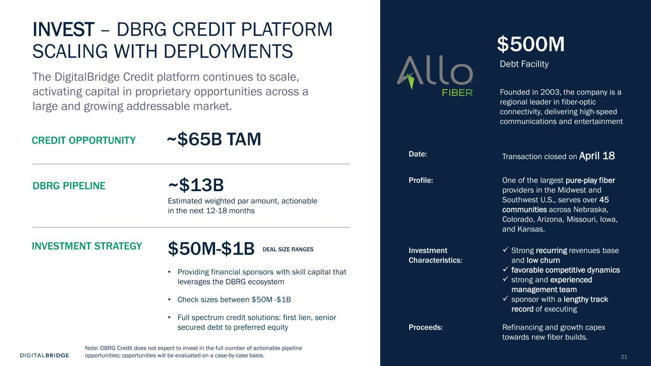
21 INVEST – DBRG CREDIT PLATFORM SCALING WITH DEPLOYMENTS DBRG PIPELINE The DigitalBridge Credit platform continues to scale, activating capital in proprietary opportunities across a large and growing addressable market. CREDIT OPPORTUNITY • Providing financial sponsors with skill capital that leverages the DBRG ecosystem • Check sizes between $50M -$1B • Full spectrum credit solutions: first lien, senior secured debt to preferred equity $50M-$1B DEAL SIZE RANGESINVESTMENT STRATEGY ~$65B TAM ~$13B Estimated weighted par amount, actionable in the next 12-18 months $500M Debt Facility Date: Transaction closed on April 18 Profile: One of the largest pure-play fiber providers in the Midwest and Southwest U.S., serves over 45 communities across Nebraska, Colorado, Arizona, Missouri, Iowa, and Kansas. Investment Characteristics: ✓ Strong recurring revenues base and low churn ✓ favorable competitive dynamics ✓ strong and experienced management team ✓ sponsor with a lengthy track record of executing Proceeds: Refinancing and growth capex towards new fiber builds. Founded in 2003, the company is a regional leader in fiber-optic connectivity, delivering high-speed communications and entertainment Note: DBRG Credit does not expect to invest in the full number of actionable pipeline opportunities; opportunities will be evaluated on a case-by-case basis.

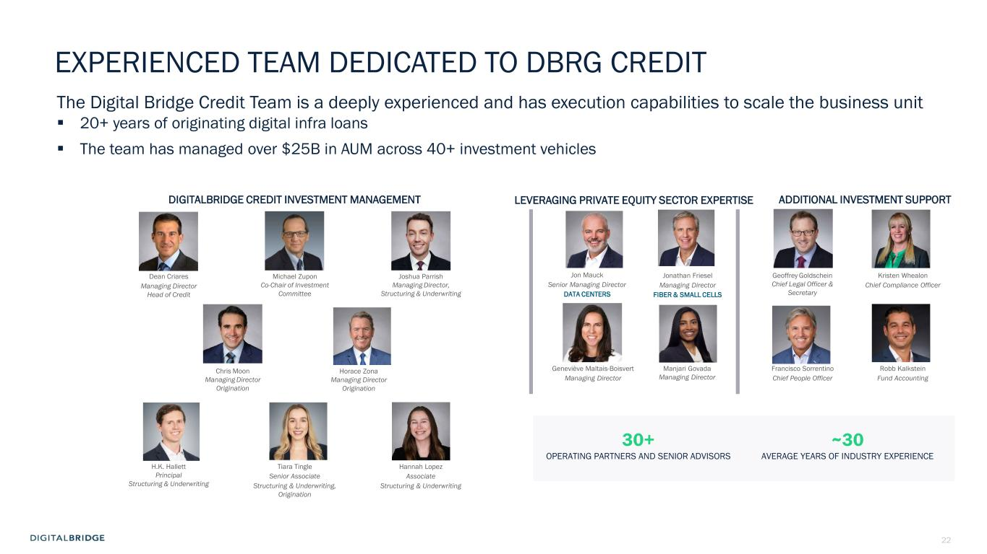
22 Robb Kalkstein Fund Accounting EXPERIENCED TEAM DEDICATED TO DBRG CREDIT DIGITALBRIDGE CREDIT INVESTMENT MANAGEMENT LEVERAGING PRIVATE EQUITY SECTOR EXPERTISE Geneviève Maltais-Boisvert Managing Director Manjari Govada Managing Director Jon Mauck Senior Managing Director DATA CENTERS ADDITIONAL INVESTMENT SUPPORT Kristen Whealon Chief Compliance Officer Jonathan Friesel Managing Director FIBER & SMALL CELLS Geoffrey Goldschein Chief Legal Officer & Secretary Dean Criares Managing Director Head of Credit Joshua Parrish Managing Director, Structuring & Underwriting H.K. Hallett Principal Structuring & Underwriting Michael Zupon Co-Chair of Investment Committee Chris Moon Managing Director Origination Francisco Sorrentino Chief People Officer Tiara Tingle Senior Associate Structuring & Underwriting, Origination Hannah Lopez Associate Structuring & Underwriting 30+ OPERATING PARTNERS AND SENIOR ADVISORS ~30 AVERAGE YEARS OF INDUSTRY EXPERIENCE Horace Zona Managing Director Origination The Digital Bridge Credit Team is a deeply experienced and has execution capabilities to scale the business unit ▪ 20+ years of originating digital infra loans ▪ The team has managed over $25B in AUM across 40+ investment vehicles

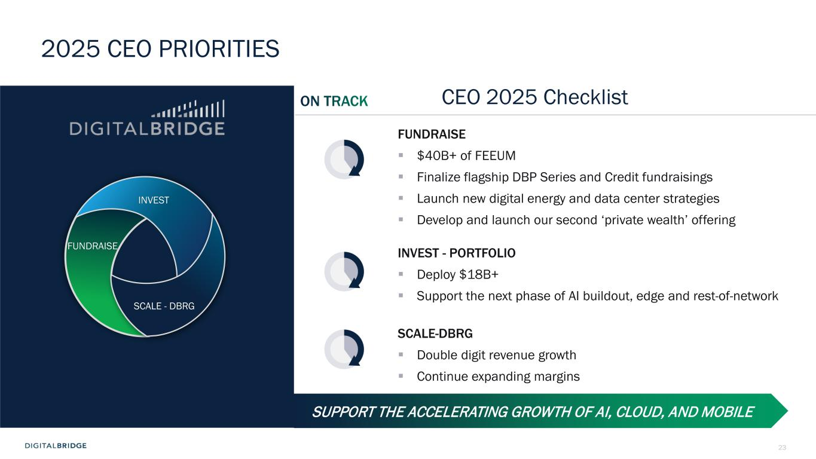
23 2025 CEO PRIORITIES CEO 2025 Checklist FUNDRAISE ▪ $40B+ of FEEUM ▪ Finalize flagship DBP Series and Credit fundraisings ▪ Launch new digital energy and data center strategies ▪ Develop and launch our second ‘private wealth’ offering INVEST - PORTFOLIO ▪ Deploy $18B+ ▪ Support the next phase of AI buildout, edge and rest-of-network SCALE-DBRG ▪ Double digit revenue growth ▪ Continue expanding margins SUPPORT THE ACCELERATING GROWTH OF AI, CLOUD, AND MOBILE INVEST FUNDRAISE SCALE - DBRG


24 4 Q&A SESSION


25 5 SUPPLEMENTAL FINANCIAL DATA

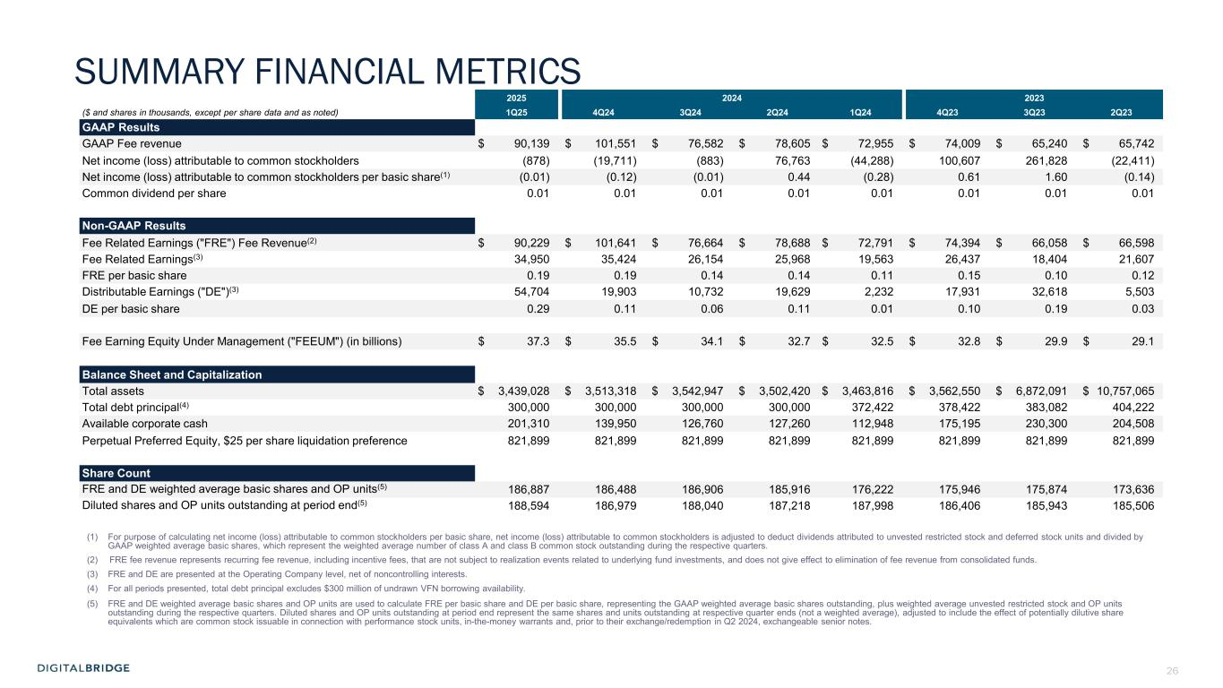
26 SUMMARY FINANCIAL METRICS 2025 2024 2023 ($ and shares in thousands, except per share data and as noted) 1Q25 4Q24 3Q24 2Q24 1Q24 4Q23 3Q23 2Q23 GAAP Results GAAP Fee revenue $ 90,139 $ 101,551 $ 76,582 $ 78,605 $ 72,955 $ 74,009 $ 65,240 $ 65,742 Net income (loss) attributable to common stockholders (878) (19,711) (883) 76,763 (44,288) 100,607 261,828 (22,411) Net income (loss) attributable to common stockholders per basic share(1) (0.01) (0.12) (0.01) 0.44 (0.28) 0.61 1.60 (0.14) Common dividend per share 0.01 0.01 0.01 0.01 0.01 0.01 0.01 0.01 Non-GAAP Results Fee Related Earnings ("FRE") Fee Revenue(2) $ 90,229 $ 101,641 $ 76,664 $ 78,688 $ 72,791 $ 74,394 $ 66,058 $ 66,598 Fee Related Earnings(3) 34,950 35,424 26,154 25,968 19,563 26,437 18,404 21,607 FRE per basic share 0.19 0.19 0.14 0.14 0.11 0.15 0.10 0.12 Distributable Earnings ("DE")(3) 54,704 19,903 10,732 19,629 2,232 17,931 32,618 5,503 DE per basic share 0.29 0.11 0.06 0.11 0.01 0.10 0.19 0.03 Fee Earning Equity Under Management ("FEEUM") (in billions) $ 37.3 $ 35.5 $ 34.1 $ 32.7 $ 32.5 $ 32.8 $ 29.9 $ 29.1 Balance Sheet and Capitalization Total assets $ 3,439,028 $ 3,513,318 $ 3,542,947 $ 3,502,420 $ 3,463,816 $ 3,562,550 $ 6,872,091 $ 10,757,065 Total debt principal(4) 300,000 300,000 300,000 300,000 372,422 378,422 383,082 404,222 Available corporate cash 201,310 139,950 126,760 127,260 112,948 175,195 230,300 204,508 Perpetual Preferred Equity, $25 per share liquidation preference 821,899 821,899 821,899 821,899 821,899 821,899 821,899 821,899 Share Count FRE and DE weighted average basic shares and OP units(5) 186,887 186,488 186,906 185,916 176,222 175,946 175,874 173,636 Diluted shares and OP units outstanding at period end(5) 188,594 186,979 188,040 187,218 187,998 186,406 185,943 185,506 (1) For purpose of calculating net income (loss) attributable to common stockholders per basic share, net income (loss) attributable to common stockholders is adjusted to deduct dividends attributed to unvested restricted stock and deferred stock units and divided by GAAP weighted average basic shares, which represent the weighted average number of class A and class B common stock outstanding during the respective quarters. (2) FRE fee revenue represents recurring fee revenue, including incentive fees, that are not subject to realization events related to underlying fund investments, and does not give effect to elimination of fee revenue from consolidated funds. (3) FRE and DE are presented at the Operating Company level, net of noncontrolling interests. (4) For all periods presented, total debt principal excludes $300 million of undrawn VFN borrowing availability. (5) FRE and DE weighted average basic shares and OP units are used to calculate FRE per basic share and DE per basic share, representing the GAAP weighted average basic shares outstanding, plus weighted average unvested restricted stock and OP units outstanding during the respective quarters. Diluted shares and OP units outstanding at period end represent the same shares and units outstanding at respective quarter ends (not a weighted average), adjusted to include the effect of potentially dilutive share equivalents which are common stock issuable in connection with performance stock units, in-the-money warrants and, prior to their exchange/redemption in Q2 2024, exchangeable senior notes.

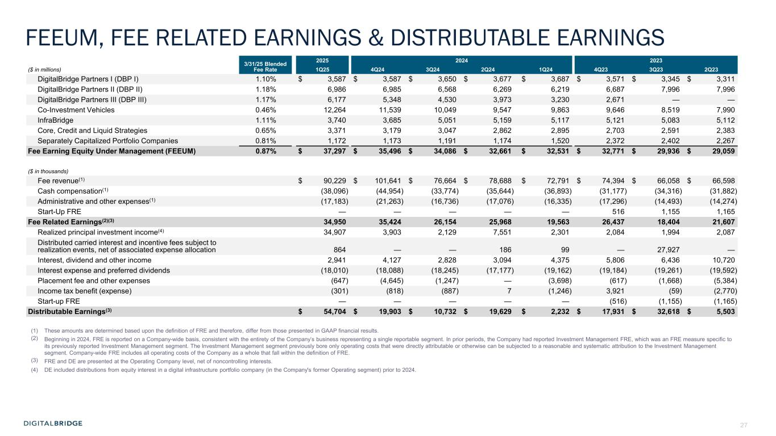
27 FEEUM, FEE RELATED EARNINGS & DISTRIBUTABLE EARNINGS 3/31/25 Blended Fee Rate 2025 2024 2023 ($ in millions) 1Q25 4Q24 3Q24 2Q24 1Q24 4Q23 3Q23 2Q23 DigitalBridge Partners I (DBP I) 1.10% $ 3,587 $ 3,587 $ 3,650 $ 3,677 $ 3,687 $ 3,571 $ 3,345 $ 3,311 DigitalBridge Partners II (DBP II) 1.18% 6,986 6,985 6,568 6,269 6,219 6,687 7,996 7,996 DigitalBridge Partners III (DBP III) 1.17% 6,177 5,348 4,530 3,973 3,230 2,671 — — Co-Investment Vehicles 0.46% 12,264 11,539 10,049 9,547 9,863 9,646 8,519 7,990 InfraBridge 1.11% 3,740 3,685 5,051 5,159 5,117 5,121 5,083 5,112 Core, Credit and Liquid Strategies 0.65% 3,371 3,179 3,047 2,862 2,895 2,703 2,591 2,383 Separately Capitalized Portfolio Companies 0.81% 1,172 1,173 1,191 1,174 1,520 2,372 2,402 2,267 Fee Earning Equity Under Management (FEEUM) 0.87% $ 37,297 $ 35,496 $ 34,086 $ 32,661 $ 32,531 $ 32,771 $ 29,936 $ 29,059 ($ in thousands) Fee revenue(1) $ 90,229 $ 101,641 $ 76,664 $ 78,688 $ 72,791 $ 74,394 $ 66,058 $ 66,598 Cash compensation(1) (38,096) (44,954) (33,774) (35,644) (36,893) (31,177) (34,316) (31,882) Administrative and other expenses(1) (17,183) (21,263) (16,736) (17,076) (16,335) (17,296) (14,493) (14,274) Start-Up FRE — — — — — 516 1,155 1,165 Fee Related Earnings(2)(3) 34,950 35,424 26,154 25,968 19,563 26,437 18,404 21,607 Realized principal investment income(4) 34,907 3,903 2,129 7,551 2,301 2,084 1,994 2,087 Distributed carried interest and incentive fees subject to realization events, net of associated expense allocation 864 — — 186 99 — 27,927 — Interest, dividend and other income 2,941 4,127 2,828 3,094 4,375 5,806 6,436 10,720 Interest expense and preferred dividends (18,010) (18,088) (18,245) (17,177) (19,162) (19,184) (19,261) (19,592) Placement fee and other expenses (647) (4,645) (1,247) — (3,698) (617) (1,668) (5,384) Income tax benefit (expense) (301) (818) (887) 7 (1,246) 3,921 (59) (2,770) Start-up FRE — — — — — (516) (1,155) (1,165) Distributable Earnings(3) $ 54,704 $ 19,903 $ 10,732 $ 19,629 $ 2,232 $ 17,931 $ 32,618 $ 5,503 (1) These amounts are determined based upon the definition of FRE and therefore, differ from those presented in GAAP financial results. (2) Beginning in 2024, FRE is reported on a Company-wide basis, consistent with the entirety of the Company’s business representing a single reportable segment. In prior periods, the Company had reported Investment Management FRE, which was an FRE measure specific to its previously reported Investment Management segment. The Investment Management segment previously bore only operating costs that were directly attributable or otherwise can be subjected to a reasonable and systematic attribution to the Investment Management segment. Company-wide FRE includes all operating costs of the Company as a whole that fall within the definition of FRE. (3) FRE and DE are presented at the Operating Company level, net of noncontrolling interests. (4) DE included distributions from equity interest in a digital infrastructure portfolio company (in the Company's former Operating segment) prior to 2024.

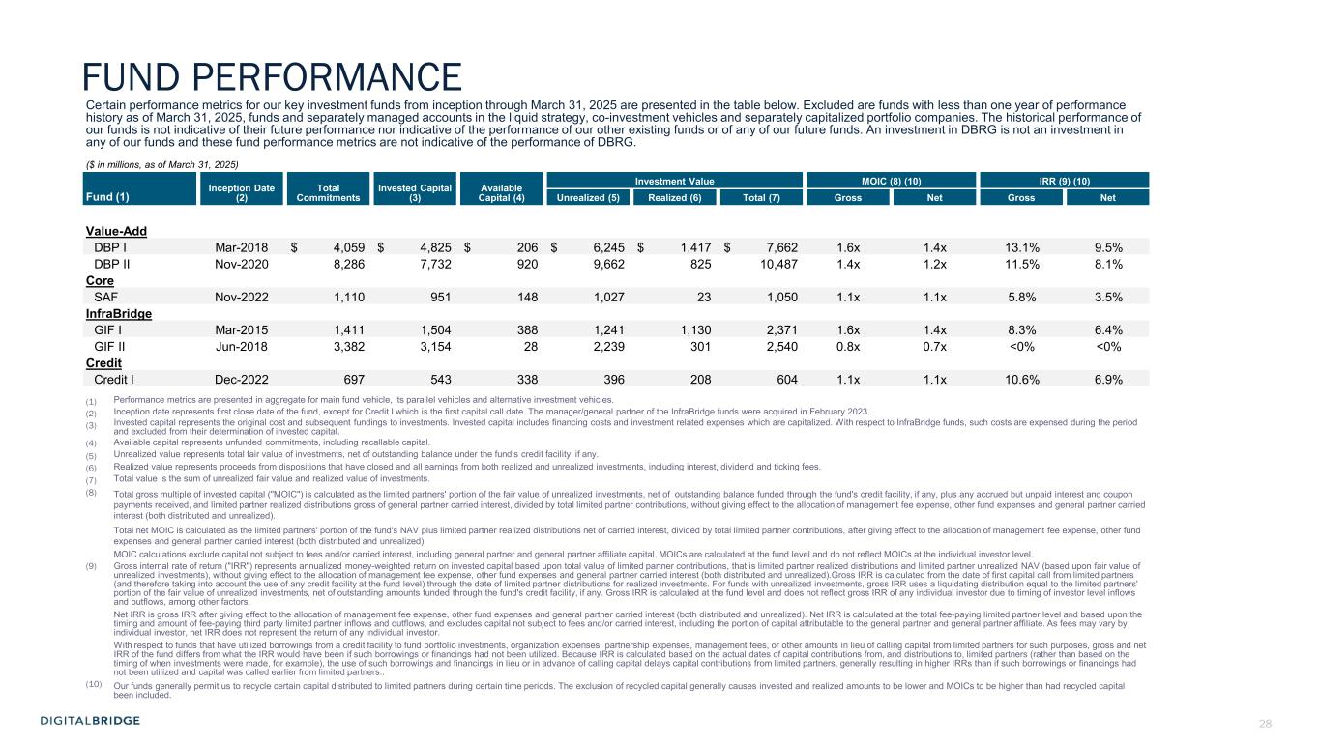
28 Certain performance metrics for our key investment funds from inception through March 31, 2025 are presented in the table below. Excluded are funds with less than one year of performance history as of March 31, 2025, funds and separately managed accounts in the liquid strategy, co-investment vehicles and separately capitalized portfolio companies. The historical performance of our funds is not indicative of their future performance nor indicative of the performance of our other existing funds or of any of our future funds. An investment in DBRG is not an investment in any of our funds and these fund performance metrics are not indicative of the performance of DBRG. ($ in millions, as of March 31, 2025) Inception Date (2) Total Commitments Invested Capital (3) Available Capital (4) Investment Value MOIC (8) (10) IRR (9) (10) Fund (1) Unrealized (5) Realized (6) Total (7) Gross Net Gross Net Value-Add DBP I Mar-2018 $ 4,059 $ 4,825 $ 206 $ 6,245 $ 1,417 $ 7,662 1.6x 1.4x 13.1% 9.5% DBP II Nov-2020 8,286 7,732 920 9,662 825 10,487 1.4x 1.2x 11.5% 8.1% Core SAF Nov-2022 1,110 951 148 1,027 23 1,050 1.1x 1.1x 5.8% 3.5% InfraBridge GIF I Mar-2015 1,411 1,504 388 1,241 1,130 2,371 1.6x 1.4x 8.3% 6.4% GIF II Jun-2018 3,382 3,154 28 2,239 301 2,540 0.8x 0.7x <0% <0% Credit Credit I Dec-2022 697 543 338 396 208 604 1.1x 1.1x 10.6% 6.9% (1) Performance metrics are presented in aggregate for main fund vehicle, its parallel vehicles and alternative investment vehicles. (2) Inception date represents first close date of the fund, except for Credit I which is the first capital call date. The manager/general partner of the InfraBridge funds were acquired in February 2023. (3) Invested capital represents the original cost and subsequent fundings to investments. Invested capital includes financing costs and investment related expenses which are capitalized. With respect to InfraBridge funds, such costs are expensed during the period and excluded from their determination of invested capital. (4) Available capital represents unfunded commitments, including recallable capital. (5) Unrealized value represents total fair value of investments, net of outstanding balance under the fund’s credit facility, if any. (6) Realized value represents proceeds from dispositions that have closed and all earnings from both realized and unrealized investments, including interest, dividend and ticking fees. (7) Total value is the sum of unrealized fair value and realized value of investments. (8) Total gross multiple of invested capital ("MOIC") is calculated as the limited partners' portion of the fair value of unrealized investments, net of outstanding balance funded through the fund's credit facility, if any, plus any accrued but unpaid interest and coupon payments received, and limited partner realized distributions gross of general partner carried interest, divided by total limited partner contributions, without giving effect to the allocation of management fee expense, other fund expenses and general partner carried interest (both distributed and unrealized). Total net MOIC is calculated as the limited partners' portion of the fund's NAV plus limited partner realized distributions net of carried interest, divided by total limited partner contributions, after giving effect to the allocation of management fee expense, other fund expenses and general partner carried interest (both distributed and unrealized). MOIC calculations exclude capital not subject to fees and/or carried interest, including general partner and general partner affiliate capital. MOICs are calculated at the fund level and do not reflect MOICs at the individual investor level. (9) Gross internal rate of return ("IRR") represents annualized money-weighted return on invested capital based upon total value of limited partner contributions, that is limited partner realized distributions and limited partner unrealized NAV (based upon fair value of unrealized investments), without giving effect to the allocation of management fee expense, other fund expenses and general partner carried interest (both distributed and unrealized).Gross IRR is calculated from the date of first capital call from limited partners (and therefore taking into account the use of any credit facility at the fund level) through the date of limited partner distributions for realized investments. For funds with unrealized investments, gross IRR uses a liquidating distribution equal to the limited partners' portion of the fair value of unrealized investments, net of outstanding amounts funded through the fund's credit facility, if any. Gross IRR is calculated at the fund level and does not reflect gross IRR of any individual investor due to timing of investor level inflows and outflows, among other factors. Net IRR is gross IRR after giving effect to the allocation of management fee expense, other fund expenses and general partner carried interest (both distributed and unrealized). Net IRR is calculated at the total fee-paying limited partner level and based upon the timing and amount of fee-paying third party limited partner inflows and outflows, and excludes capital not subject to fees and/or carried interest, including the portion of capital attributable to the general partner and general partner affiliate. As fees may vary by individual investor, net IRR does not represent the return of any individual investor. With respect to funds that have utilized borrowings from a credit facility to fund portfolio investments, organization expenses, partnership expenses, management fees, or other amounts in lieu of calling capital from limited partners for such purposes, gross and net IRR of the fund differs from what the IRR would have been if such borrowings or financings had not been utilized. Because IRR is calculated based on the actual dates of capital contributions from, and distributions to, limited partners (rather than based on the timing of when investments were made, for example), the use of such borrowings and financings in lieu or in advance of calling capital delays capital contributions from limited partners, generally resulting in higher IRRs than if such borrowings or financings had not been utilized and capital was called earlier from limited partners.. (10) Our funds generally permit us to recycle certain capital distributed to limited partners during certain time periods. The exclusion of recycled capital generally causes invested and realized amounts to be lower and MOICs to be higher than had recycled capital been included. FUND PERFORMANCE

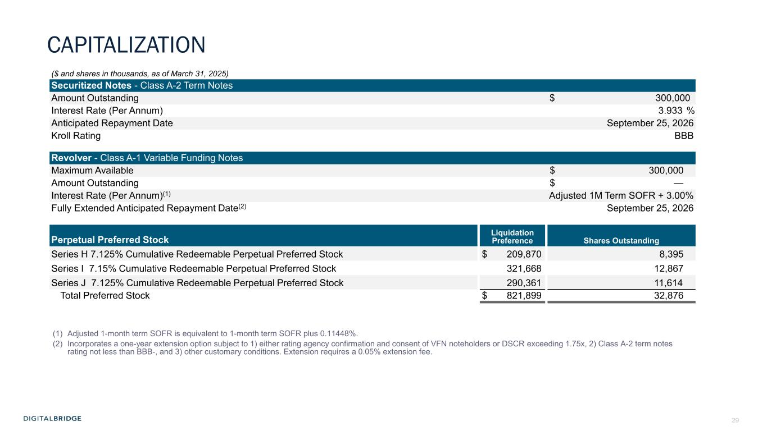
29 ($ and shares in thousands, as of March 31, 2025) Securitized Notes - Class A-2 Term Notes Amount Outstanding $ 300,000 Interest Rate (Per Annum) 3.933 % Anticipated Repayment Date September 25, 2026 Kroll Rating BBB Revolver - Class A-1 Variable Funding Notes Maximum Available $ 300,000 Amount Outstanding $ — Interest Rate (Per Annum)(1) Adjusted 1M Term SOFR + 3.00% Fully Extended Anticipated Repayment Date(2) September 25, 2026 Liquidation Preference Shares OutstandingPerpetual Preferred Stock Series H 7.125% Cumulative Redeemable Perpetual Preferred Stock $ 209,870 8,395 Series I 7.15% Cumulative Redeemable Perpetual Preferred Stock 321,668 12,867 Series J 7.125% Cumulative Redeemable Perpetual Preferred Stock 290,361 11,614 Total Preferred Stock $ 821,899 32,876 (1) Adjusted 1-month term SOFR is equivalent to 1-month term SOFR plus 0.11448%. (2) Incorporates a one-year extension option subject to 1) either rating agency confirmation and consent of VFN noteholders or DSCR exceeding 1.75x, 2) Class A-2 term notes rating not less than BBB-, and 3) other customary conditions. Extension requires a 0.05% extension fee. CAPITALIZATION

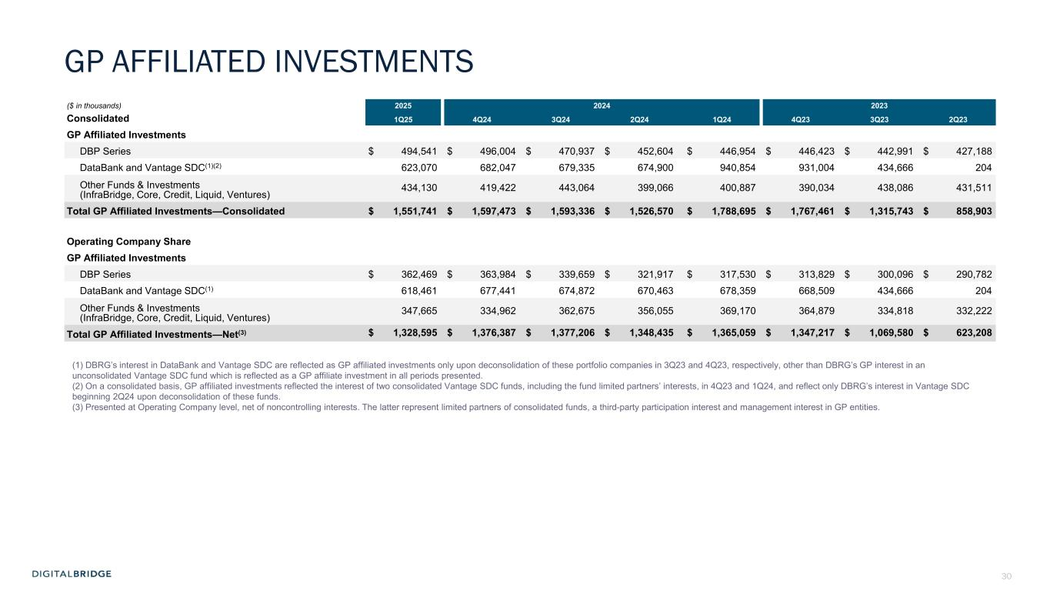
30 ($ in thousands) 2025 2024 2023 Consolidated 1Q25 4Q24 3Q24 2Q24 1Q24 4Q23 3Q23 2Q23 GP Affiliated Investments DBP Series $ 494,541 $ 496,004 $ 470,937 $ 452,604 $ 446,954 $ 446,423 $ 442,991 $ 427,188 DataBank and Vantage SDC(1)(2) 623,070 682,047 679,335 674,900 940,854 931,004 434,666 204 Other Funds & Investments (InfraBridge, Core, Credit, Liquid, Ventures) 434,130 419,422 443,064 399,066 400,887 390,034 438,086 431,511 Total GP Affiliated Investments—Consolidated $ 1,551,741 $ 1,597,473 $ 1,593,336 $ 1,526,570 $ 1,788,695 $ 1,767,461 $ 1,315,743 $ 858,903 Operating Company Share GP Affiliated Investments DBP Series $ 362,469 $ 363,984 $ 339,659 $ 321,917 $ 317,530 $ 313,829 $ 300,096 $ 290,782 DataBank and Vantage SDC(1) 618,461 677,441 674,872 670,463 678,359 668,509 434,666 204 Other Funds & Investments (InfraBridge, Core, Credit, Liquid, Ventures) 347,665 334,962 362,675 356,055 369,170 364,879 334,818 332,222 Total GP Affiliated Investments—Net(3) $ 1,328,595 $ 1,376,387 $ 1,377,206 $ 1,348,435 $ 1,365,059 $ 1,347,217 $ 1,069,580 $ 623,208 GP AFFILIATED INVESTMENTS (1) DBRG’s interest in DataBank and Vantage SDC are reflected as GP affiliated investments only upon deconsolidation of these portfolio companies in 3Q23 and 4Q23, respectively, other than DBRG’s GP interest in an unconsolidated Vantage SDC fund which is reflected as a GP affiliate investment in all periods presented. (2) On a consolidated basis, GP affiliated investments reflected the interest of two consolidated Vantage SDC funds, including the fund limited partners’ interests, in 4Q23 and 1Q24, and reflect only DBRG’s interest in Vantage SDC beginning 2Q24 upon deconsolidation of these funds. (3) Presented at Operating Company level, net of noncontrolling interests. The latter represent limited partners of consolidated funds, a third-party participation interest and management interest in GP entities.

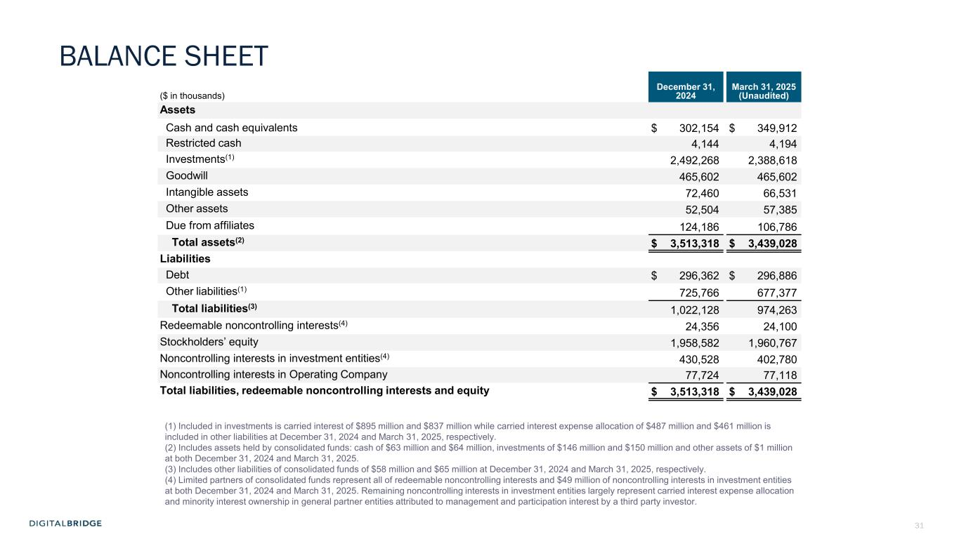
31 ($ in thousands) December 31, 2024 March 31, 2025 (Unaudited) Assets Cash and cash equivalents $ 302,154 $ 349,912 Restricted cash 4,144 4,194 Investments(1) 2,492,268 2,388,618 Goodwill 465,602 465,602 Intangible assets 72,460 66,531 Other assets 52,504 57,385 Due from affiliates 124,186 106,786 Total assets(2) $ 3,513,318 $ 3,439,028 Liabilities Debt $ 296,362 $ 296,886 Other liabilities(1) 725,766 677,377 Total liabilities(3) 1,022,128 974,263 Redeemable noncontrolling interests(4) 24,356 24,100 Stockholders’ equity 1,958,582 1,960,767 Noncontrolling interests in investment entities(4) 430,528 402,780 Noncontrolling interests in Operating Company 77,724 77,118 Total liabilities, redeemable noncontrolling interests and equity $ 3,513,318 $ 3,439,028 (1) Included in investments is carried interest of $895 million and $837 million while carried interest expense allocation of $487 million and $461 million is included in other liabilities at December 31, 2024 and March 31, 2025, respectively. (2) Includes assets held by consolidated funds: cash of $63 million and $64 million, investments of $146 million and $150 million and other assets of $1 million at both December 31, 2024 and March 31, 2025. (3) Includes other liabilities of consolidated funds of $58 million and $65 million at December 31, 2024 and March 31, 2025, respectively. (4) Limited partners of consolidated funds represent all of redeemable noncontrolling interests and $49 million of noncontrolling interests in investment entities at both December 31, 2024 and March 31, 2025. Remaining noncontrolling interests in investment entities largely represent carried interest expense allocation and minority interest ownership in general partner entities attributed to management and participation interest by a third party investor. BALANCE SHEET

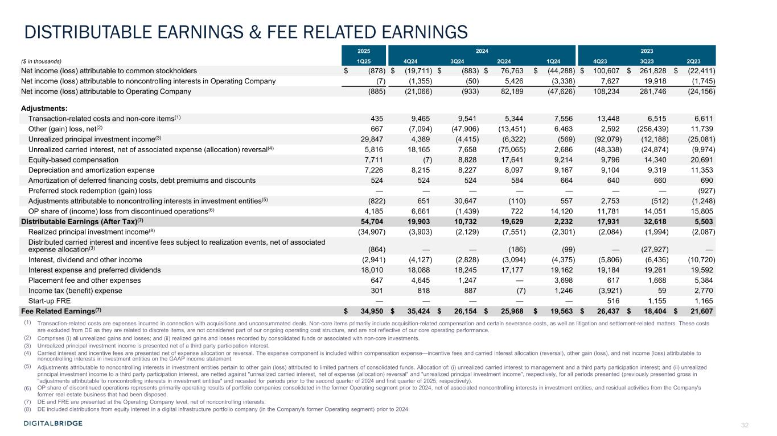
32 DISTRIBUTABLE EARNINGS & FEE RELATED EARNINGS 2025 2024 2023 ($ in thousands) 1Q25 4Q24 3Q24 2Q24 1Q24 4Q23 3Q23 2Q23 Net income (loss) attributable to common stockholders $ (878) $ (19,711) $ (883) $ 76,763 $ (44,288) $ 100,607 $ 261,828 $ (22,411) Net income (loss) attributable to noncontrolling interests in Operating Company (7) (1,355) (50) 5,426 (3,338) 7,627 19,918 (1,745) Net income (loss) attributable to Operating Company (885) (21,066) (933) 82,189 (47,626) 108,234 281,746 (24,156) Adjustments: Transaction-related costs and non-core items(1) 435 9,465 9,541 5,344 7,556 13,448 6,515 6,611 Other (gain) loss, net(2) 667 (7,094) (47,906) (13,451) 6,463 2,592 (256,439) 11,739 Unrealized principal investment income(3) 29,847 4,389 (4,415) (6,322) (569) (92,079) (12,188) (25,081) Unrealized carried interest, net of associated expense (allocation) reversal(4) 5,816 18,165 7,658 (75,065) 2,686 (48,338) (24,874) (9,974) Equity-based compensation 7,711 (7) 8,828 17,641 9,214 9,796 14,340 20,691 Depreciation and amortization expense 7,226 8,215 8,227 8,097 9,167 9,104 9,319 11,353 Amortization of deferred financing costs, debt premiums and discounts 524 524 524 584 664 640 660 690 Preferred stock redemption (gain) loss — — — — — — — (927) Adjustments attributable to noncontrolling interests in investment entities(5) (822) 651 30,647 (110) 557 2,753 (512) (1,248) OP share of (income) loss from discontinued operations(6) 4,185 6,661 (1,439) 722 14,120 11,781 14,051 15,805 Distributable Earnings (After Tax)(7) 54,704 19,903 10,732 19,629 2,232 17,931 32,618 5,503 Realized principal investment income(8) (34,907) (3,903) (2,129) (7,551) (2,301) (2,084) (1,994) (2,087) Distributed carried interest and incentive fees subject to realization events, net of associated expense allocation(3) (864) — — (186) (99) — (27,927) — Interest, dividend and other income (2,941) (4,127) (2,828) (3,094) (4,375) (5,806) (6,436) (10,720) Interest expense and preferred dividends 18,010 18,088 18,245 17,177 19,162 19,184 19,261 19,592 Placement fee and other expenses 647 4,645 1,247 — 3,698 617 1,668 5,384 Income tax (benefit) expense 301 818 887 (7) 1,246 (3,921) 59 2,770 Start-up FRE — — — — — 516 1,155 1,165 Fee Related Earnings(7) $ 34,950 $ 35,424 $ 26,154 $ 25,968 $ 19,563 $ 26,437 $ 18,404 $ 21,607 (1) Transaction-related costs are expenses incurred in connection with acquisitions and unconsummated deals. Non-core items primarily include acquisition-related compensation and certain severance costs, as well as litigation and settlement-related matters. These costs are excluded from DE as they are related to discrete items, are not considered part of our ongoing operating cost structure, and are not reflective of our core operating performance. (2) Comprises (i) all unrealized gains and losses; and (ii) realized gains and losses recorded by consolidated funds or associated with non-core investments. (3) Unrealized principal investment income is presented net of a third party participation interest. (4) Carried interest and incentive fees are presented net of expense allocation or reversal. The expense component is included within compensation expense—incentive fees and carried interest allocation (reversal), other gain (loss), and net income (loss) attributable to noncontrolling interests in investment entities on the GAAP income statement. (5) Adjustments attributable to noncontrolling interests in investment entities pertain to other gain (loss) attributed to limited partners of consolidated funds. Allocation of: (i) unrealized carried interest to management and a third party participation interest; and (ii) unrealized principal investment income to a third party participation interest, are netted against "unrealized carried interest, net of expense (allocation) reversal" and "unrealized principal investment income", respectively, for all periods presented (previously presented gross in "adjustments attributable to noncontrolling interests in investment entities" and recasted for periods prior to the second quarter of 2024 and first quarter of 2025, respectively). (6) OP share of discontinued operations represents primarily operating results of portfolio companies consolidated in the former Operating segment prior to 2024, net of associated noncontrolling interests in investment entities, and residual activities from the Company's former real estate business that had been disposed. (7) DE and FRE are presented at the Operating Company level, net of noncontrolling interests. (8) DE included distributions from equity interest in a digital infrastructure portfolio company (in the Company's former Operating segment) prior to 2024.

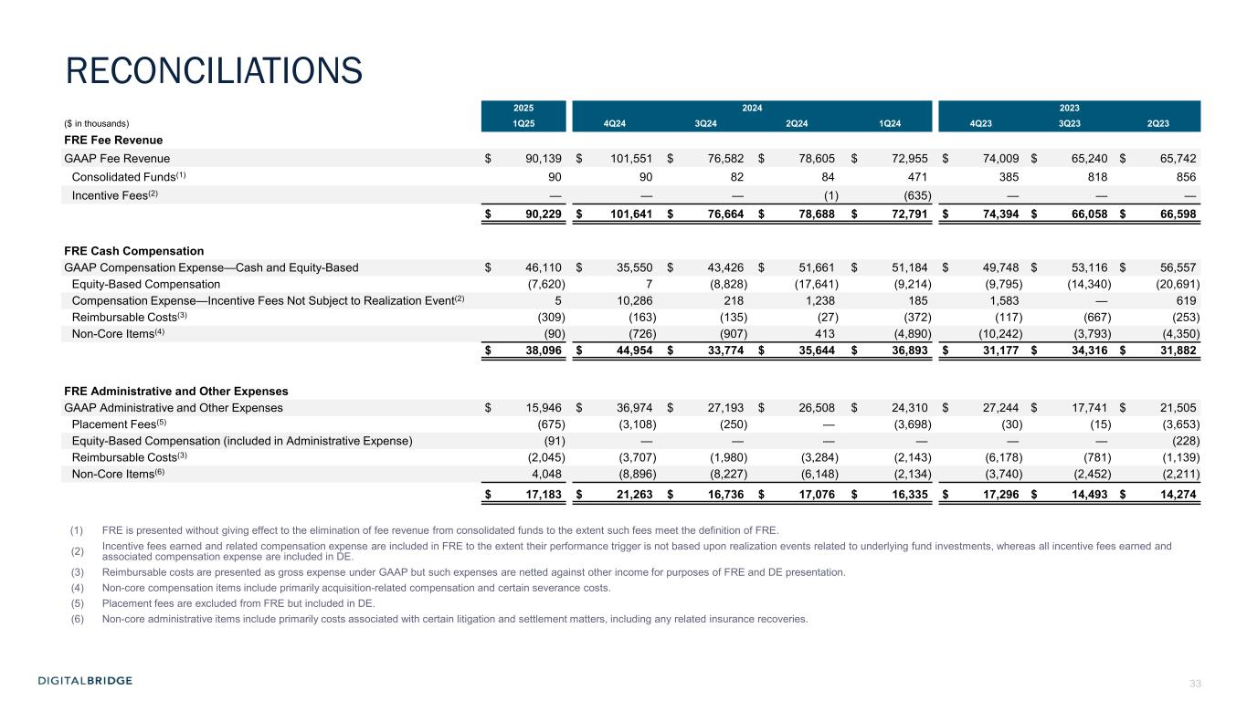
33 2025 2024 2023 ($ in thousands) 1Q25 4Q24 3Q24 2Q24 1Q24 4Q23 3Q23 2Q23 FRE Fee Revenue GAAP Fee Revenue $ 90,139 $ 101,551 $ 76,582 $ 78,605 $ 72,955 $ 74,009 $ 65,240 $ 65,742 Consolidated Funds(1) 90 90 82 84 471 385 818 856 Incentive Fees(2) — — — (1) (635) — — — $ 90,229 $ 101,641 $ 76,664 $ 78,688 $ 72,791 $ 74,394 $ 66,058 $ 66,598 FRE Cash Compensation GAAP Compensation Expense—Cash and Equity-Based $ 46,110 $ 35,550 $ 43,426 $ 51,661 $ 51,184 $ 49,748 $ 53,116 $ 56,557 Equity-Based Compensation (7,620) 7 (8,828) (17,641) (9,214) (9,795) (14,340) (20,691) Compensation Expense—Incentive Fees Not Subject to Realization Event(2) 5 10,286 218 1,238 185 1,583 — 619 Reimbursable Costs(3) (309) (163) (135) (27) (372) (117) (667) (253) Non-Core Items(4) (90) (726) (907) 413 (4,890) (10,242) (3,793) (4,350) $ 38,096 $ 44,954 $ 33,774 $ 35,644 $ 36,893 $ 31,177 $ 34,316 $ 31,882 FRE Administrative and Other Expenses GAAP Administrative and Other Expenses $ 15,946 $ 36,974 $ 27,193 $ 26,508 $ 24,310 $ 27,244 $ 17,741 $ 21,505 Placement Fees(5) (675) (3,108) (250) — (3,698) (30) (15) (3,653) Equity-Based Compensation (included in Administrative Expense) (91) — — — — — — (228) Reimbursable Costs(3) (2,045) (3,707) (1,980) (3,284) (2,143) (6,178) (781) (1,139) Non-Core Items(6) 4,048 (8,896) (8,227) (6,148) (2,134) (3,740) (2,452) (2,211) $ 17,183 $ 21,263 $ 16,736 $ 17,076 $ 16,335 $ 17,296 $ 14,493 $ 14,274 (1) FRE is presented without giving effect to the elimination of fee revenue from consolidated funds to the extent such fees meet the definition of FRE. (2) Incentive fees earned and related compensation expense are included in FRE to the extent their performance trigger is not based upon realization events related to underlying fund investments, whereas all incentive fees earned and associated compensation expense are included in DE. (3) Reimbursable costs are presented as gross expense under GAAP but such expenses are netted against other income for purposes of FRE and DE presentation. (4) Non-core compensation items include primarily acquisition-related compensation and certain severance costs. (5) Placement fees are excluded from FRE but included in DE. (6) Non-core administrative items include primarily costs associated with certain litigation and settlement matters, including any related insurance recoveries. RECONCILIATIONS

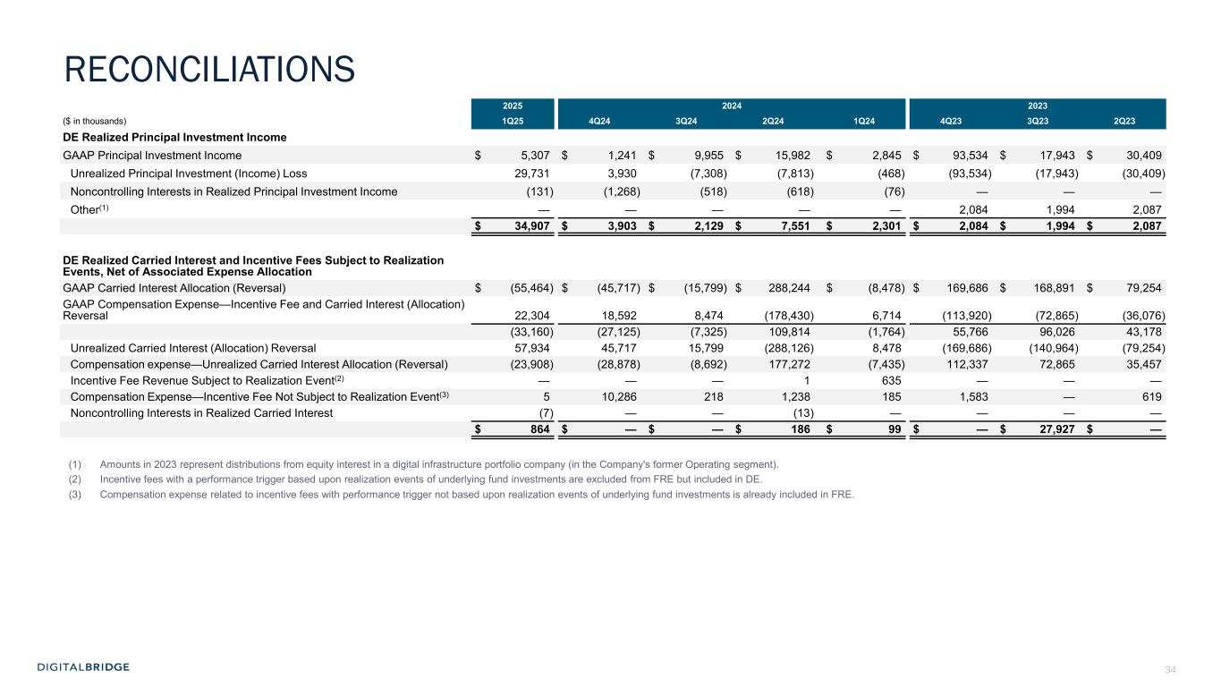
34 2025 2024 2023 ($ in thousands) 1Q25 4Q24 3Q24 2Q24 1Q24 4Q23 3Q23 2Q23 DE Realized Principal Investment Income GAAP Principal Investment Income $ 5,307 $ 1,241 $ 9,955 $ 15,982 $ 2,845 $ 93,534 $ 17,943 $ 30,409 Unrealized Principal Investment (Income) Loss 29,731 3,930 (7,308) (7,813) (468) (93,534) (17,943) (30,409) Noncontrolling Interests in Realized Principal Investment Income (131) (1,268) (518) (618) (76) — — — Other(1) — — — — — 2,084 1,994 2,087 $ 34,907 $ 3,903 $ 2,129 $ 7,551 $ 2,301 $ 2,084 $ 1,994 $ 2,087 DE Realized Carried Interest and Incentive Fees Subject to Realization Events, Net of Associated Expense Allocation GAAP Carried Interest Allocation (Reversal) $ (55,464) $ (45,717) $ (15,799) $ 288,244 $ (8,478) $ 169,686 $ 168,891 $ 79,254 GAAP Compensation Expense—Incentive Fee and Carried Interest (Allocation) Reversal 22,304 18,592 8,474 (178,430) 6,714 (113,920) (72,865) (36,076) (33,160) (27,125) (7,325) 109,814 (1,764) 55,766 96,026 43,178 Unrealized Carried Interest (Allocation) Reversal 57,934 45,717 15,799 (288,126) 8,478 (169,686) (140,964) (79,254) Compensation expense—Unrealized Carried Interest Allocation (Reversal) (23,908) (28,878) (8,692) 177,272 (7,435) 112,337 72,865 35,457 Incentive Fee Revenue Subject to Realization Event(2) — — — 1 635 — — — Compensation Expense—Incentive Fee Not Subject to Realization Event(3) 5 10,286 218 1,238 185 1,583 — 619 Noncontrolling Interests in Realized Carried Interest (7) — — (13) — — — — $ 864 $ — $ — $ 186 $ 99 $ — $ 27,927 $ — (1) Amounts in 2023 represent distributions from equity interest in a digital infrastructure portfolio company (in the Company's former Operating segment). (2) Incentive fees with a performance trigger based upon realization events of underlying fund investments are excluded from FRE but included in DE. (3) Compensation expense related to incentive fees with performance trigger not based upon realization events of underlying fund investments is already included in FRE. RECONCILIATIONS

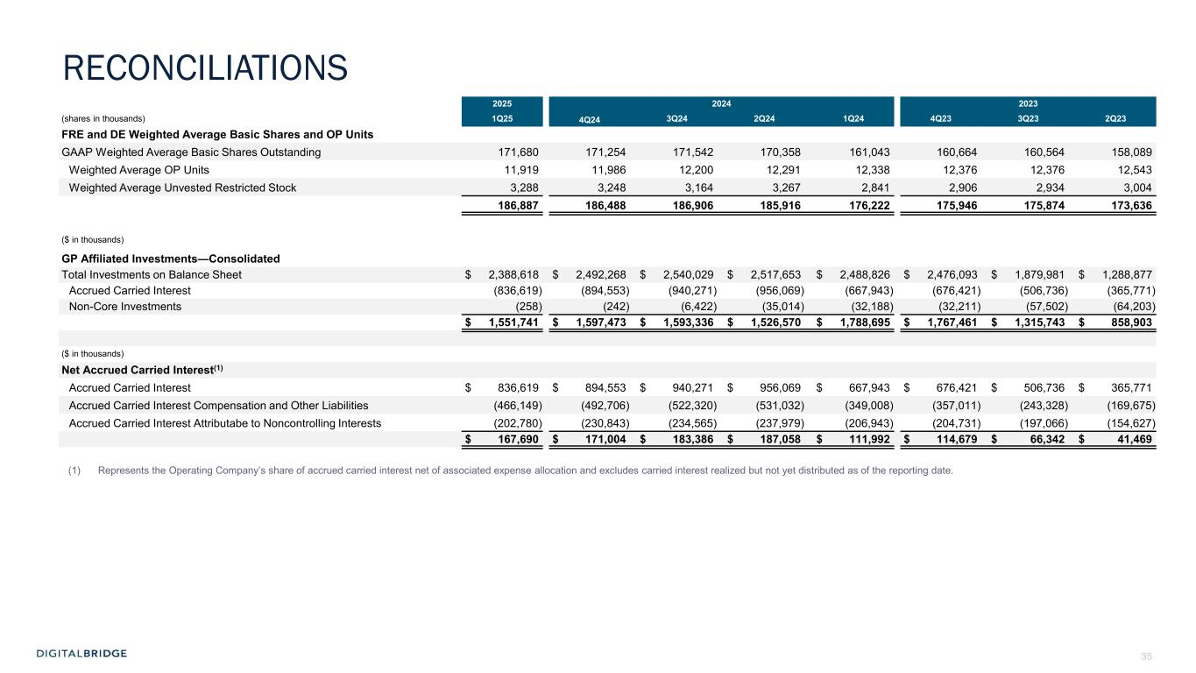
35 2025 2024 2023 (shares in thousands) 1Q25 4Q24 3Q24 2Q24 1Q24 4Q23 3Q23 2Q23 FRE and DE Weighted Average Basic Shares and OP Units GAAP Weighted Average Basic Shares Outstanding 171,680 171,254 171,542 170,358 161,043 160,664 160,564 158,089 Weighted Average OP Units 11,919 11,986 12,200 12,291 12,338 12,376 12,376 12,543 Weighted Average Unvested Restricted Stock 3,288 3,248 3,164 3,267 2,841 2,906 2,934 3,004 186,887 186,488 186,906 185,916 176,222 175,946 175,874 173,636 ($ in thousands) GP Affiliated Investments—Consolidated Total Investments on Balance Sheet $ 2,388,618 $ 2,492,268 $ 2,540,029 $ 2,517,653 $ 2,488,826 $ 2,476,093 $ 1,879,981 $ 1,288,877 Accrued Carried Interest (836,619) (894,553) (940,271) (956,069) (667,943) (676,421) (506,736) (365,771) Non-Core Investments (258) (242) (6,422) (35,014) (32,188) (32,211) (57,502) (64,203) $ 1,551,741 $ 1,597,473 $ 1,593,336 $ 1,526,570 $ 1,788,695 $ 1,767,461 $ 1,315,743 $ 858,903 ($ in thousands) Net Accrued Carried Interest(1) Accrued Carried Interest $ 836,619 $ 894,553 $ 940,271 $ 956,069 $ 667,943 $ 676,421 $ 506,736 $ 365,771 Accrued Carried Interest Compensation and Other Liabilities (466,149) (492,706) (522,320) (531,032) (349,008) (357,011) (243,328) (169,675) Accrued Carried Interest Attributabe to Noncontrolling Interests (202,780) (230,843) (234,565) (237,979) (206,943) (204,731) (197,066) (154,627) $ 167,690 $ 171,004 $ 183,386 $ 187,058 $ 111,992 $ 114,679 $ 66,342 $ 41,469 (1) Represents the Operating Company’s share of accrued carried interest net of associated expense allocation and excludes carried interest realized but not yet distributed as of the reporting date. RECONCILIATIONS


36 6 APPENDIX

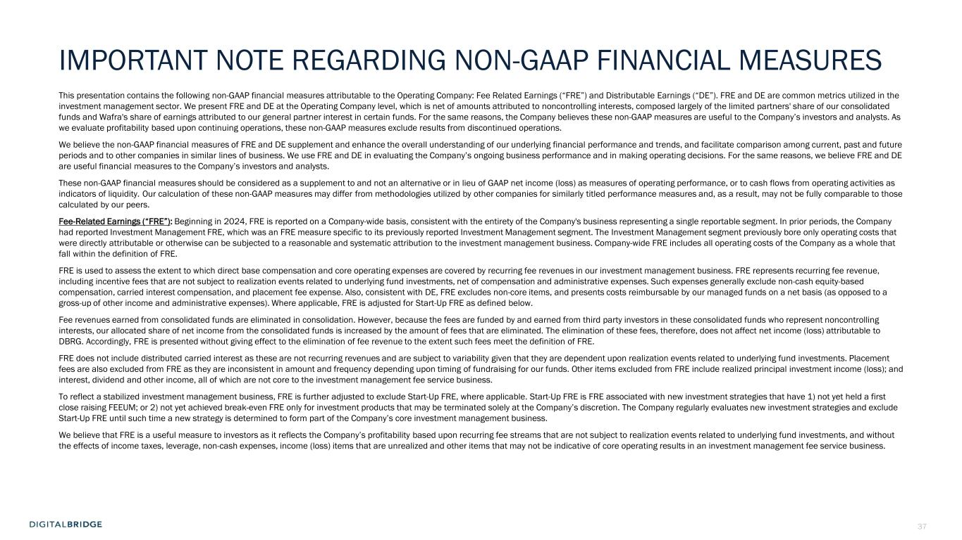
37 IMPORTANT NOTE REGARDING NON-GAAP FINANCIAL MEASURES This presentation contains the following non-GAAP financial measures attributable to the Operating Company: Fee Related Earnings (“FRE”) and Distributable Earnings (“DE”). FRE and DE are common metrics utilized in the investment management sector. We present FRE and DE at the Operating Company level, which is net of amounts attributed to noncontrolling interests, composed largely of the limited partners' share of our consolidated funds and Wafra's share of earnings attributed to our general partner interest in certain funds. For the same reasons, the Company believes these non-GAAP measures are useful to the Company’s investors and analysts. As we evaluate profitability based upon continuing operations, these non-GAAP measures exclude results from discontinued operations. We believe the non-GAAP financial measures of FRE and DE supplement and enhance the overall understanding of our underlying financial performance and trends, and facilitate comparison among current, past and future periods and to other companies in similar lines of business. We use FRE and DE in evaluating the Company’s ongoing business performance and in making operating decisions. For the same reasons, we believe FRE and DE are useful financial measures to the Company’s investors and analysts. These non-GAAP financial measures should be considered as a supplement to and not an alternative or in lieu of GAAP net income (loss) as measures of operating performance, or to cash flows from operating activities as indicators of liquidity. Our calculation of these non-GAAP measures may differ from methodologies utilized by other companies for similarly titled performance measures and, as a result, may not be fully comparable to those calculated by our peers. Fee-Related Earnings (“FRE”): Beginning in 2024, FRE is reported on a Company-wide basis, consistent with the entirety of the Company's business representing a single reportable segment. In prior periods, the Company had reported Investment Management FRE, which was an FRE measure specific to its previously reported Investment Management segment. The Investment Management segment previously bore only operating costs that were directly attributable or otherwise can be subjected to a reasonable and systematic attribution to the investment management business. Company-wide FRE includes all operating costs of the Company as a whole that fall within the definition of FRE. FRE is used to assess the extent to which direct base compensation and core operating expenses are covered by recurring fee revenues in our investment management business. FRE represents recurring fee revenue, including incentive fees that are not subject to realization events related to underlying fund investments, net of compensation and administrative expenses. Such expenses generally exclude non-cash equity-based compensation, carried interest compensation, and placement fee expense. Also, consistent with DE, FRE excludes non-core items, and presents costs reimbursable by our managed funds on a net basis (as opposed to a gross-up of other income and administrative expenses). Where applicable, FRE is adjusted for Start-Up FRE as defined below. Fee revenues earned from consolidated funds are eliminated in consolidation. However, because the fees are funded by and earned from third party investors in these consolidated funds who represent noncontrolling interests, our allocated share of net income from the consolidated funds is increased by the amount of fees that are eliminated. The elimination of these fees, therefore, does not affect net income (loss) attributable to DBRG. Accordingly, FRE is presented without giving effect to the elimination of fee revenue to the extent such fees meet the definition of FRE. FRE does not include distributed carried interest as these are not recurring revenues and are subject to variability given that they are dependent upon realization events related to underlying fund investments. Placement fees are also excluded from FRE as they are inconsistent in amount and frequency depending upon timing of fundraising for our funds. Other items excluded from FRE include realized principal investment income (loss); and interest, dividend and other income, all of which are not core to the investment management fee service business. To reflect a stabilized investment management business, FRE is further adjusted to exclude Start-Up FRE, where applicable. Start-Up FRE is FRE associated with new investment strategies that have 1) not yet held a first close raising FEEUM; or 2) not yet achieved break-even FRE only for investment products that may be terminated solely at the Company’s discretion. The Company regularly evaluates new investment strategies and exclude Start-Up FRE until such time a new strategy is determined to form part of the Company’s core investment management business. We believe that FRE is a useful measure to investors as it reflects the Company’s profitability based upon recurring fee streams that are not subject to realization events related to underlying fund investments, and without the effects of income taxes, leverage, non-cash expenses, income (loss) items that are unrealized and other items that may not be indicative of core operating results in an investment management fee service business.

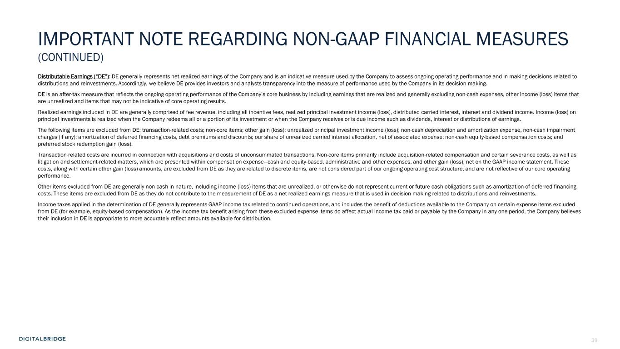
38 IMPORTANT NOTE REGARDING NON-GAAP FINANCIAL MEASURES (CONTINUED) Distributable Earnings (“DE”): DE generally represents net realized earnings of the Company and is an indicative measure used by the Company to assess ongoing operating performance and in making decisions related to distributions and reinvestments. Accordingly, we believe DE provides investors and analysts transparency into the measure of performance used by the Company in its decision making. DE is an after-tax measure that reflects the ongoing operating performance of the Company’s core business by including earnings that are realized and generally excluding non-cash expenses, other income (loss) items that are unrealized and items that may not be indicative of core operating results. Realized earnings included in DE are generally comprised of fee revenue, including all incentive fees, realized principal investment income (loss), distributed carried interest, interest and dividend income. Income (loss) on principal investments is realized when the Company redeems all or a portion of its investment or when the Company receives or is due income such as dividends, interest or distributions of earnings. The following items are excluded from DE: transaction-related costs; non-core items; other gain (loss); unrealized principal investment income (loss); non-cash depreciation and amortization expense, non-cash impairment charges (if any); amortization of deferred financing costs, debt premiums and discounts; our share of unrealized carried interest allocation, net of associated expense; non-cash equity-based compensation costs; and preferred stock redemption gain (loss). Transaction-related costs are incurred in connection with acquisitions and costs of unconsummated transactions. Non-core items primarily include acquisition-related compensation and certain severance costs, as well as litigation and settlement-related matters, which are presented within compensation expense—cash and equity-based, administrative and other expenses, and other gain (loss), net on the GAAP income statement. These costs, along with certain other gain (loss) amounts, are excluded from DE as they are related to discrete items, are not considered part of our ongoing operating cost structure, and are not reflective of our core operating performance. Other items excluded from DE are generally non-cash in nature, including income (loss) items that are unrealized, or otherwise do not represent current or future cash obligations such as amortization of deferred financing costs. These items are excluded from DE as they do not contribute to the measurement of DE as a net realized earnings measure that is used in decision making related to distributions and reinvestments. Income taxes applied in the determination of DE generally represents GAAP income tax related to continued operations, and includes the benefit of deductions available to the Company on certain expense items excluded from DE (for example, equity-based compensation). As the income tax benefit arising from these excluded expense items do affect actual income tax paid or payable by the Company in any one period, the Company believes their inclusion in DE is appropriate to more accurately reflect amounts available for distribution.

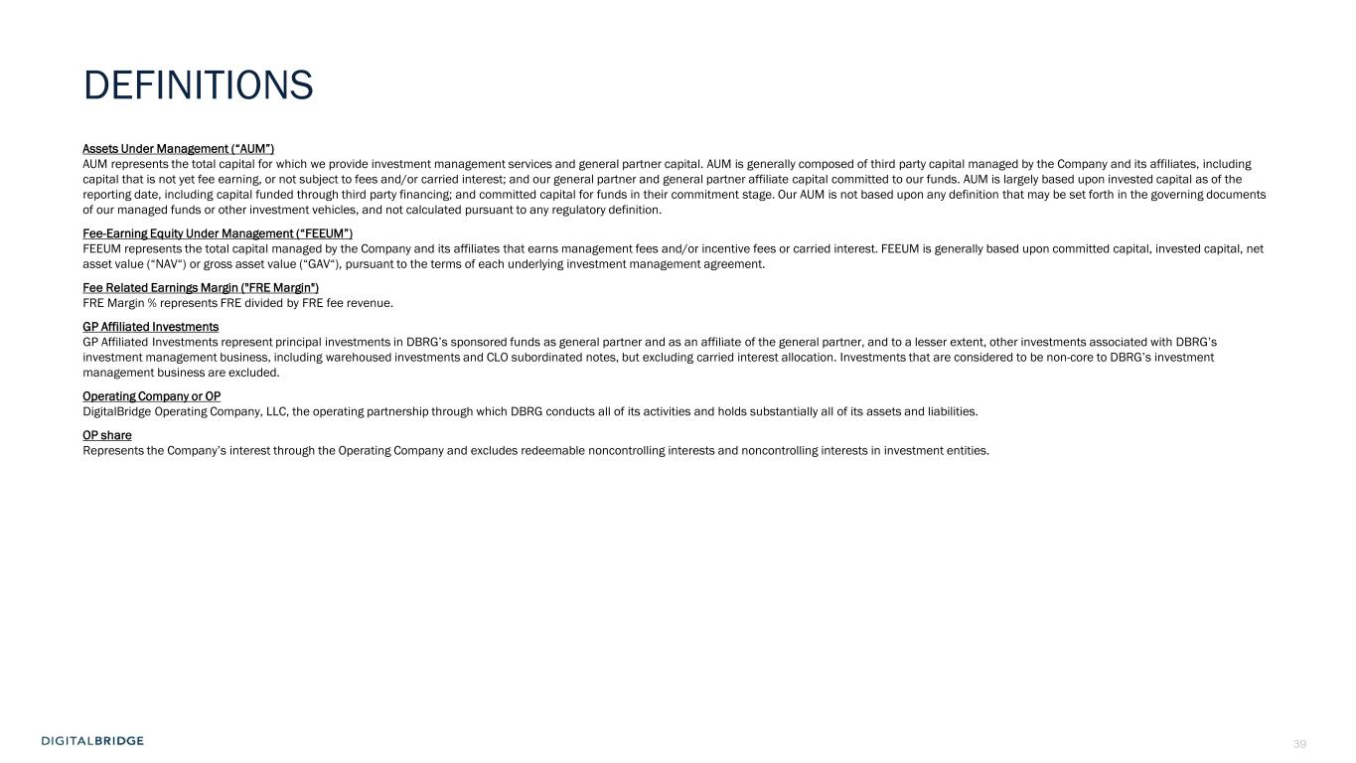
39 DEFINITIONS Assets Under Management (“AUM”) AUM represents the total capital for which we provide investment management services and general partner capital. AUM is generally composed of third party capital managed by the Company and its affiliates, including capital that is not yet fee earning, or not subject to fees and/or carried interest; and our general partner and general partner affiliate capital committed to our funds. AUM is largely based upon invested capital as of the reporting date, including capital funded through third party financing; and committed capital for funds in their commitment stage. Our AUM is not based upon any definition that may be set forth in the governing documents of our managed funds or other investment vehicles, and not calculated pursuant to any regulatory definition. Fee-Earning Equity Under Management (“FEEUM”) FEEUM represents the total capital managed by the Company and its affiliates that earns management fees and/or incentive fees or carried interest. FEEUM is generally based upon committed capital, invested capital, net asset value (“NAV“) or gross asset value (“GAV“), pursuant to the terms of each underlying investment management agreement. Fee Related Earnings Margin ("FRE Margin") FRE Margin % represents FRE divided by FRE fee revenue. GP Affiliated Investments GP Affiliated Investments represent principal investments in DBRG’s sponsored funds as general partner and as an affiliate of the general partner, and to a lesser extent, other investments associated with DBRG’s investment management business, including warehoused investments and CLO subordinated notes, but excluding carried interest allocation. Investments that are considered to be non-core to DBRG’s investment management business are excluded. Operating Company or OP DigitalBridge Operating Company, LLC, the operating partnership through which DBRG conducts all of its activities and holds substantially all of its assets and liabilities. OP share Represents the Company’s interest through the Operating Company and excludes redeemable noncontrolling interests and noncontrolling interests in investment entities.


40

