UNITED STATES
SECURITIES AND EXCHANGE COMMISSION
Washington, D.C. 20549
FORM 8-K
CURRENT REPORT
Pursuant to Section 13 or 15(d)
of the Securities Exchange Act of 1934
Date of Report (Date of earliest event reported): August 7, 2024
DIGITALBRIDGE GROUP, INC.
(Exact Name of Registrant as Specified in Its Charter)
Maryland |  |  |  |  |  | 001-37980 |  |  |  |  |  | 46-4591526
(State or Other Jurisdiction of  Incorporation or Organization) |  |  |  |  |  | (Commission  File Number) |  |  |  |  |  | (I.R.S. Employer  Identification No.)
750 Park of Commerce Drive, Suite 210
Boca Raton, Florida 33487
(Address of Principal Executive Offices, Including Zip Code)
(561) 570-4644
Registrant’s telephone number, including area code:
N/A
(Former name or former address, if changed since last report.)
Check the appropriate box below if the Form 8-K filing is intended to simultaneously satisfy the filing obligation of the registrant under any of the following provisions (see General Instruction A.2. below):
☐ |  |  | Written communications pursuant to Rule 425 under the Securities Act (17 CFR 230.425)
☐ |  |  | Soliciting material pursuant to Rule 14a-12 under the Exchange Act (17 CFR 240.14a-12)
☐ |  |  | Pre-commencement communications pursuant to Rule 14d-2(b) under the Exchange Act (17 CFR 240.14d-2(b))
☐ |  |  | Pre-commencement communications pursuant to Rule 13e-4(c) under the Exchange Act (17 CFR 240.13e-4(c))
Securities registered pursuant to Section 12(b) of the Act:
Title of Class |  |  |  |  |  | Trading Symbol(s) |  |  |  |  |  | Name of Each Exchange on Which Registered
Class A Common Stock, $0.01 par value |  |  |  |  |  | DBRG |  |  |  |  |  | New York Stock Exchange
Preferred Stock, 7.125% Series H Cumulative Redeemable, $0.01 par value |  |  |  |  |  | DBRG.PRH |  |  |  |  |  | New York Stock Exchange
Preferred Stock, 7.15% Series I Cumulative Redeemable, $0.01 par value |  |  |  |  |  | DBRG.PRI |  |  |  |  |  | New York Stock Exchange
Preferred Stock, 7.125% Series J Cumulative Redeemable, $0.01 par value |  |  |  |  |  | DBRG.PRJ |  |  |  |  |  | New York Stock Exchange
Indicate by check mark whether the registrant is an emerging growth company as defined in Rule 405 of the Securities Act of 1933 (§230.405 of this chapter) or Rule 12b-2 of the Securities Exchange Act of 1934 (§240.12b-2 of this chapter).
 |  |  | Emerging growth company |  |  | ☐
 |  |  | If an emerging growth company, indicate by check mark if the registrant has elected not to use the extended transition period for complying with any new or revised financial accounting standards provided pursuant to Section 13(a) of the Exchange Act. |  |  | ☐

Item 2.02 Results of Operations and Financial Condition.
On August 7, 2024, DigitalBridge Group, Inc. (the “Company”) issued an earnings release and detailed presentation announcing its financial position as of June 30, 2024 and its financial results for the quarter ended June 30, 2024. A copy of the earnings release is attached as Exhibit 99.1 to this Current Report on Form 8-K.
The information included in this Current Report on Form 8-K, including Exhibit 99.1 hereto, shall not be deemed “filed” for the purposes of Section 18 of the Securities Exchange Act of 1934, as amended (the “Exchange Act”), or otherwise subject to the liabilities of that section, nor shall it be deemed incorporated by reference into any filing made by the Company under the Exchange Act or the Securities Act of 1933, as amended, except as shall be expressly set forth by specific reference in such a filing.
Use of Website to Distribute Material Company Information
The Company’s website address is www.digitalbridge.com. The Company uses its website as a channel of distribution for important company information. Important information, including press releases, analyst presentations and financial information regarding the Company, is routinely posted on and accessible on the Shareholders subpage of its website, which is accessible by clicking on the tab labeled “Shareholders” on the website home page. The Company also uses its website to expedite public access to time-critical information regarding the Company in advance of or in lieu of distributing a press release or a filing with the U.S. Securities and Exchange Commission disclosing the same information. Therefore, investors should look to the Shareholders subpage of the Company’s website for important and time-critical information. Visitors to the Company’s website can also register to receive automatic e-mail and other notifications alerting them when new information is made available on the Shareholders subpage of the website.
Item 9.01 Financial Statements and Exhibits.
(d) Exhibits. The following exhibits are being furnished herewith to this Current Report on Form 8-K.
Exhibit No. |  |  |  |  |  | Description
99.1 |  |  |  |  |  | Earnings Release dated August 7, 2024
104 |  |  |  |  |  | Cover Page Interactive Data File (embedded within the Inline XBRL document)

SIGNATURES
Pursuant to the requirements of the Securities Exchange Act of 1934, as amended, the registrant has duly caused this report to be signed on its behalf by the undersigned hereunto duly authorized.
Date: |  |  | August 7, 2024 |  |  | DIGITALBRIDGE GROUP, INC.
 |  |  |  |  |  | By: |  |  | /s/ Thomas Mayrhofer
 |  |  |  |  |  |  |  |  | Thomas Mayrhofer
 |  |  |  |  |  |  |  |  | Executive Vice President, Chief Financial Officer and Treasurer



1 EARNINGS PRESENTATION 2Q 2024 August 7, 2024

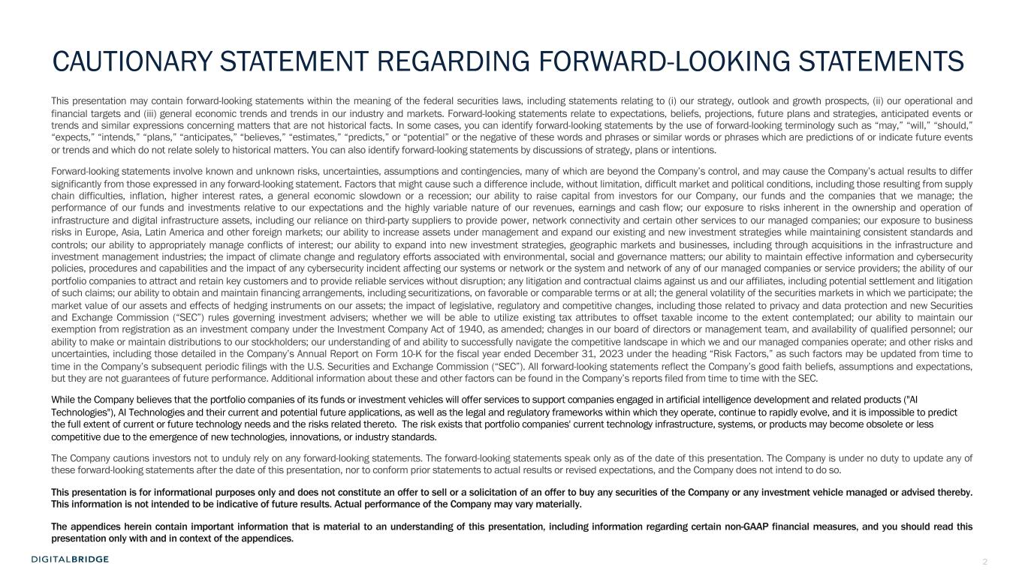
2 CAUTIONARY STATEMENT REGARDING FORWARD-LOOKING STATEMENTS This presentation may contain forward-looking statements within the meaning of the federal securities laws, including statements relating to (i) our strategy, outlook and growth prospects, (ii) our operational and financial targets and (iii) general economic trends and trends in our industry and markets. Forward-looking statements relate to expectations, beliefs, projections, future plans and strategies, anticipated events or trends and similar expressions concerning matters that are not historical facts. In some cases, you can identify forward-looking statements by the use of forward-looking terminology such as “may,” “will,” “should,” “expects,” “intends,” “plans,” “anticipates,” “believes,” “estimates,” “predicts,” or “potential” or the negative of these words and phrases or similar words or phrases which are predictions of or indicate future events or trends and which do not relate solely to historical matters. You can also identify forward-looking statements by discussions of strategy, plans or intentions. Forward-looking statements involve known and unknown risks, uncertainties, assumptions and contingencies, many of which are beyond the Company’s control, and may cause the Company’s actual results to differ significantly from those expressed in any forward-looking statement. Factors that might cause such a difference include, without limitation, difficult market and political conditions, including those resulting from supply chain difficulties, inflation, higher interest rates, a general economic slowdown or a recession; our ability to raise capital from investors for our Company, our funds and the companies that we manage; the performance of our funds and investments relative to our expectations and the highly variable nature of our revenues, earnings and cash flow; our exposure to risks inherent in the ownership and operation of infrastructure and digital infrastructure assets, including our reliance on third-party suppliers to provide power, network connectivity and certain other services to our managed companies; our exposure to business risks in Europe, Asia, Latin America and other foreign markets; our ability to increase assets under management and expand our existing and new investment strategies while maintaining consistent standards and controls; our ability to appropriately manage conflicts of interest; our ability to expand into new investment strategies, geographic markets and businesses, including through acquisitions in the infrastructure and investment management industries; the impact of climate change and regulatory efforts associated with environmental, social and governance matters; our ability to maintain effective information and cybersecurity policies, procedures and capabilities and the impact of any cybersecurity incident affecting our systems or network or the system and network of any of our managed companies or service providers; the ability of our portfolio companies to attract and retain key customers and to provide reliable services without disruption; any litigation and contractual claims against us and our affiliates, including potential settlement and litigation of such claims; our ability to obtain and maintain financing arrangements, including securitizations, on favorable or comparable terms or at all; the general volatility of the securities markets in which we participate; the market value of our assets and effects of hedging instruments on our assets; the impact of legislative, regulatory and competitive changes, including those related to privacy and data protection and new Securities and Exchange Commission (“SEC”) rules governing investment advisers; whether we will be able to utilize existing tax attributes to offset taxable income to the extent contemplated; our ability to maintain our exemption from registration as an investment company under the Investment Company Act of 1940, as amended; changes in our board of directors or management team, and availability of qualified personnel; our ability to make or maintain distributions to our stockholders; our understanding of and ability to successfully navigate the competitive landscape in which we and our managed companies operate; and other risks and uncertainties, including those detailed in the Company’s Annual Report on Form 10-K for the fiscal year ended December 31, 2023 under the heading “Risk Factors,” as such factors may be updated from time to time in the Company’s subsequent periodic filings with the U.S. Securities and Exchange Commission (“SEC”). All forward-looking statements reflect the Company’s good faith beliefs, assumptions and expectations, but they are not guarantees of future performance. Additional information about these and other factors can be found in the Company’s reports filed from time to time with the SEC. While the Company believes that the portfolio companies of its funds or investment vehicles will offer services to support companies engaged in artificial intelligence development and related products ("AI Technologies"), AI Technologies and their current and potential future applications, as well as the legal and regulatory frameworks within which they operate, continue to rapidly evolve, and it is impossible to predict the full extent of current or future technology needs and the risks related thereto. The risk exists that portfolio companies' current technology infrastructure, systems, or products may become obsolete or less competitive due to the emergence of new technologies, innovations, or industry standards. The Company cautions investors not to unduly rely on any forward-looking statements. The forward-looking statements speak only as of the date of this presentation. The Company is under no duty to update any of these forward-looking statements after the date of this presentation, nor to conform prior statements to actual results or revised expectations, and the Company does not intend to do so. This presentation is for informational purposes only and does not constitute an offer to sell or a solicitation of an offer to buy any securities of the Company or any investment vehicle managed or advised thereby. This information is not intended to be indicative of future results. Actual performance of the Company may vary materially. The appendices herein contain important information that is material to an understanding of this presentation, including information regarding certain non-GAAP financial measures, and you should read this presentation only with and in context of the appendices.

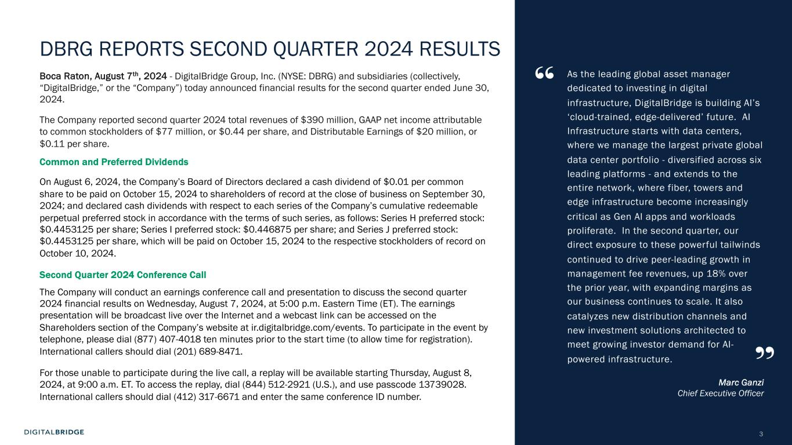
3 DBRG REPORTS SECOND QUARTER 2024 RESULTS Boca Raton, August 7th, 2024 - DigitalBridge Group, Inc. (NYSE: DBRG) and subsidiaries (collectively, “DigitalBridge,” or the “Company”) today announced financial results for the second quarter ended June 30, 2024. The Company reported second quarter 2024 total revenues of $390 million, GAAP net income attributable to common stockholders of $77 million, or $0.44 per share, and Distributable Earnings of $20 million, or $0.11 per share. Common and Preferred Dividends On August 6, 2024, the Company’s Board of Directors declared a cash dividend of $0.01 per common share to be paid on October 15, 2024 to shareholders of record at the close of business on September 30, 2024; and declared cash dividends with respect to each series of the Company’s cumulative redeemable perpetual preferred stock in accordance with the terms of such series, as follows: Series H preferred stock: $0.4453125 per share; Series I preferred stock: $0.446875 per share; and Series J preferred stock: $0.4453125 per share, which will be paid on October 15, 2024 to the respective stockholders of record on October 10, 2024. Second Quarter 2024 Conference Call The Company will conduct an earnings conference call and presentation to discuss the second quarter 2024 financial results on Wednesday, August 7, 2024, at 5:00 p.m. Eastern Time (ET). The earnings presentation will be broadcast live over the Internet and a webcast link can be accessed on the Shareholders section of the Company’s website at ir.digitalbridge.com/events. To participate in the event by telephone, please dial (877) 407-4018 ten minutes prior to the start time (to allow time for registration). International callers should dial (201) 689-8471. For those unable to participate during the live call, a replay will be available starting Thursday, August 8, 2024, at 9:00 a.m. ET. To access the replay, dial (844) 512-2921 (U.S.), and use passcode 13739028. International callers should dial (412) 317-6671 and enter the same conference ID number. As the leading global asset manager dedicated to investing in digital infrastructure, DigitalBridge is building AI’s ‘cloud-trained, edge-delivered’ future. AI Infrastructure starts with data centers, where we manage the largest private global data center portfolio - diversified across six leading platforms - and extends to the entire network, where fiber, towers and edge infrastructure become increasingly critical as Gen AI apps and workloads proliferate. In the second quarter, our direct exposure to these powerful tailwinds continued to drive peer-leading growth in management fee revenues, up 18% over the prior year, with expanding margins as our business continues to scale. It also catalyzes new distribution channels and new investment solutions architected to meet growing investor demand for AI- powered infrastructure. Marc Ganzi Chief Executive Officer “ ”

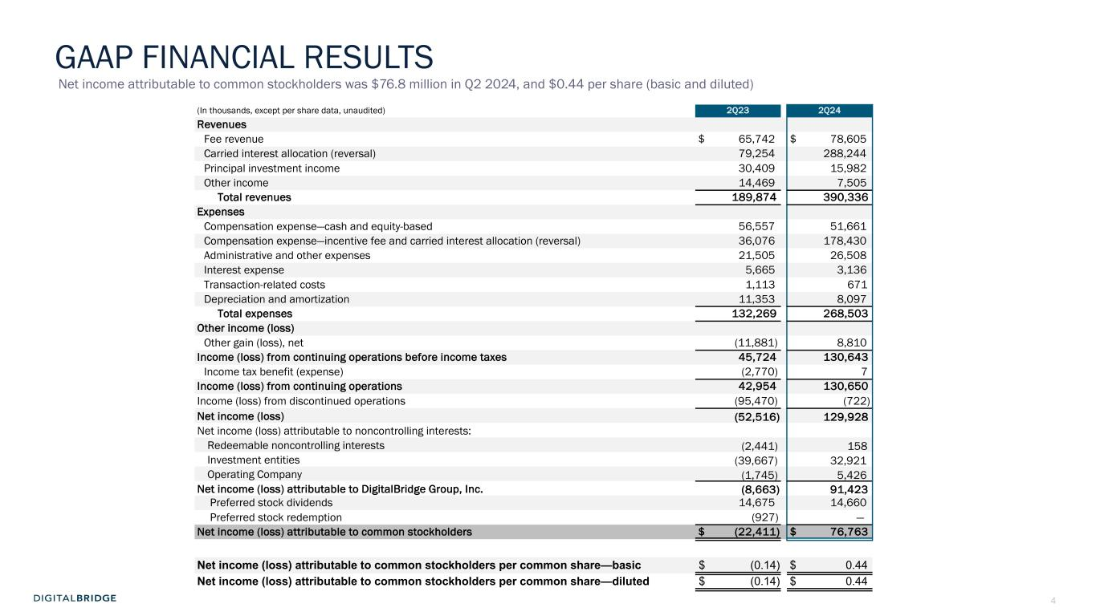
4 (In thousands, except per share data, unaudited) 2Q23 2Q24 Revenues Fee revenue $ 65,742 $ 78,605 Carried interest allocation (reversal) 79,254 288,244 Principal investment income 30,409 15,982 Other income 14,469 7,505 Total revenues 189,874 390,336 Expenses Compensation expense—cash and equity-based 56,557 51,661 Compensation expense—incentive fee and carried interest allocation (reversal) 36,076 178,430 Administrative and other expenses 21,505 26,508 Interest expense 5,665 3,136 Transaction-related costs 1,113 671 Depreciation and amortization 11,353 8,097 Total expenses 132,269 268,503 Other income (loss) Other gain (loss), net (11,881) 8,810 Income (loss) from continuing operations before income taxes 45,724 130,643 Income tax benefit (expense) (2,770) 7 Income (loss) from continuing operations 42,954 130,650 Income (loss) from discontinued operations (95,470) (722) Net income (loss) (52,516) 129,928 Net income (loss) attributable to noncontrolling interests: Redeemable noncontrolling interests (2,441) 158 Investment entities (39,667) 32,921 Operating Company (1,745) 5,426 Net income (loss) attributable to DigitalBridge Group, Inc. (8,663) 91,423 Preferred stock dividends 14,675 14,660 Preferred stock redemption (927) — Net income (loss) attributable to common stockholders $ (22,411) $ 76,763 Net income (loss) attributable to common stockholders per common share—basic $ (0.14) $ 0.44 Net income (loss) attributable to common stockholders per common share—diluted $ (0.14) $ 0.44 Net income attributable to common stockholders was $76.8 million in Q2 2024, and $0.44 per share (basic and diluted) GAAP FINANCIAL RESULTS


5 AGENDA BUSINESS UPDATESE CT IO N 1 FINANCIAL RESULTSSE CT IO N2 3 EXECUTING THE DIGITAL PLAYBOOKSE CT IO N

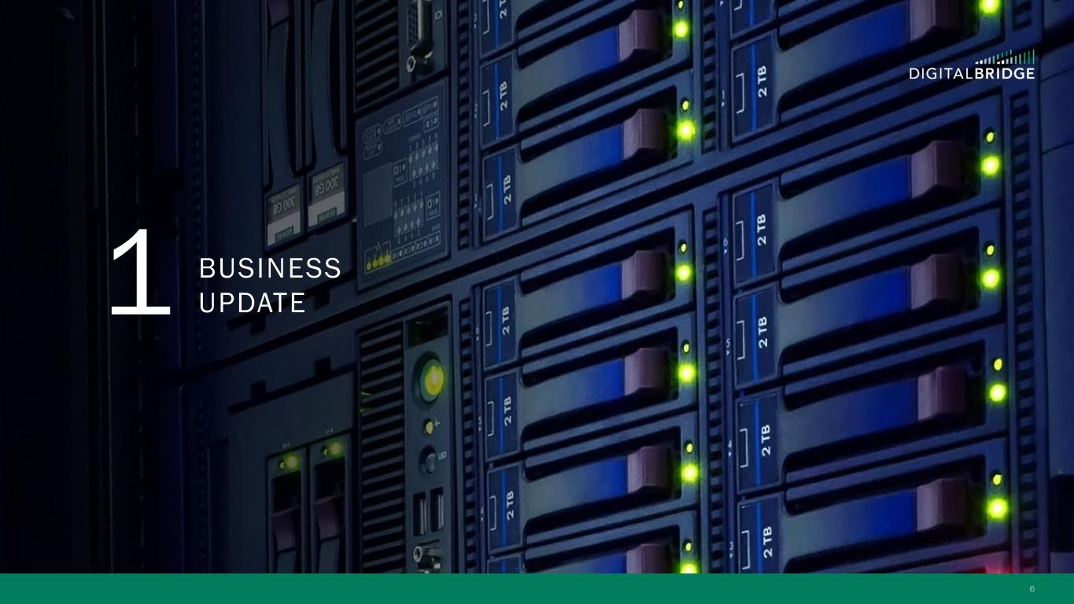
6 1 BUSINESS UPDATE

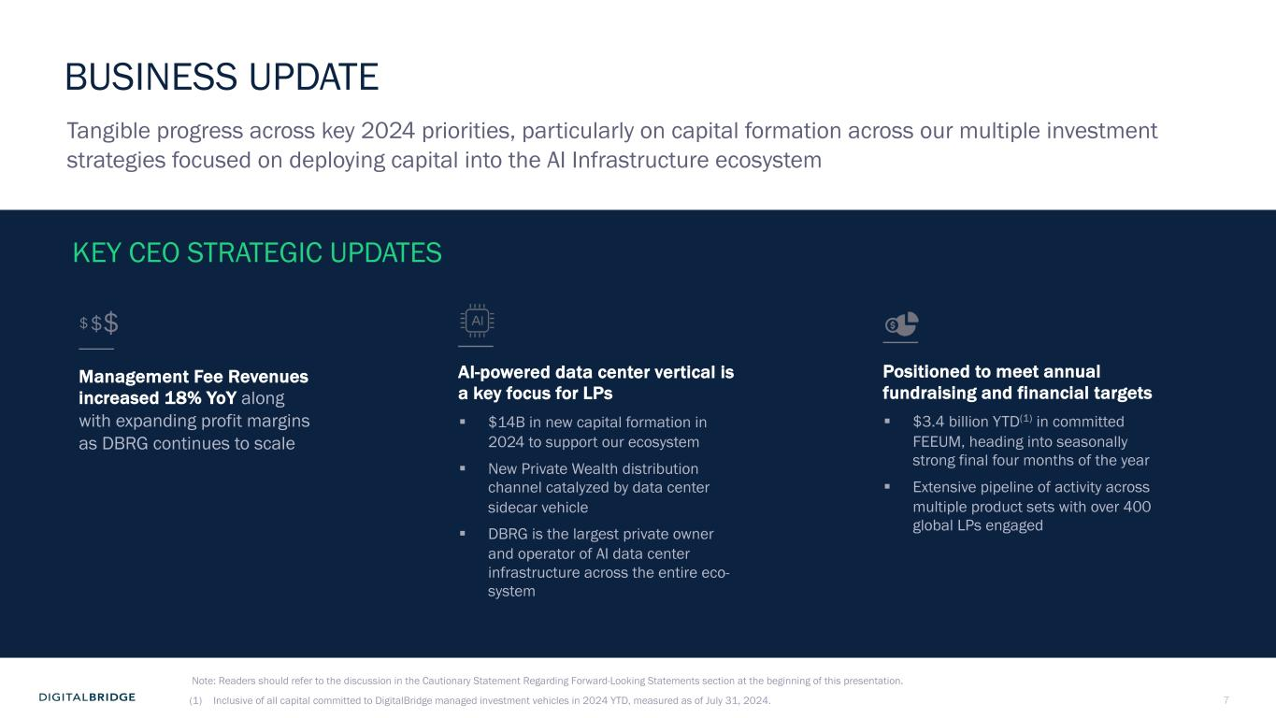
7 BUSINESS UPDATE (1) Inclusive of all capital committed to DigitalBridge managed investment vehicles in 2024 YTD, measured as of July 31, 2024. KEY CEO STRATEGIC UPDATES Management Fee Revenues increased 18% YoY along with expanding profit margins as DBRG continues to scale Positioned to meet annual fundraising and financial targets § $3.4 billion YTD(1) in committed FEEUM, heading into seasonally strong final four months of the year § Extensive pipeline of activity across multiple product sets with over 400 global LPs engaged AI-powered data center vertical is a key focus for LPs § $14B in new capital formation in 2024 to support our ecosystem § New Private Wealth distribution channel catalyzed by data center sidecar vehicle § DBRG is the largest private owner and operator of AI data center infrastructure across the entire eco- system $$$ Tangible progress across key 2024 priorities, particularly on capital formation across our multiple investment strategies focused on deploying capital into the AI Infrastructure ecosystem Note: Readers should refer to the discussion in the Cautionary Statement Regarding Forward-Looking Statements section at the beginning of this presentation.

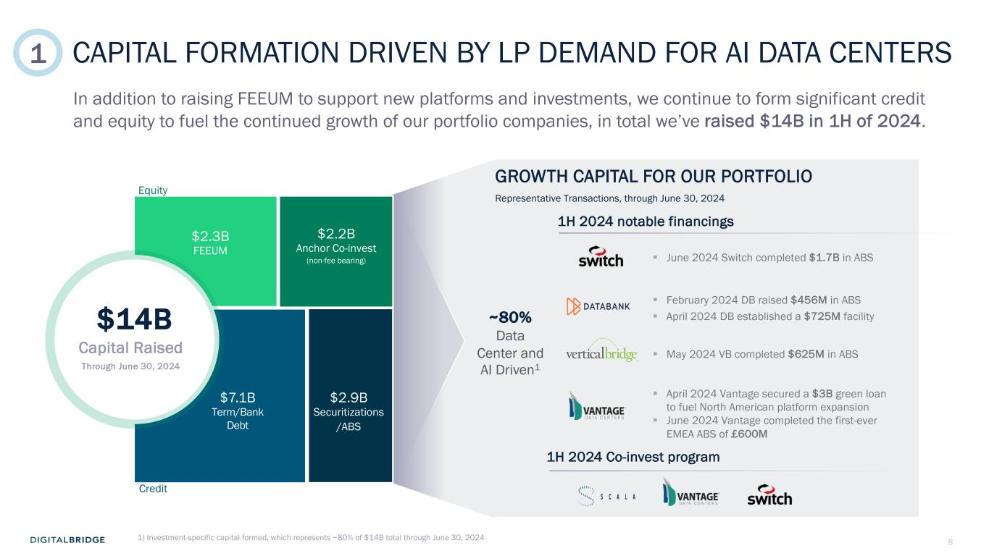
8 CAPITAL FORMATION DRIVEN BY LP DEMAND FOR AI DATA CENTERS GROWTH CAPITAL FOR OUR PORTFOLIO 1H 2024 Co-invest program 1H 2024 notable financings § February 2024 DB raised $456M in ABS § April 2024 DB established a $725M facility § June 2024 Switch completed $1.7B in ABS § May 2024 VB completed $625M in ABS § April 2024 Vantage secured a $3B green loan to fuel North American platform expansion § June 2024 Vantage completed the first-ever EMEA ABS of £600M $14B Capital Raised Through June 30, 2024 $2.2B Anchor Co-invest (non-fee bearing) $2.3B FEEUM $7.1B Term/Bank Debt Equity Credit $2.9B Securitizations /ABS ~80% Data Center and AI Driven1 Representative Transactions, through June 30, 2024 In addition to raising FEEUM to support new platforms and investments, we continue to form significant credit and equity to fuel the continued growth of our portfolio companies, in total we’ve raised $14B in 1H of 2024. 1) Investment-specific capital formed, which represents ~80% of $14B total through June 30, 2024 1

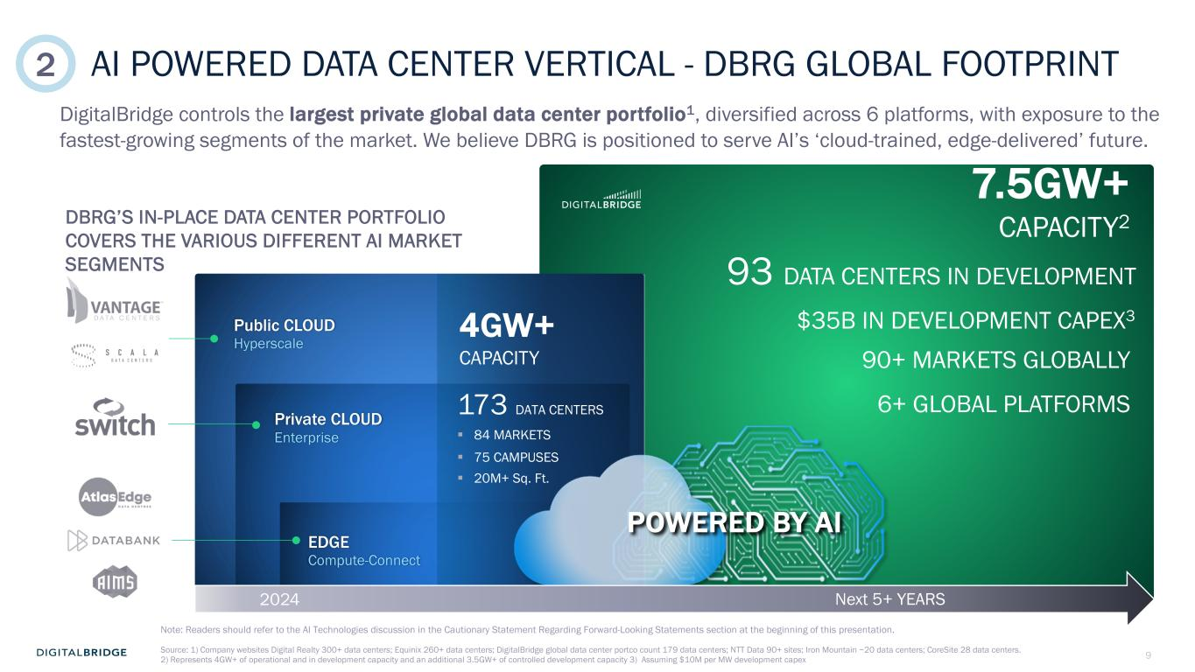
9 AI POWERED DATA CENTER VERTICAL - DBRG GLOBAL FOOTPRINT 7.5GW+ CAPACITY2 90+ MARKETS GLOBALLY Public CLOUD Hyperscale Private CLOUD Enterprise EDGE Compute-Connect 173 DATA CENTERS § 84 MARKETS § 75 CAMPUSES § 20M+ Sq. Ft. 4GW+ CAPACITY POWERED BY AI DigitalBridge controls the largest private global data center portfolio1, diversified across 6 platforms, with exposure to the fastest-growing segments of the market. We believe DBRG is positioned to serve AI’s ‘cloud-trained, edge-delivered’ future. 93 DATA CENTERS IN DEVELOPMENT $35B IN DEVELOPMENT CAPEX3 6+ GLOBAL PLATFORMS Source: 1) Company websites Digital Realty 300+ data centers; Equinix 260+ data centers; DigitalBridge global data center portco count 179 data centers; NTT Data 90+ sites; Iron Mountain ~20 data centers; CoreSite 28 data centers. 2) Represents 4GW+ of operational and in development capacity and an additional 3.5GW+ of controlled development capacity 3) Assuming $10M per MW development capex DBRG’S IN-PLACE DATA CENTER PORTFOLIO COVERS THE VARIOUS DIFFERENT AI MARKET SEGMENTS 2 2024 Next 5+ YEARS Note: Readers should refer to the AI Technologies discussion in the Cautionary Statement Regarding Forward-Looking Statements section at the beginning of this presentation.

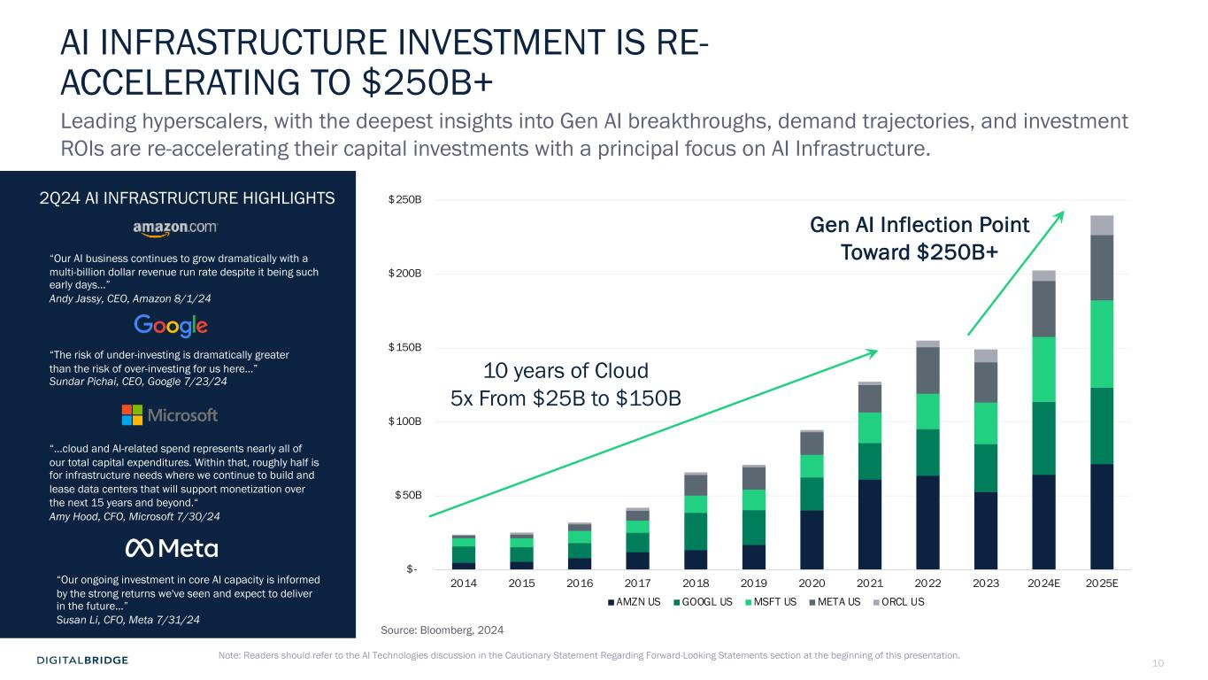
10 $- $50B $100B $150B $200B $250B 2014 2015 2016 2017 2018 2019 2020 2021 2022 2023 2024E 2025E AMZN US GOOGL US MSFT US META US ORCL US AI INFRASTRUCTURE INVESTMENT IS RE- ACCELERATING TO $250B+ 10 years of Cloud 5x From $25B to $150B Gen AI Inflection Point Toward $250B+ Leading hyperscalers, with the deepest insights into Gen AI breakthroughs, demand trajectories, and investment ROIs are re-accelerating their capital investments with a principal focus on AI Infrastructure. “The risk of under-investing is dramatically greater than the risk of over-investing for us here…” Sundar Pichai, CEO, Google 7/23/24 “Our AI business continues to grow dramatically with a multi-billion dollar revenue run rate despite it being such early days…” Andy Jassy, CEO, Amazon 8/1/24 “Our ongoing investment in core AI capacity is informed by the strong returns we've seen and expect to deliver in the future…” Susan Li, CFO, Meta 7/31/24 “…cloud and AI-related spend represents nearly all of our total capital expenditures. Within that, roughly half is for infrastructure needs where we continue to build and lease data centers that will support monetization over the next 15 years and beyond.“ Amy Hood, CFO, Microsoft 7/30/24 2Q24 AI INFRASTRUCTURE HIGHLIGHTS Source: Bloomberg, 2024 Note: Readers should refer to the AI Technologies discussion in the Cautionary Statement Regarding Forward-Looking Statements section at the beginning of this presentation.

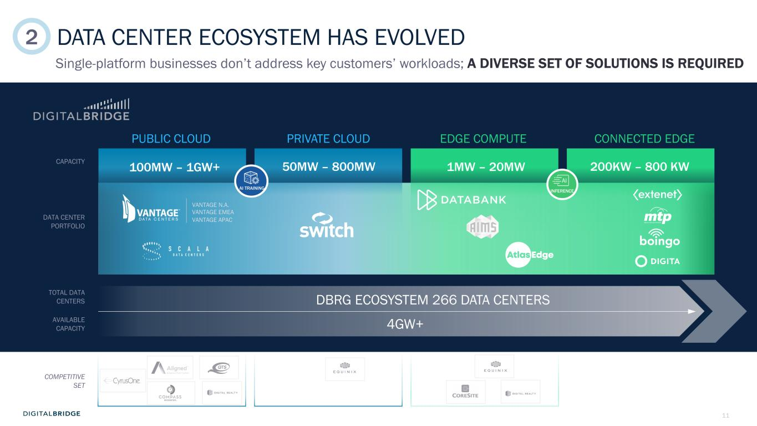
11 DATA CENTER ECOSYSTEM HAS EVOLVED Single-platform businesses don’t address key customers’ workloads; A DIVERSE SET OF SOLUTIONS IS REQUIRED PUBLIC CLOUD PRIVATE CLOUD EDGE COMPUTE CONNECTED EDGE 50MW – 800MW TOTAL DATA CENTERS AVAILABLE CAPACITY COMPETITIVE SET 100MW – 1GW+CAPACITY DATA CENTER PORTFOLIO VANTAGE N.A. VANTAGE EMEA VANTAGE APAC 1MW – 20MW 200KW – 800 KW DBRG ECOSYSTEM 266 DATA CENTERS 4GW+ INFERENCEAI TRAINING 2

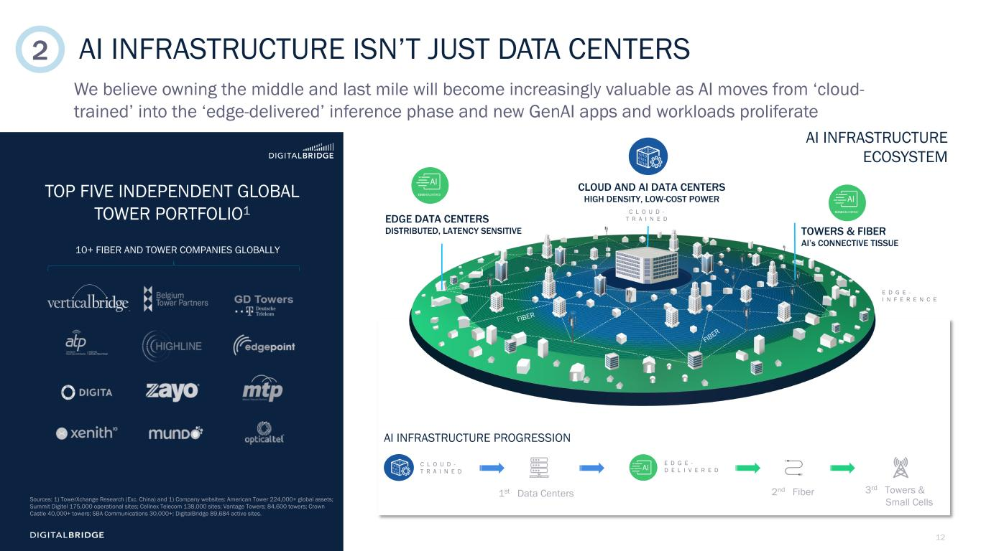
12 CLOUD AND AI DATA CENTERS HIGH DENSITY, LOW-COST POWER EDGE DATA CENTERS DISTRIBUTED, LATENCY SENSITIVE FIBER FIBER I N F E R E N C E E D G E - D E L I V E R E D C L O U D - T R A I N E D AI INFRASTRUCTURE ISN’T JUST DATA CENTERS We believe owning the middle and last mile will become increasingly valuable as AI moves from ‘cloud- trained’ into the ‘edge-delivered’ inference phase and new GenAI apps and workloads proliferate AI INFRASTRUCTURE PROGRESSION E D G E - D E L I V E R E D C L O U D - T R A I N E D 8 10+ FIBER AND TOWER COMPANIES GLOBALLY TOP FIVE INDEPENDENT GLOBAL TOWER PORTFOLIO1 Sources: 1) TowerXchange Research (Exc. China) and 1) Company websites: American Tower 224,000+ global assets; Summit Digitel 175,000 operational sites; Cellnex Telecom 138,000 sites; Vantage Towers; 84,600 towers; Crown Castle 40,000+ towers; SBA Communications 30,000+; DigitalBridge 89,684 active sites. AI INFRASTRUCTURE ECOSYSTEM TOWERS & FIBER AI’s CONNECTIVE TISSUE EDGE-DELIVERED EDGE-DELIVERED 1st Data Centers 2nd Fiber 3rd Towers & Small Cells E D G E - I N F E R E N C E C L O U D - T R A I N E D 2

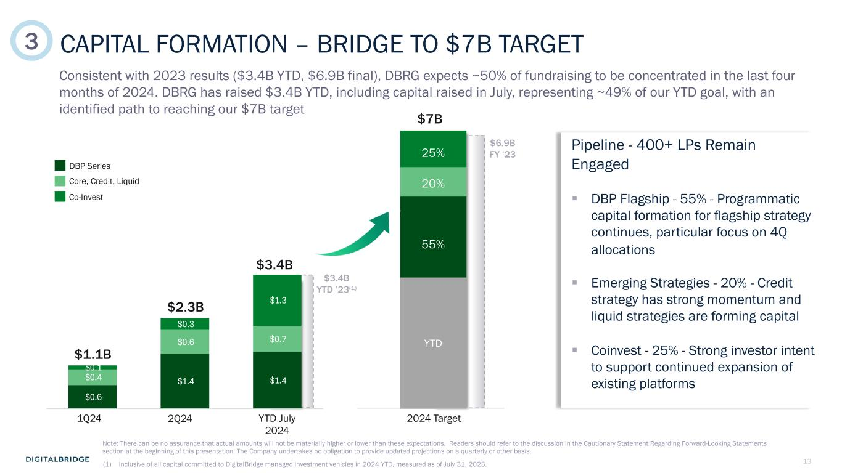
13 $0.6 $1.4 $1.4 $0.4 $0.6 $0.7 $0.1 $0.3 $1.3 1Q24 2Q24 Post 2Q24 CAPITAL FORMATION – BRIDGE TO $7B TARGET Consistent with 2023 results ($3.4B YTD, $6.9B final), DBRG expects ~50% of fundraising to be concentrated in the last four months of 2024. DBRG has raised $3.4B YTD, including capital raised in July, representing ~49% of our YTD goal, with an identified path to reaching our $7B target DBP Series Co-Invest Core, Credit, Liquid $1.1B $2.3B $3.4B 1Q24 2Q24 YTD July 2024 2024 Target $7B 55% 20% 25% YTD Pipeline - 400+ LPs Remain Engaged § DBP Flagship - 55% - Programmatic capital formation for flagship strategy continues, particular focus on 4Q allocations § Emerging Strategies - 20% - Credit strategy has strong momentum and liquid strategies are forming capital § Coinvest - 25% - Strong investor intent to support continued expansion of existing platforms $3.4B YTD ’23(1) $6.9B FY ‘23 (1) Inclusive of all capital committed to DigitalBridge managed investment vehicles in 2024 YTD, measured as of July 31, 2023. 3 Note: There can be no assurance that actual amounts will not be materially higher or lower than these expectations. Readers should refer to the discussion in the Cautionary Statement Regarding Forward-Looking Statements section at the beginning of this presentation. The Company undertakes no obligation to provide updated projections on a quarterly or other basis.

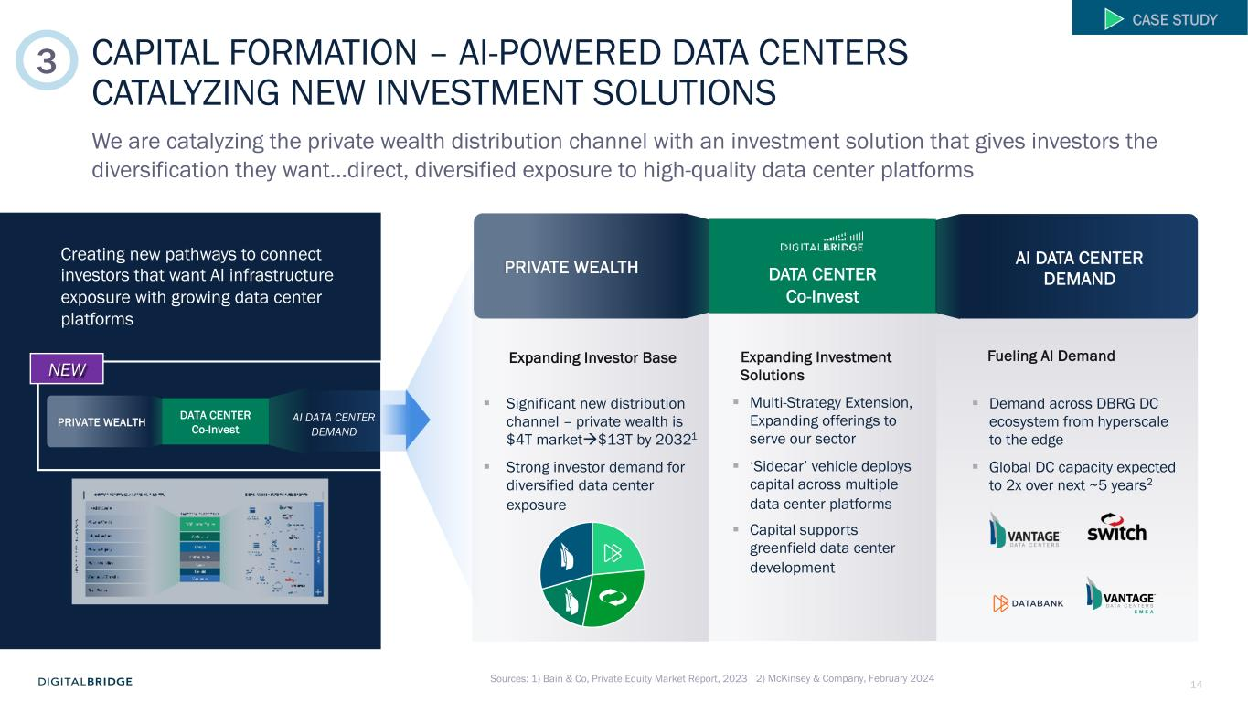
14 Expanding Investment Solutions Creating new pathways to connect investors that want AI infrastructure exposure with growing data center platforms PRIVATE WEALTH DATA CENTER Co-Invest AI DATA CENTER DEMAND NEW Sources: 1) Bain & Co, Private Equity Market Report, 2023 CAPITAL FORMATION – AI-POWERED DATA CENTERS CATALYZING NEW INVESTMENT SOLUTIONS We are catalyzing the private wealth distribution channel with an investment solution that gives investors the diversification they want…direct, diversified exposure to high-quality data center platforms CASE STUDY Expanding Investor Base § Significant new distribution channel – private wealth is $4T marketà$13T by 20321 § Strong investor demand for diversified data center exposure § Multi-Strategy Extension, Expanding offerings to serve our sector § ‘Sidecar’ vehicle deploys capital across multiple data center platforms § Capital supports greenfield data center development § Demand across DBRG DC ecosystem from hyperscale to the edge § Global DC capacity expected to 2x over next ~5 years2 Fueling AI Demand PRIVATE WEALTH DATA CENTER Co-Invest AI DATA CENTER DEMAND 3 2) McKinsey & Company, February 2024

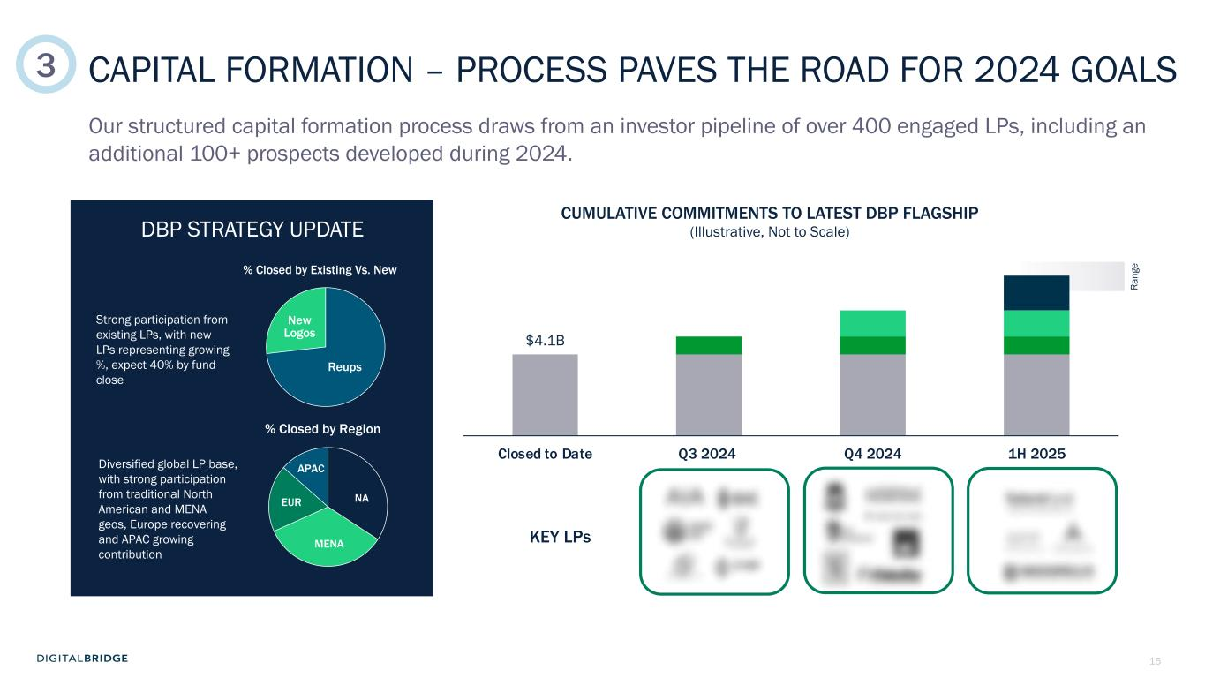
15 $4.1B Closed to Date Q3 2024 Q4 2024 1H 2025 CAPITAL FORMATION – PROCESS PAVES THE ROAD FOR 2024 GOALS Our structured capital formation process draws from an investor pipeline of over 400 engaged LPs, including an additional 100+ prospects developed during 2024. DBP STRATEGY UPDATE KEY LPs % Closed by Existing Vs. New % Closed by Region Ra ng e CUMULATIVE COMMITMENTS TO LATEST DBP FLAGSHIP (Illustrative, Not to Scale) New Logos Reups NAEUR APAC MENA Strong participation from existing LPs, with new LPs representing growing %, expect 40% by fund close Diversified global LP base, with strong participation from traditional North American and MENA geos, Europe recovering and APAC growing contribution 3

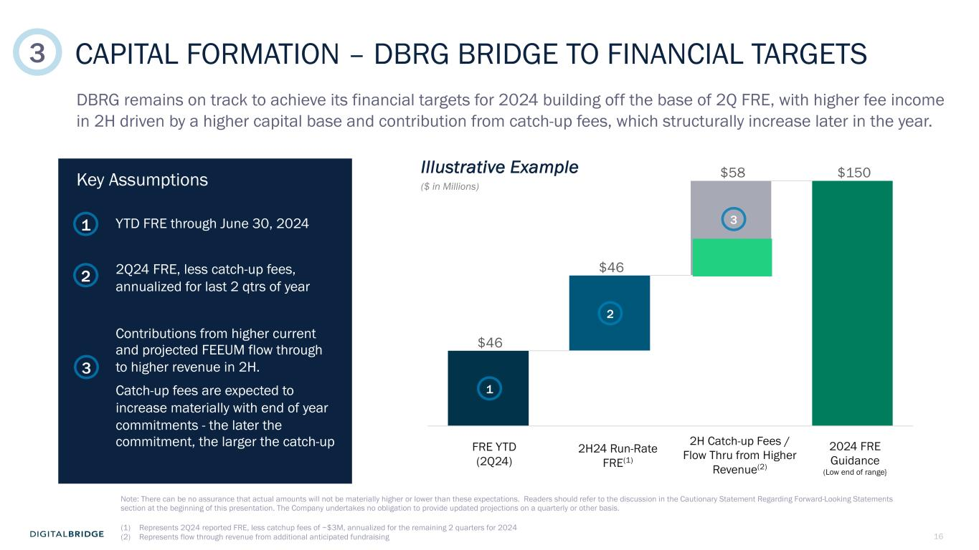
16 $46 $46 $58 $150 CAPITAL FORMATION – DBRG BRIDGE TO FINANCIAL TARGETS DBRG remains on track to achieve its financial targets for 2024 building off the base of 2Q FRE, with higher fee income in 2H driven by a higher capital base and contribution from catch-up fees, which structurally increase later in the year. YTD FRE through June 30, 2024 2Q24 FRE, less catch-up fees, annualized for last 2 qtrs of year Contributions from higher current and projected FEEUM flow through to higher revenue in 2H. Catch-up fees are expected to increase materially with end of year commitments - the later the commitment, the larger the catch-up Illustrative Example FRE YTD (2Q24) 2H24 Run-Rate FRE(1) (1) Represents 2Q24 reported FRE, less catchup fees of ~$3M, annualized for the remaining 2 quarters for 2024 (2) Represents flow through revenue from additional anticipated fundraising 2H Catch-up Fees / Flow Thru from Higher Revenue(2) ($ in Millions) 2024 FRE Guidance (Low end of range} Key Assumptions 2 2 1 1 3 3 3 Note: There can be no assurance that actual amounts will not be materially higher or lower than these expectations. Readers should refer to the discussion in the Cautionary Statement Regarding Forward-Looking Statements section at the beginning of this presentation. The Company undertakes no obligation to provide updated projections on a quarterly or other basis.


17 2 FINANCIAL UPDATE

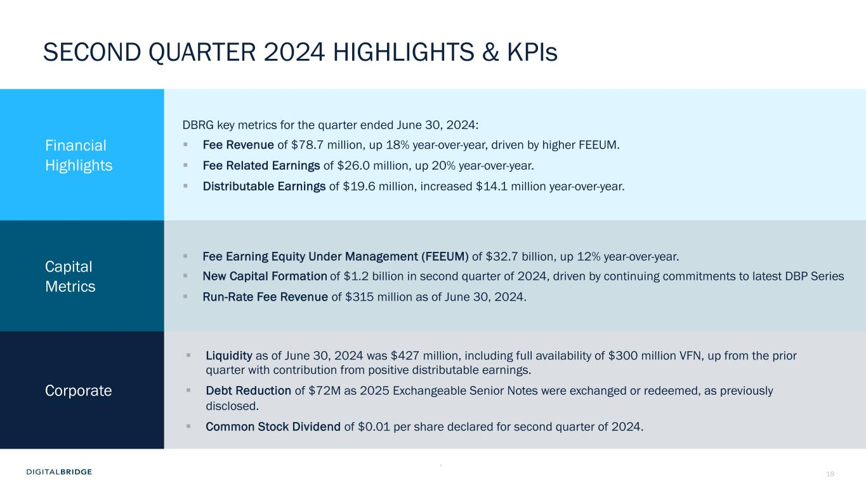
18 SECOND QUARTER 2024 HIGHLIGHTS & KPIs Financial Highlights DBRG key metrics for the quarter ended June 30, 2024: § Fee Revenue of $78.7 million, up 18% year-over-year, driven by higher FEEUM. § Fee Related Earnings of $26.0 million, up 20% year-over-year. § Distributable Earnings of $19.6 million, increased $14.1 million year-over-year. Capital Metrics § Fee Earning Equity Under Management (FEEUM) of $32.7 billion, up 12% year-over-year. § New Capital Formation of $1.2 billion in second quarter of 2024, driven by continuing commitments to latest DBP Series § Run-Rate Fee Revenue of $315 million as of June 30, 2024. Corporate § Liquidity as of June 30, 2024 was $427 million, including full availability of $300 million VFN, up from the prior quarter with contribution from positive distributable earnings. § Debt Reduction of $72M as 2025 Exchangeable Senior Notes were exchanged or redeemed, as previously disclosed. § Common Stock Dividend of $0.01 per share declared for second quarter of 2024. (1) Inclusive of all capital committed to DigitalBridge managed investment vehicles as of March 31, 2024 .

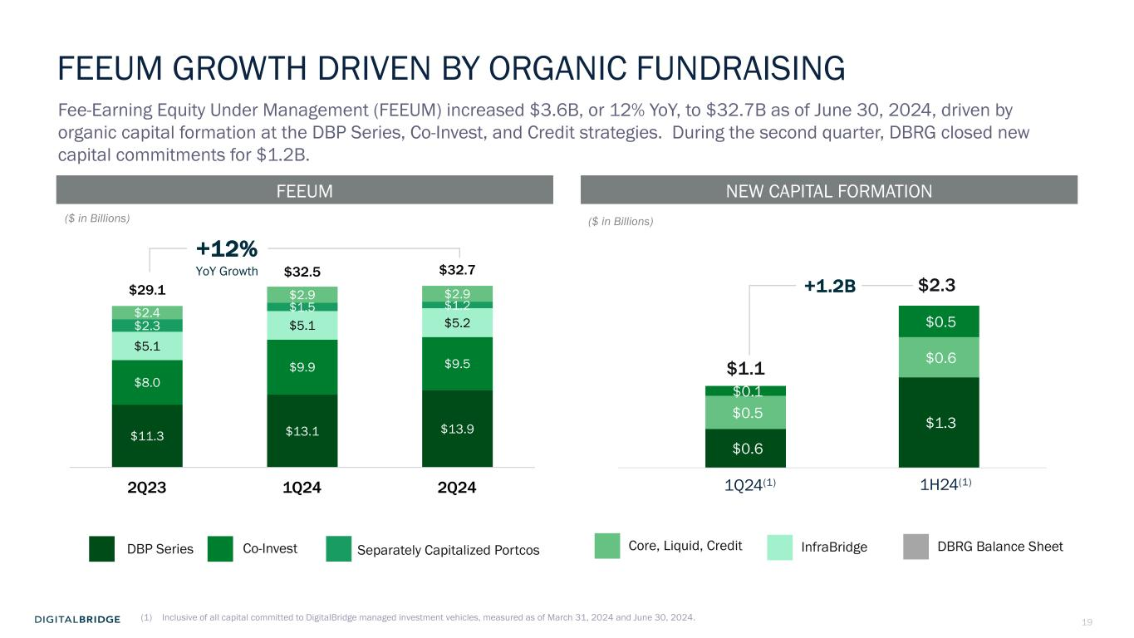
19 $0.6 $1.3 $0.5 $0.6 $0.1 $0.5 $11.3 $13.1 $13.9 $8.0 $9.9 $9.5 $5.1 $5.1 $5.2 $2.3 $1.5 $1.2 $2.4 $2.9 $2.9 $29.1 $32.5 $32.7 2Q23 1Q24 2Q24 FEEUM GROWTH DRIVEN BY ORGANIC FUNDRAISING Fee-Earning Equity Under Management (FEEUM) increased $3.6B, or 12% YoY, to $32.7B as of June 30, 2024, driven by organic capital formation at the DBP Series, Co-Invest, and Credit strategies. During the second quarter, DBRG closed new capital commitments for $1.2B. DBP Series Co-Invest Separately Capitalized Portcos Core, Liquid, Credit NEW CAPITAL FORMATIONFEEUM InfraBridge +12% YoY Growth DBRG Balance Sheet ($ in Billions) ($ in Billions) (1) Inclusive of all capital committed to DigitalBridge managed investment vehicles, measured as of March 31, 2024 and June 30, 2024. 1H24(1) $2.3 1Q24(1) $1.1 +1.2B

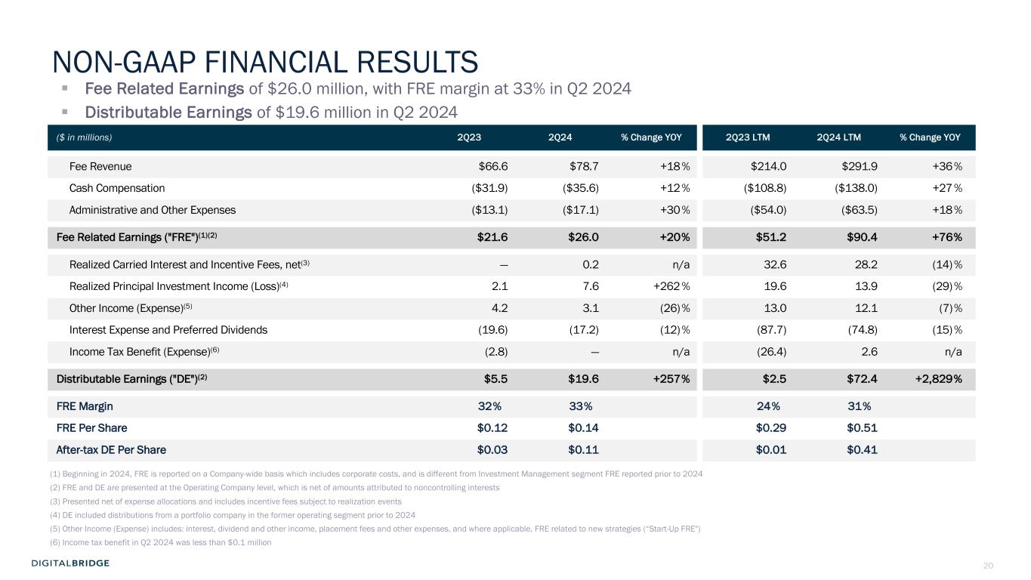
20 § Fee Related Earnings of $26.0 million, with FRE margin at 33% in Q2 2024 § Distributable Earnings of $19.6 million in Q2 2024 ($ in millions) 2Q23 2Q24 % Change YOY 2Q23 LTM 2Q24 LTM % Change YOY Fee Revenue $66.6 $78.7 +18% $214.0 $291.9 +36% Cash Compensation ($31.9) ($35.6) +12% ($108.8) ($138.0) +27% Administrative and Other Expenses ($13.1) ($17.1) +30% ($54.0) ($63.5) +18% Fee Related Earnings ("FRE")(1)(2) $21.6 $26.0 +20% $51.2 $90.4 +76% Realized Carried Interest and Incentive Fees, net(3) — 0.2 n/a 32.6 28.2 (14)% Realized Principal Investment Income (Loss)(4) 2.1 7.6 +262 % 19.6 13.9 (29)% Other Income (Expense)(5) 4.2 3.1 (26)% 13.0 12.1 (7)% Interest Expense and Preferred Dividends (19.6) (17.2) (12)% (87.7) (74.8) (15)% Income Tax Benefit (Expense)(6) (2.8) — n/a (26.4) 2.6 n/a Distributable Earnings ("DE")(2) $5.5 $19.6 +257% $2.5 $72.4 +2,829% FRE Margin 32% 33% 24% 31% FRE Per Share $0.12 $0.14 $0.29 $0.51 After-tax DE Per Share $0.03 $0.11 $0.01 $0.41 (1) Beginning in 2024, FRE is reported on a Company-wide basis which includes corporate costs, and is different from Investment Management segment FRE reported prior to 2024 (2) FRE and DE are presented at the Operating Company level, which is net of amounts attributed to noncontrolling interests (3) Presented net of expense allocations and includes incentive fees subject to realization events (4) DE included distributions from a portfolio company in the former operating segment prior to 2024 (5) Other Income (Expense) includes: interest, dividend and other income, placement fees and other expenses, and where applicable, FRE related to new strategies (“Start-Up FRE") (6) Income tax benefit in Q2 2024 was less than $0.1 million NON-GAAP FINANCIAL RESULTS

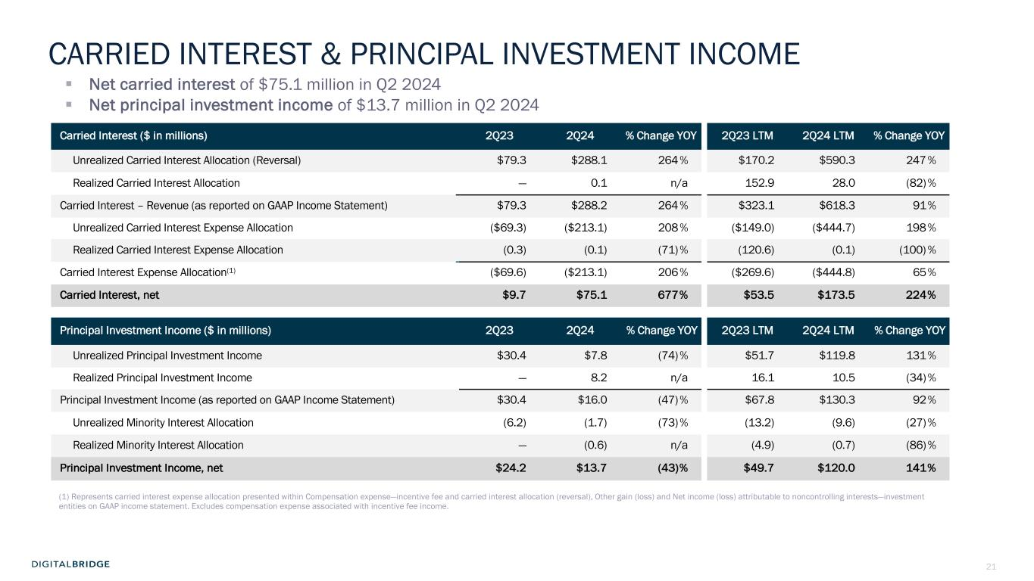
21 Carried Interest ($ in millions) 2Q23 2Q24 % Change YOY 2Q23 LTM 2Q24 LTM % Change YOY Unrealized Carried Interest Allocation (Reversal) $79.3 $288.1 264% $170.2 $590.3 247% Realized Carried Interest Allocation — 0.1 n/a 152.9 28.0 (82)% Carried Interest – Revenue (as reported on GAAP Income Statement) $79.3 $288.2 264% $323.1 $618.3 91% Unrealized Carried Interest Expense Allocation ($69.3) ($213.1) 208% ($149.0) ($444.7) 198% Realized Carried Interest Expense Allocation (0.3) (0.1) (71)% (120.6) (0.1) (100) % Carried Interest Expense Allocation(1) ($69.6) ($213.1) 206% ($269.6) ($444.8) 65% Carried Interest, net $9.7 $75.1 677% $53.5 $173.5 224% Principal Investment Income ($ in millions) 2Q23 2Q24 % Change YOY 2Q23 LTM 2Q24 LTM % Change YOY Unrealized Principal Investment Income $30.4 $7.8 (74)% $51.7 $119.8 131% Realized Principal Investment Income — 8.2 n/a 16.1 10.5 (34)% Principal Investment Income (as reported on GAAP Income Statement) $30.4 $16.0 (47)% $67.8 $130.3 92% Unrealized Minority Interest Allocation (6.2) (1.7) (73)% (13.2) (9.6) (27)% Realized Minority Interest Allocation — (0.6) n/a (4.9) (0.7) (86)% Principal Investment Income, net $24.2 $13.7 (43)% $49.7 $120.0 141% (1) Represents carried interest expense allocation presented within Compensation expense—incentive fee and carried interest allocation (reversal), Other gain (loss) and Net income (loss) attributable to noncontrolling interests—investment entities on GAAP income statement. Excludes compensation expense associated with incentive fee income. § Net carried interest of $75.1 million in Q2 2024 § Net principal investment income of $13.7 million in Q2 2024 CARRIED INTEREST & PRINCIPAL INVESTMENT INCOME

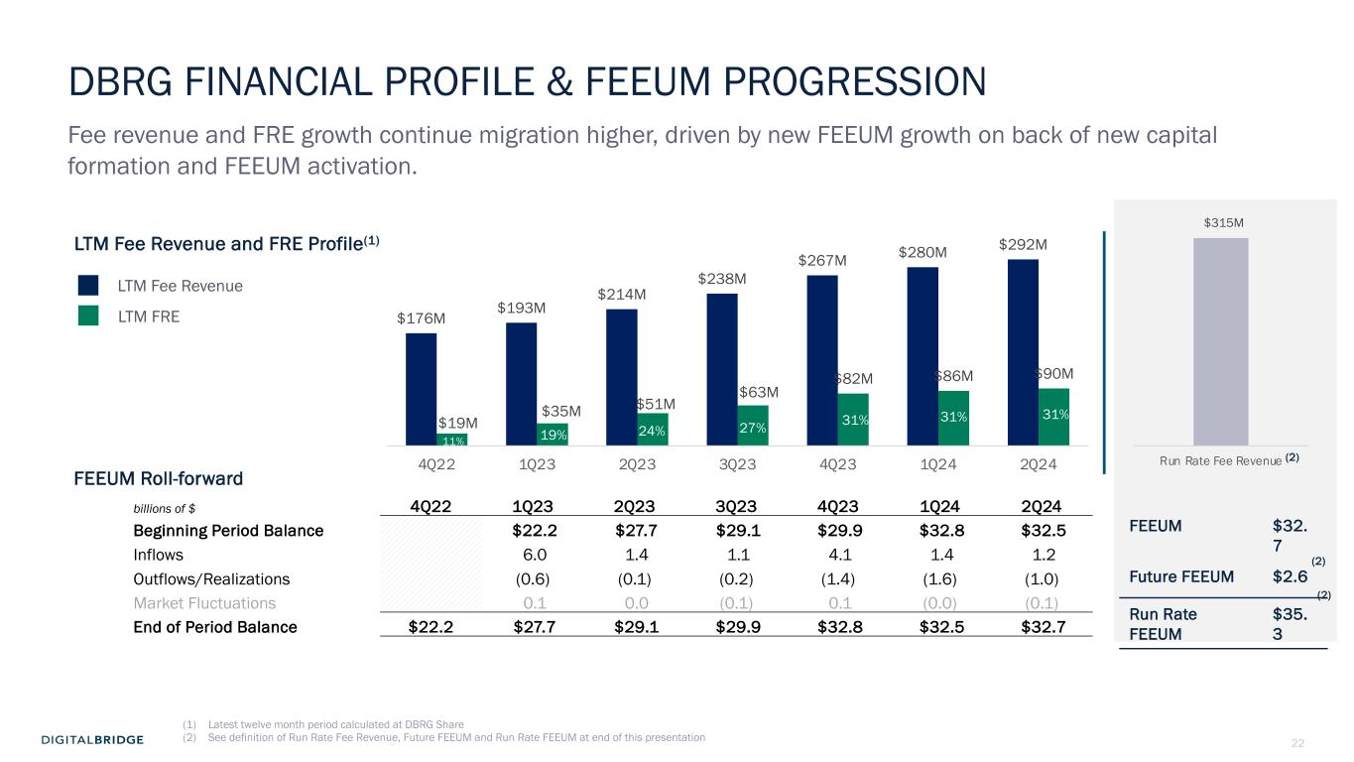
22 $315M Run Rate Fee Revenue DBRG FINANCIAL PROFILE & FEEUM PROGRESSION Fee revenue and FRE growth continue migration higher, driven by new FEEUM growth on back of new capital formation and FEEUM activation. LTM Fee Revenue LTM FRE billions of $ 4Q22 1Q23 2Q23 3Q23 4Q23 1Q24 2Q24 Beginning Period Balance $22.2 $27.7 $29.1 $29.9 $32.8 $32.5 Inflows 6.0 1.4 1.1 4.1 1.4 1.2 Outflows/Realizations (0.6) (0.1) (0.2) (1.4) (1.6) (1.0) Market Fluctuations 0.1 0.0 (0.1) 0.1 (0.0) (0.1) End of Period Balance $22.2 $27.7 $29.1 $29.9 $32.8 $32.5 $32.7 LTM Fee Revenue and FRE Profile(1) (2) $176M $193M $214M $238M $267M $280M $292M $19M $35M $51M $63M $82M $86M $90M 4Q22 1Q23 2Q23 3Q23 4Q23 1Q24 2Q24 FEEUM Roll-forward FEEUM $32. 7 Future FEEUM $2.6 Run Rate FEEUM $35. 3 31% 19% 24% 27% 31% 31% 11% (2) (2) (1) Latest twelve month period calculated at DBRG Share (2) See definition of Run Rate Fee Revenue, Future FEEUM and Run Rate FEEUM at end of this presentation

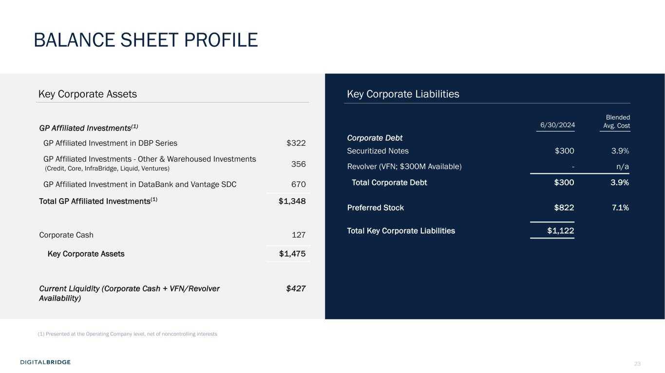
23 (1) Presented at the Operating Company level, net of noncontrolling interests GP Affiliated Investments(1) GP Affiliated Investment in DBP Series $322 GP Affiliated Investments - Other & Warehoused Investments (Credit, Core, InfraBridge, Liquid, Ventures) 356 GP Affiliated Investment in DataBank and Vantage SDC 670 Total GP Affiliated Investments(1) $1,348 Corporate Cash 127 Key Corporate Assets $1,475 Current Liquidity (Corporate Cash + VFN/Revolver Availability) $427 Key Corporate Assets Key Corporate Liabilities Corporate Debt Securitized Notes $300 3.9% Revolver (VFN; $300M Available) - n/a Total Corporate Debt $300 3.9% Preferred Stock $822 7.1% Total Key Corporate Liabilities $1,122 Blended Avg. Cost6/30/2024 BALANCE SHEET PROFILE

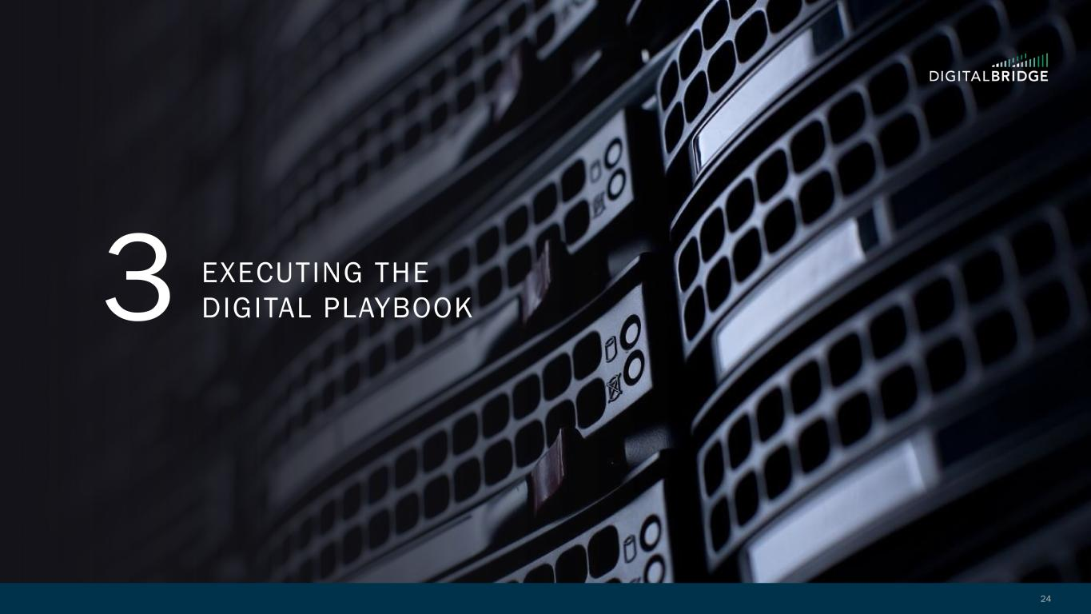
24 3 EXECUTING THE DIGITAL PLAYBOOK

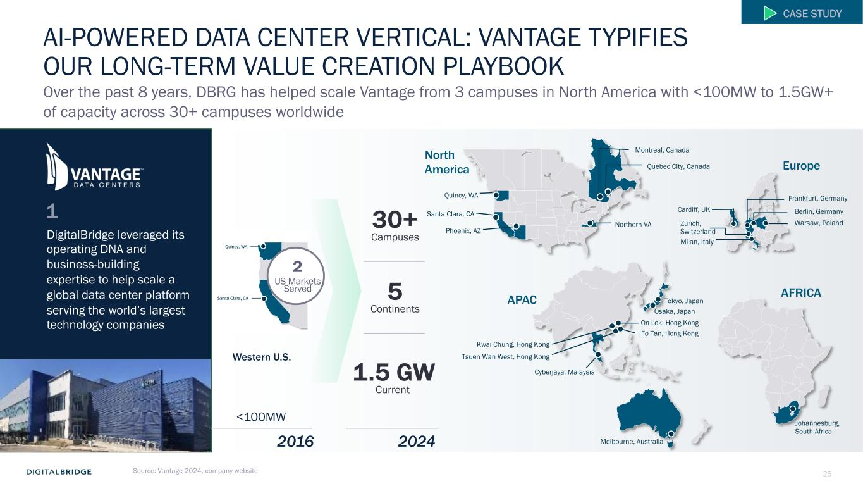
25Source: Vantage 2024, company website Over the past 8 years, DBRG has helped scale Vantage from 3 campuses in North America with <100MW to 1.5GW+ of capacity across 30+ campuses worldwide APAC Tokyo, Japan Osaka, Japan On Lok, Hong Kong Fo Tan, Hong Kong Melbourne, Australia Kwai Chung, Hong Kong Cyberjaya, Malaysia Tsuen Wan West, Hong Kong Europe Cardiff, UK Berlin, Germany Warsaw, Poland Frankfurt, Germany Zurich, Switzerland Milan, Italy North America Quincy, WA Santa Clara, CA Phoenix, AZ Northern VA Montreal, Canada Quebec City, Canada 2 US Markets Served 30+ Campuses 5 Continents 1.5 GW Current Western U.S. 2016 2024 <100MW 1 DigitalBridge leveraged its operating DNA and business-building expertise to help scale a global data center platform serving the world’s largest technology companies AI-POWERED DATA CENTER VERTICAL: VANTAGE TYPIFIES OUR LONG-TERM VALUE CREATION PLAYBOOK CASE STUDY AFRICA Johannesburg, South Africa

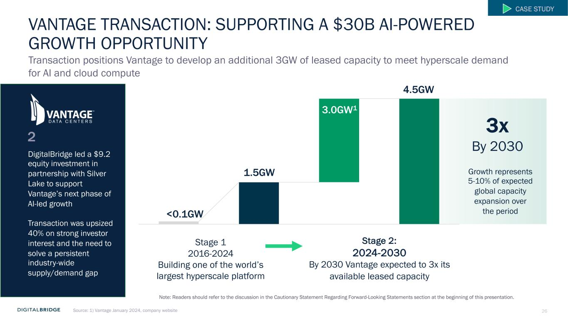
26 VANTAGE TRANSACTION: SUPPORTING A $30B AI-POWERED GROWTH OPPORTUNITY Transaction positions Vantage to develop an additional 3GW of leased capacity to meet hyperscale demand for AI and cloud compute Stage 2: 2024-2030 By 2030 Vantage expected to 3x its available leased capacity DigitalBridge led a $9.2 equity investment in partnership with Silver Lake to support Vantage’s next phase of AI-led growth Transaction was upsized 40% on strong investor interest and the need to solve a persistent industry-wide supply/demand gap 2 Growth represents 5-10% of expected global capacity expansion over the period 1.5GW 3.0GW1 <0.1GW Stage 1 2016-2024 Building one of the world’s largest hyperscale platform 4.5GW 3x By 2030 CASE STUDY Source: 1) Vantage January 2024, company website Note: Readers should refer to the discussion in the Cautionary Statement Regarding Forward-Looking Statements section at the beginning of this presentation.

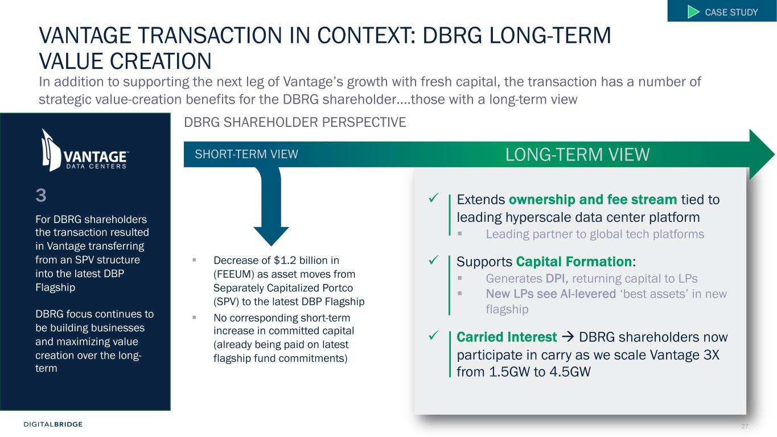
27 VANTAGE TRANSACTION IN CONTEXT: DBRG LONG-TERM VALUE CREATION § Decrease of $1.2 billion in (FEEUM) as asset moves from Separately Capitalized Portco (SPV) to the latest DBP Flagship § No corresponding short-term increase in committed capital (already being paid on latest flagship fund commitments) LONG-TERM VIEWSHORT-TERM VIEW For DBRG shareholders the transaction resulted in Vantage transferring from an SPV structure into the latest DBP Flagship DBRG focus continues to be building businesses and maximizing value creation over the long- term 3 In addition to supporting the next leg of Vantage’s growth with fresh capital, the transaction has a number of strategic value-creation benefits for the DBRG shareholder….those with a long-term view DBRG SHAREHOLDER PERSPECTIVE CASE STUDY ü Extends ownership and fee stream tied to leading hyperscale data center platform § Leading partner to global tech platforms ü Supports Capital Formation: § Generates DPI, returning capital to LPs § New LPs see AI-levered ‘best assets’ in new flagship ü Carried Interest à DBRG shareholders now participate in carry as we scale Vantage 3X from 1.5GW to 4.5GW

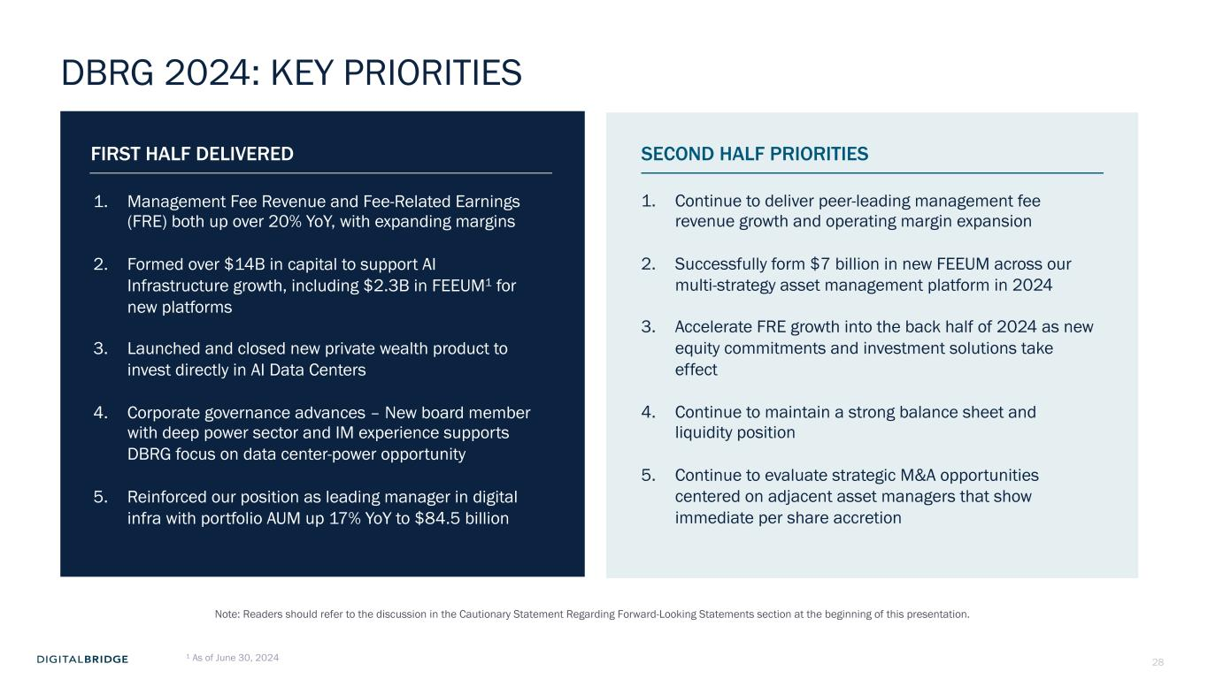
28 FIRST HALF DELIVERED SECOND HALF PRIORITIES DBRG 2024: KEY PRIORITIES 1. Management Fee Revenue and Fee-Related Earnings (FRE) both up over 20% YoY, with expanding margins 2. Formed over $14B in capital to support AI Infrastructure growth, including $2.3B in FEEUM1 for new platforms 3. Launched and closed new private wealth product to invest directly in AI Data Centers 4. Corporate governance advances – New board member with deep power sector and IM experience supports DBRG focus on data center-power opportunity 5. Reinforced our position as leading manager in digital infra with portfolio AUM up 17% YoY to $84.5 billion 1. Continue to deliver peer-leading management fee revenue growth and operating margin expansion 2. Successfully form $7 billion in new FEEUM across our multi-strategy asset management platform in 2024 3. Accelerate FRE growth into the back half of 2024 as new equity commitments and investment solutions take effect 4. Continue to maintain a strong balance sheet and liquidity position 5. Continue to evaluate strategic M&A opportunities centered on adjacent asset managers that show immediate per share accretion 1 As of June 30, 2024 Note: Readers should refer to the discussion in the Cautionary Statement Regarding Forward-Looking Statements section at the beginning of this presentation.

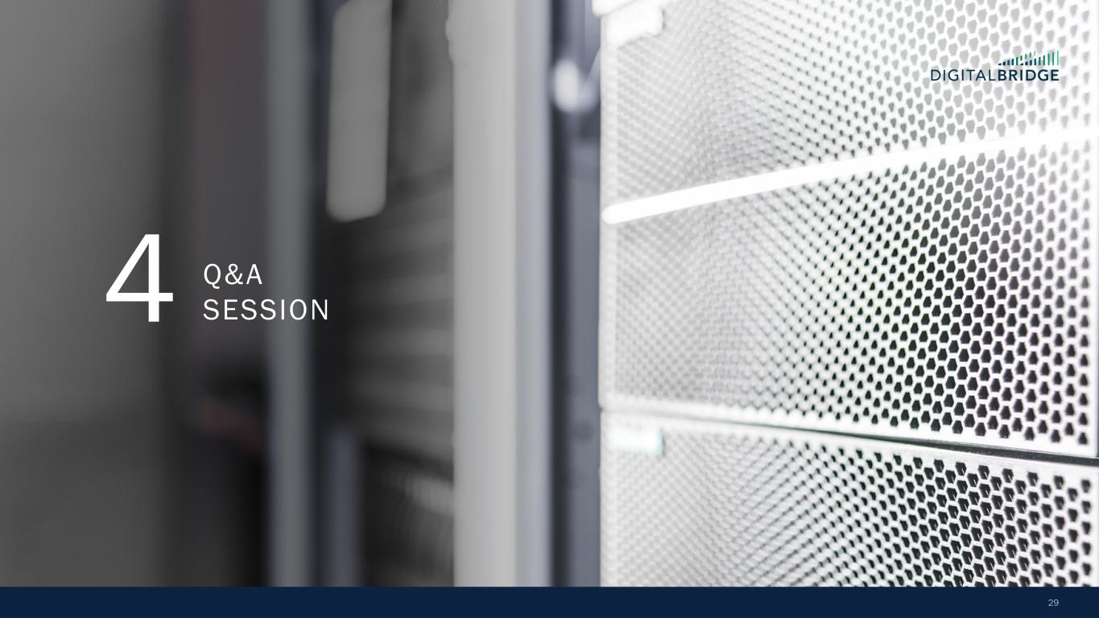
29 4 Q&A SESSION


30 5 SUPPLEMENTAL FINANCIAL DATA

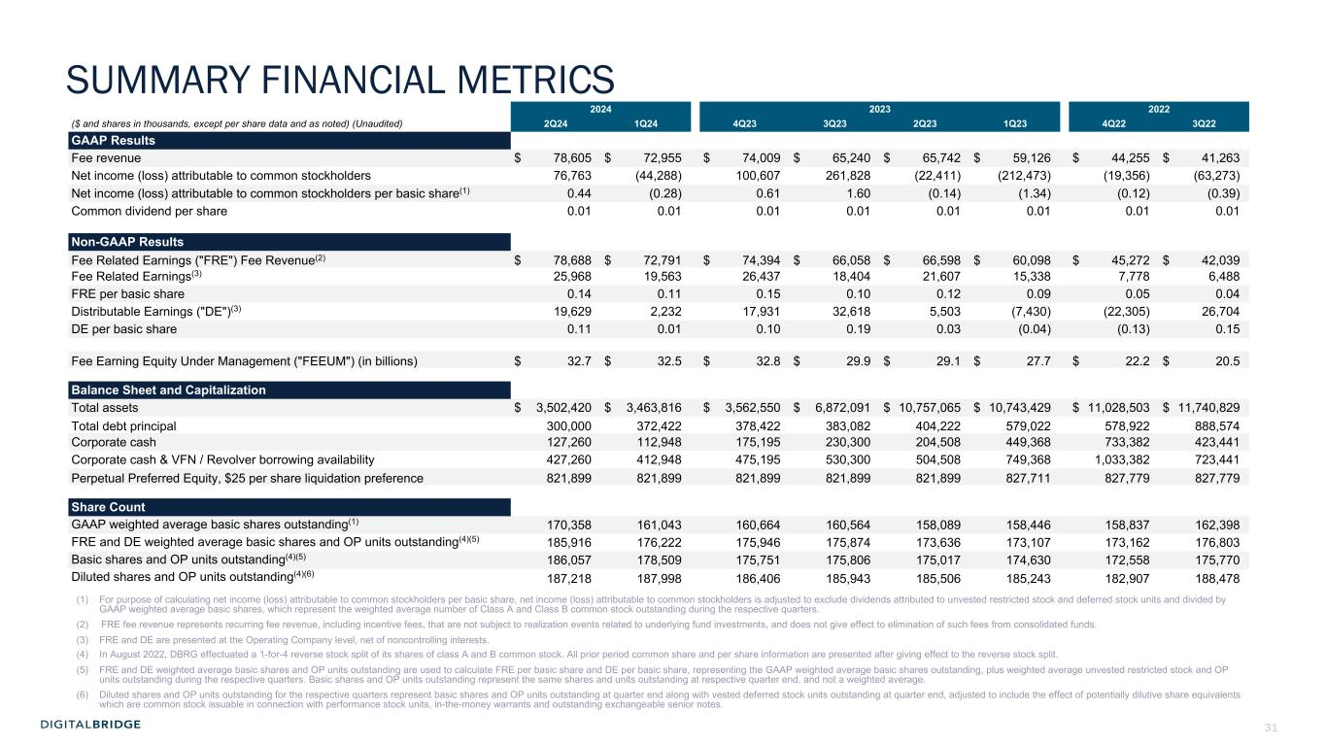
31 2024 2023 2022 ($ and shares in thousands, except per share data and as noted) (Unaudited) 2Q24 1Q24 4Q23 3Q23 2Q23 1Q23 4Q22 3Q22 GAAP Results Fee revenue $ 78,605 $ 72,955 $ 74,009 $ 65,240 $ 65,742 $ 59,126 $ 44,255 $ 41,263 Net income (loss) attributable to common stockholders 76,763 (44,288) 100,607 261,828 (22,411) (212,473) (19,356) (63,273) Net income (loss) attributable to common stockholders per basic share(1) 0.44 (0.28) 0.61 1.60 (0.14) (1.34) (0.12) (0.39) Common dividend per share 0.01 0.01 0.01 0.01 0.01 0.01 0.01 0.01 Non-GAAP Results Fee Related Earnings ("FRE") Fee Revenue(2) $ 78,688 $ 72,791 $ 74,394 $ 66,058 $ 66,598 $ 60,098 $ 45,272 $ 42,039 Fee Related Earnings(3) 25,968 19,563 26,437 18,404 21,607 15,338 7,778 6,488 FRE per basic share 0.14 0.11 0.15 0.10 0.12 0.09 0.05 0.04 Distributable Earnings ("DE")(3) 19,629 2,232 17,931 32,618 5,503 (7,430) (22,305) 26,704 DE per basic share 0.11 0.01 0.10 0.19 0.03 (0.04) (0.13) 0.15 Fee Earning Equity Under Management ("FEEUM") (in billions) $ 32.7 $ 32.5 $ 32.8 $ 29.9 $ 29.1 $ 27.7 $ 22.2 $ 20.5 Balance Sheet and Capitalization Total assets $ 3,502,420 $ 3,463,816 $ 3,562,550 $ 6,872,091 $ 10,757,065 $ 10,743,429 $ 11,028,503 $ 11,740,829 Total debt principal 300,000 372,422 378,422 383,082 404,222 579,022 578,922 888,574 Corporate cash 127,260 112,948 175,195 230,300 204,508 449,368 733,382 423,441 Corporate cash & VFN / Revolver borrowing availability 427,260 412,948 475,195 530,300 504,508 749,368 1,033,382 723,441 Perpetual Preferred Equity, $25 per share liquidation preference 821,899 821,899 821,899 821,899 821,899 827,711 827,779 827,779 Share Count GAAP weighted average basic shares outstanding(1) 170,358 161,043 160,664 160,564 158,089 158,446 158,837 162,398 FRE and DE weighted average basic shares and OP units outstanding(4)(5) 185,916 176,222 175,946 175,874 173,636 173,107 173,162 176,803 Basic shares and OP units outstanding(4)(5) 186,057 178,509 175,751 175,806 175,017 174,630 172,558 175,770 Diluted shares and OP units outstanding(4)(6) 187,218 187,998 186,406 185,943 185,506 185,243 182,907 188,478 (1) For purpose of calculating net income (loss) attributable to common stockholders per basic share, net income (loss) attributable to common stockholders is adjusted to exclude dividends attributed to unvested restricted stock and deferred stock units and divided by GAAP weighted average basic shares, which represent the weighted average number of Class A and Class B common stock outstanding during the respective quarters. (2) FRE fee revenue represents recurring fee revenue, including incentive fees, that are not subject to realization events related to underlying fund investments, and does not give effect to elimination of such fees from consolidated funds. (3) FRE and DE are presented at the Operating Company level, net of noncontrolling interests. (4) In August 2022, DBRG effectuated a 1-for-4 reverse stock split of its shares of class A and B common stock. All prior period common share and per share information are presented after giving effect to the reverse stock split. (5) FRE and DE weighted average basic shares and OP units outstanding are used to calculate FRE per basic share and DE per basic share, representing the GAAP weighted average basic shares outstanding, plus weighted average unvested restricted stock and OP units outstanding during the respective quarters. Basic shares and OP units outstanding represent the same shares and units outstanding at respective quarter end, and not a weighted average. (6) Diluted shares and OP units outstanding for the respective quarters represent basic shares and OP units outstanding at quarter end along with vested deferred stock units outstanding at quarter end, adjusted to include the effect of potentially dilutive share equivalents which are common stock issuable in connection with performance stock units, in-the-money warrants and outstanding exchangeable senior notes. SUMMARY FINANCIAL METRICS

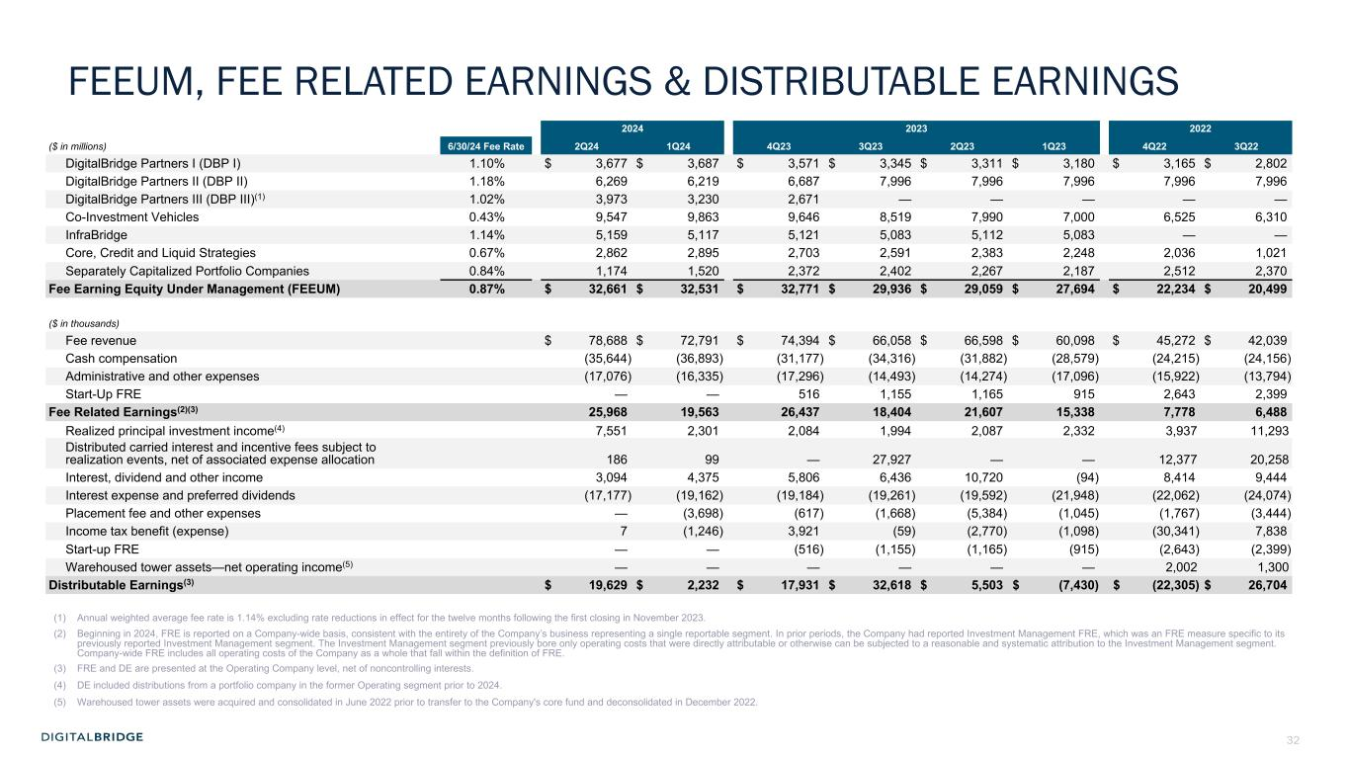
32 2024 2023 2022 ($ in millions) 6/30/24 Fee Rate 2Q24 1Q24 4Q23 3Q23 2Q23 1Q23 4Q22 3Q22 DigitalBridge Partners I (DBP I) 1.10% $ 3,677 $ 3,687 $ 3,571 $ 3,345 $ 3,311 $ 3,180 $ 3,165 $ 2,802 DigitalBridge Partners II (DBP II) 1.18% 6,269 6,219 6,687 7,996 7,996 7,996 7,996 7,996 DigitalBridge Partners III (DBP III)(1) 1.02% 3,973 3,230 2,671 — — — — — Co-Investment Vehicles 0.43% 9,547 9,863 9,646 8,519 7,990 7,000 6,525 6,310 InfraBridge 1.14% 5,159 5,117 5,121 5,083 5,112 5,083 — — Core, Credit and Liquid Strategies 0.67% 2,862 2,895 2,703 2,591 2,383 2,248 2,036 1,021 Separately Capitalized Portfolio Companies 0.84% 1,174 1,520 2,372 2,402 2,267 2,187 2,512 2,370 Fee Earning Equity Under Management (FEEUM) 0.87% $ 32,661 $ 32,531 $ 32,771 $ 29,936 $ 29,059 $ 27,694 $ 22,234 $ 20,499 ($ in thousands) Fee revenue $ 78,688 $ 72,791 $ 74,394 $ 66,058 $ 66,598 $ 60,098 $ 45,272 $ 42,039 Cash compensation (35,644) (36,893) (31,177) (34,316) (31,882) (28,579) (24,215) (24,156) Administrative and other expenses (17,076) (16,335) (17,296) (14,493) (14,274) (17,096) (15,922) (13,794) Start-Up FRE — — 516 1,155 1,165 915 2,643 2,399 Fee Related Earnings(2)(3) 25,968 19,563 26,437 18,404 21,607 15,338 7,778 6,488 Realized principal investment income(4) 7,551 2,301 2,084 1,994 2,087 2,332 3,937 11,293 Distributed carried interest and incentive fees subject to realization events, net of associated expense allocation 186 99 — 27,927 — — 12,377 20,258 Interest, dividend and other income 3,094 4,375 5,806 6,436 10,720 (94) 8,414 9,444 Interest expense and preferred dividends (17,177) (19,162) (19,184) (19,261) (19,592) (21,948) (22,062) (24,074) Placement fee and other expenses — (3,698) (617) (1,668) (5,384) (1,045) (1,767) (3,444) Income tax benefit (expense) 7 (1,246) 3,921 (59) (2,770) (1,098) (30,341) 7,838 Start-up FRE — — (516) (1,155) (1,165) (915) (2,643) (2,399) Warehoused tower assets—net operating income(5) — — — — — — 2,002 1,300 Distributable Earnings(3) $ 19,629 $ 2,232 $ 17,931 $ 32,618 $ 5,503 $ (7,430) $ (22,305) $ 26,704 (1) Annual weighted average fee rate is 1.14% excluding rate reductions in effect for the twelve months following the first closing in November 2023. (2) Beginning in 2024, FRE is reported on a Company-wide basis, consistent with the entirety of the Company’s business representing a single reportable segment. In prior periods, the Company had reported Investment Management FRE, which was an FRE measure specific to its previously reported Investment Management segment. The Investment Management segment previously bore only operating costs that were directly attributable or otherwise can be subjected to a reasonable and systematic attribution to the Investment Management segment. Company-wide FRE includes all operating costs of the Company as a whole that fall within the definition of FRE. (3) FRE and DE are presented at the Operating Company level, net of noncontrolling interests. (4) DE included distributions from a portfolio company in the former Operating segment prior to 2024. (5) Warehoused tower assets were acquired and consolidated in June 2022 prior to transfer to the Company's core fund and deconsolidated in December 2022. FEEUM, FEE RELATED EARNINGS & DISTRIBUTABLE EARNINGS

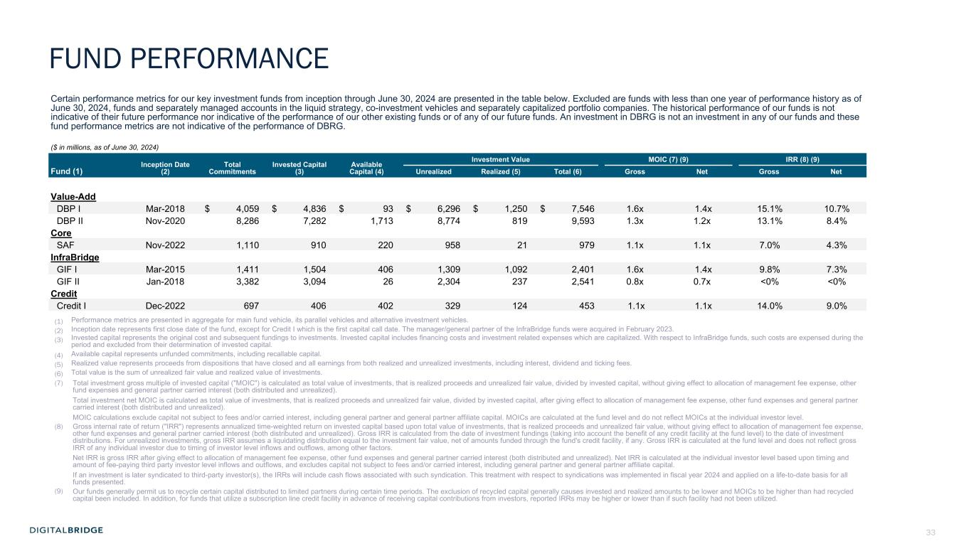
33 Certain performance metrics for our key investment funds from inception through June 30, 2024 are presented in the table below. Excluded are funds with less than one year of performance history as of June 30, 2024, funds and separately managed accounts in the liquid strategy, co-investment vehicles and separately capitalized portfolio companies. The historical performance of our funds is not indicative of their future performance nor indicative of the performance of our other existing funds or of any of our future funds. An investment in DBRG is not an investment in any of our funds and these fund performance metrics are not indicative of the performance of DBRG. ($ in millions, as of June 30, 2024) Inception Date (2) Total Commitments Invested Capital (3) Available Capital (4) Investment Value MOIC (7) (9) IRR (8) (9) Fund (1) Unrealized Realized (5) Total (6) Gross Net Gross Net Value-Add DBP I Mar-2018 $ 4,059 $ 4,836 $ 93 $ 6,296 $ 1,250 $ 7,546 1.6x 1.4x 15.1% 10.7% DBP II Nov-2020 8,286 7,282 1,713 8,774 819 9,593 1.3x 1.2x 13.1% 8.4% Core SAF Nov-2022 1,110 910 220 958 21 979 1.1x 1.1x 7.0% 4.3% InfraBridge GIF I Mar-2015 1,411 1,504 406 1,309 1,092 2,401 1.6x 1.4x 9.8% 7.3% GIF II Jan-2018 3,382 3,094 26 2,304 237 2,541 0.8x 0.7x <0% <0% Credit Credit I Dec-2022 697 406 402 329 124 453 1.1x 1.1x 14.0% 9.0% (1) Performance metrics are presented in aggregate for main fund vehicle, its parallel vehicles and alternative investment vehicles. (2) Inception date represents first close date of the fund, except for Credit I which is the first capital call date. The manager/general partner of the InfraBridge funds were acquired in February 2023. (3) Invested capital represents the original cost and subsequent fundings to investments. Invested capital includes financing costs and investment related expenses which are capitalized. With respect to InfraBridge funds, such costs are expensed during the period and excluded from their determination of invested capital. (4) Available capital represents unfunded commitments, including recallable capital. (5) Realized value represents proceeds from dispositions that have closed and all earnings from both realized and unrealized investments, including interest, dividend and ticking fees. (6) Total value is the sum of unrealized fair value and realized value of investments. (7) Total investment gross multiple of invested capital ("MOIC") is calculated as total value of investments, that is realized proceeds and unrealized fair value, divided by invested capital, without giving effect to allocation of management fee expense, other fund expenses and general partner carried interest (both distributed and unrealized). Total investment net MOIC is calculated as total value of investments, that is realized proceeds and unrealized fair value, divided by invested capital, after giving effect to allocation of management fee expense, other fund expenses and general partner carried interest (both distributed and unrealized). MOIC calculations exclude capital not subject to fees and/or carried interest, including general partner and general partner affiliate capital. MOICs are calculated at the fund level and do not reflect MOICs at the individual investor level. (8) Gross internal rate of return ("IRR") represents annualized time-weighted return on invested capital based upon total value of investments, that is realized proceeds and unrealized fair value, without giving effect to allocation of management fee expense, other fund expenses and general partner carried interest (both distributed and unrealized). Gross IRR is calculated from the date of investment fundings (taking into account the benefit of any credit facility at the fund level) to the date of investment distributions. For unrealized investments, gross IRR assumes a liquidating distribution equal to the investment fair value, net of amounts funded through the fund's credit facility, if any. Gross IRR is calculated at the fund level and does not reflect gross IRR of any individual investor due to timing of investor level inflows and outflows, among other factors. Net IRR is gross IRR after giving effect to allocation of management fee expense, other fund expenses and general partner carried interest (both distributed and unrealized). Net IRR is calculated at the individual investor level based upon timing and amount of fee-paying third party investor level inflows and outflows, and excludes capital not subject to fees and/or carried interest, including general partner and general partner affiliate capital. If an investment is later syndicated to third-party investor(s), the IRRs will include cash flows associated with such syndication. This treatment with respect to syndications was implemented in fiscal year 2024 and applied on a life-to-date basis for all funds presented. (9) Our funds generally permit us to recycle certain capital distributed to limited partners during certain time periods. The exclusion of recycled capital generally causes invested and realized amounts to be lower and MOICs to be higher than had recycled capital been included. In addition, for funds that utilize a subscription line credit facility in advance of receiving capital contributions from investors, reported IRRs may be higher or lower than if such facility had not been utilized. FUND PERFORMANCE

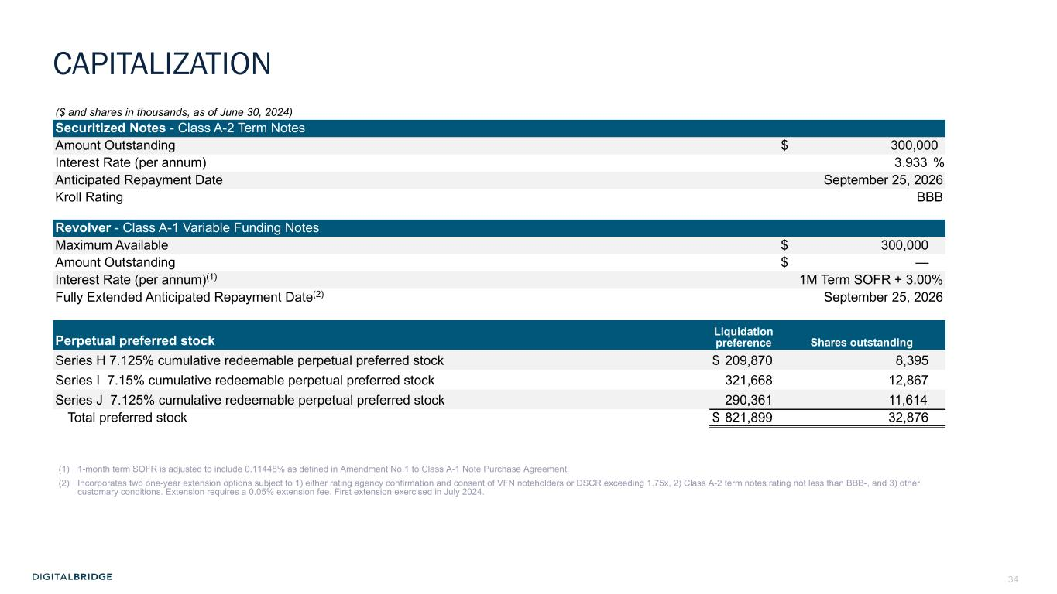
34 ($ and shares in thousands, as of June 30, 2024) Securitized Notes - Class A-2 Term Notes Amount Outstanding $ 300,000 Interest Rate (per annum) 3.933 % Anticipated Repayment Date September 25, 2026 Kroll Rating BBB Revolver - Class A-1 Variable Funding Notes Maximum Available $ 300,000 Amount Outstanding $ — Interest Rate (per annum)(1) 1M Term SOFR + 3.00% Fully Extended Anticipated Repayment Date(2) September 25, 2026 Liquidation preference Shares outstandingPerpetual preferred stock Series H 7.125% cumulative redeemable perpetual preferred stock $ 209,870 8,395 Series I 7.15% cumulative redeemable perpetual preferred stock 321,668 12,867 Series J 7.125% cumulative redeemable perpetual preferred stock 290,361 11,614 Total preferred stock $ 821,899 32,876 (1) 1-month term SOFR is adjusted to include 0.11448% as defined in Amendment No.1 to Class A-1 Note Purchase Agreement. (2) Incorporates two one-year extension options subject to 1) either rating agency confirmation and consent of VFN noteholders or DSCR exceeding 1.75x, 2) Class A-2 term notes rating not less than BBB-, and 3) other customary conditions. Extension requires a 0.05% extension fee. First extension exercised in July 2024. CAPITALIZATION

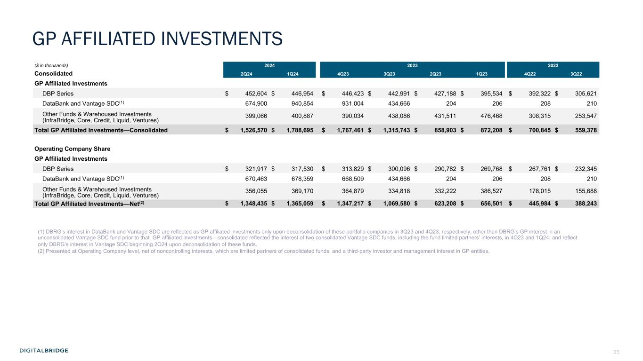
35 ($ in thousands) 2024 2023 2022 Consolidated 2Q24 1Q24 4Q23 3Q23 2Q23 1Q23 4Q22 3Q22 GP Affiliated Investments DBP Series $ 452,604 $ 446,954 $ 446,423 $ 442,991 $ 427,188 $ 395,534 $ 392,322 $ 305,621 DataBank and Vantage SDC(1) 674,900 940,854 931,004 434,666 204 206 208 210 Other Funds & Warehoused Investments (InfraBridge, Core, Credit, Liquid, Ventures) 399,066 400,887 390,034 438,086 431,511 476,468 308,315 253,547 Total GP Affiliated Investments—Consolidated $ 1,526,570 $ 1,788,695 $ 1,767,461 $ 1,315,743 $ 858,903 $ 872,208 $ 700,845 $ 559,378 Operating Company Share GP Affiliated Investments DBP Series $ 321,917 $ 317,530 $ 313,829 $ 300,096 $ 290,782 $ 269,768 $ 267,761 $ 232,345 DataBank and Vantage SDC(1) 670,463 678,359 668,509 434,666 204 206 208 210 Other Funds & Warehoused Investments (InfraBridge, Core, Credit, Liquid, Ventures) 356,055 369,170 364,879 334,818 332,222 386,527 178,015 155,688 Total GP Affiliated Investments—Net(2) $ 1,348,435 $ 1,365,059 $ 1,347,217 $ 1,069,580 $ 623,208 $ 656,501 $ 445,984 $ 388,243 (1) DBRG’s interest in DataBank and Vantage SDC are reflected as GP affiliated investments only upon deconsolidation of these portfolio companies in 3Q23 and 4Q23, respectively, other than DBRG’s GP interest in an unconsolidated Vantage SDC fund prior to that. GP affiliated investments—consolidated reflected the interest of two consolidated Vantage SDC funds, including the fund limited partners’ interests, in 4Q23 and 1Q24, and reflect only DBRG’s interest in Vantage SDC beginning 2Q24 upon deconsolidation of these funds. (2) Presented at Operating Company level, net of noncontrolling interests, which are limited partners of consolidated funds, and a third-party investor and management interest in GP entities. GP AFFILIATED INVESTMENTS

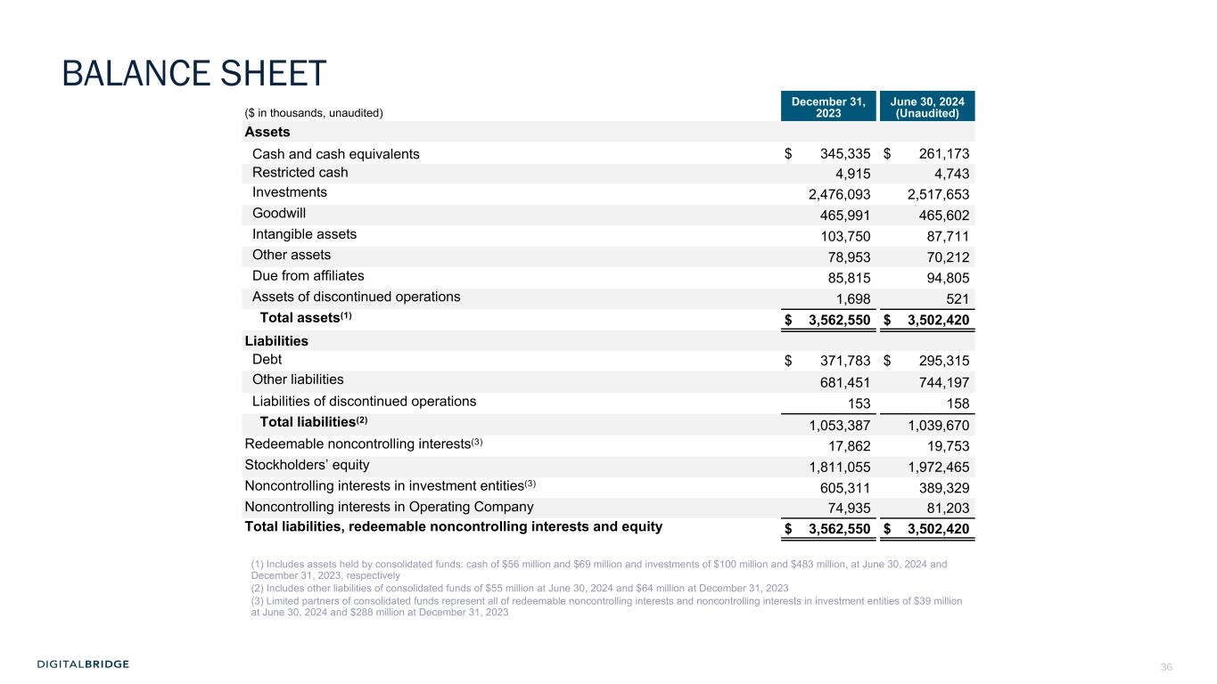
36 ($ in thousands, unaudited) December 31, 2023 June 30, 2024 (Unaudited) Assets Cash and cash equivalents $ 345,335 $ 261,173 Restricted cash 4,915 4,743 Investments 2,476,093 2,517,653 Goodwill 465,991 465,602 Intangible assets 103,750 87,711 Other assets 78,953 70,212 Due from affiliates 85,815 94,805 Assets of discontinued operations 1,698 521 Total assets(1) $ 3,562,550 $ 3,502,420 Liabilities Debt $ 371,783 $ 295,315 Other liabilities 681,451 744,197 Liabilities of discontinued operations 153 158 Total liabilities(2) 1,053,387 1,039,670 Redeemable noncontrolling interests(3) 17,862 19,753 Stockholders’ equity 1,811,055 1,972,465 Noncontrolling interests in investment entities(3) 605,311 389,329 Noncontrolling interests in Operating Company 74,935 81,203 Total liabilities, redeemable noncontrolling interests and equity $ 3,562,550 $ 3,502,420 (1) Includes assets held by consolidated funds: cash of $56 million and $69 million and investments of $100 million and $483 million, at June 30, 2024 and December 31, 2023, respectively (2) Includes other liabilities of consolidated funds of $55 million at June 30, 2024 and $64 million at December 31, 2023 (3) Limited partners of consolidated funds represent all of redeemable noncontrolling interests and noncontrolling interests in investment entities of $39 million at June 30, 2024 and $288 million at December 31, 2023 BALANCE SHEET

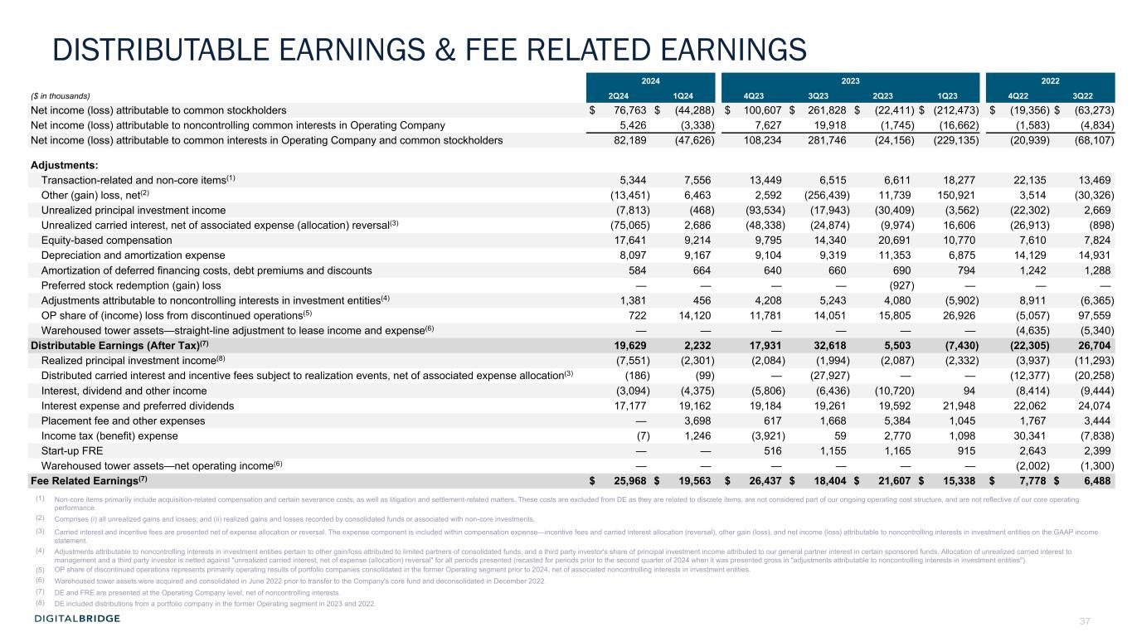
37 DISTRIBUTABLE EARNINGS & FEE RELATED EARNINGS 2024 2023 2022 ($ in thousands) 2Q24 1Q24 4Q23 3Q23 2Q23 1Q23 4Q22 3Q22 Net income (loss) attributable to common stockholders $ 76,763 $ (44,288) $ 100,607 $ 261,828 $ (22,411) $ (212,473) $ (19,356) $ (63,273) Net income (loss) attributable to noncontrolling common interests in Operating Company 5,426 (3,338) 7,627 19,918 (1,745) (16,662) (1,583) (4,834) Net income (loss) attributable to common interests in Operating Company and common stockholders 82,189 (47,626) 108,234 281,746 (24,156) (229,135) (20,939) (68,107) Adjustments: Transaction-related and non-core items(1) 5,344 7,556 13,449 6,515 6,611 18,277 22,135 13,469 Other (gain) loss, net(2) (13,451) 6,463 2,592 (256,439) 11,739 150,921 3,514 (30,326) Unrealized principal investment income (7,813) (468) (93,534) (17,943) (30,409) (3,562) (22,302) 2,669 Unrealized carried interest, net of associated expense (allocation) reversal(3) (75,065) 2,686 (48,338) (24,874) (9,974) 16,606 (26,913) (898) Equity-based compensation 17,641 9,214 9,795 14,340 20,691 10,770 7,610 7,824 Depreciation and amortization expense 8,097 9,167 9,104 9,319 11,353 6,875 14,129 14,931 Amortization of deferred financing costs, debt premiums and discounts 584 664 640 660 690 794 1,242 1,288 Preferred stock redemption (gain) loss — — — — (927) — — — Adjustments attributable to noncontrolling interests in investment entities(4) 1,381 456 4,208 5,243 4,080 (5,902) 8,911 (6,365) OP share of (income) loss from discontinued operations(5) 722 14,120 11,781 14,051 15,805 26,926 (5,057) 97,559 Warehoused tower assets—straight-line adjustment to lease income and expense(6) — — — — — — (4,635) (5,340) Distributable Earnings (After Tax)(7) 19,629 2,232 17,931 32,618 5,503 (7,430) (22,305) 26,704 Realized principal investment income(8) (7,551) (2,301) (2,084) (1,994) (2,087) (2,332) (3,937) (11,293) Distributed carried interest and incentive fees subject to realization events, net of associated expense allocation(3) (186) (99) — (27,927) — — (12,377) (20,258) Interest, dividend and other income (3,094) (4,375) (5,806) (6,436) (10,720) 94 (8,414) (9,444) Interest expense and preferred dividends 17,177 19,162 19,184 19,261 19,592 21,948 22,062 24,074 Placement fee and other expenses — 3,698 617 1,668 5,384 1,045 1,767 3,444 Income tax (benefit) expense (7) 1,246 (3,921) 59 2,770 1,098 30,341 (7,838) Start-up FRE — — 516 1,155 1,165 915 2,643 2,399 Warehoused tower assets—net operating income(6) — — — — — — (2,002) (1,300) Fee Related Earnings(7) $ 25,968 $ 19,563 $ 26,437 $ 18,404 $ 21,607 $ 15,338 $ 7,778 $ 6,488 (1) Non-core items primarily include acquisition-related compensation and certain severance costs, as well as litigation and settlement-related matters. These costs are excluded from DE as they are related to discrete items, are not considered part of our ongoing operating cost structure, and are not reflective of our core operating performance. (2) Comprises (i) all unrealized gains and losses; and (ii) realized gains and losses recorded by consolidated funds or associated with non-core investments. (3) Carried interest and incentive fees are presented net of expense allocation or reversal. The expense component is included within compensation expense—incentive fees and carried interest allocation (reversal), other gain (loss), and net income (loss) attributable to noncontrolling interests in investment entities on the GAAP income statement. (4) Adjustments attributable to noncontrolling interests in investment entities pertain to other gain/loss attributed to limited partners of consolidated funds, and a third party investor's share of principal investment income attributed to our general partner interest in certain sponsored funds. Allocation of unrealized carried interest to management and a third party investor is netted against "unrealized carried interest, net of expense (allocation) reversal" for all periods presented (recasted for periods prior to the second quarter of 2024 when it was presented gross in "adjustments attributable to noncontrolling interests in investment entities"). (5) OP share of discontinued operations represents primarily operating results of portfolio companies consolidated in the former Operating segment prior to 2024, net of associated noncontrolling interests in investment entities. (6) Warehoused tower assets were acquired and consolidated in June 2022 prior to transfer to the Company's core fund and deconsolidated in December 2022. (7) DE and FRE are presented at the Operating Company level, net of noncontrolling interests. (8) DE included distributions from a portfolio company in the former Operating segment in 2023 and 2022.

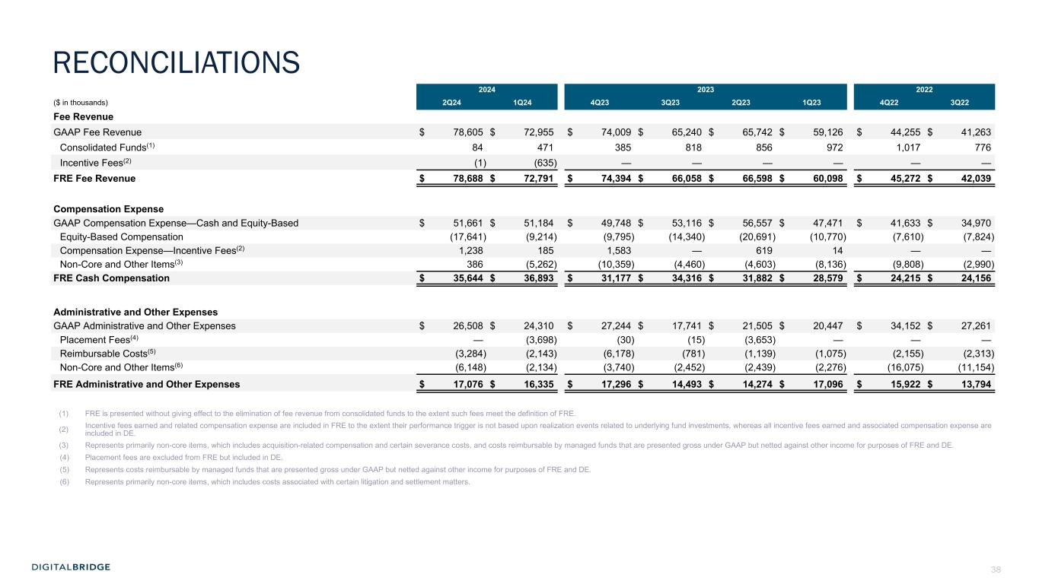
38 2024 2023 2022 ($ in thousands) 2Q24 1Q24 4Q23 3Q23 2Q23 1Q23 4Q22 3Q22 Fee Revenue GAAP Fee Revenue $ 78,605 $ 72,955 $ 74,009 $ 65,240 $ 65,742 $ 59,126 $ 44,255 $ 41,263 Consolidated Funds(1) 84 471 385 818 856 972 1,017 776 Incentive Fees(2) (1) (635) — — — — — — FRE Fee Revenue $ 78,688 $ 72,791 $ 74,394 $ 66,058 $ 66,598 $ 60,098 $ 45,272 $ 42,039 Compensation Expense GAAP Compensation Expense—Cash and Equity-Based $ 51,661 $ 51,184 $ 49,748 $ 53,116 $ 56,557 $ 47,471 $ 41,633 $ 34,970 Equity-Based Compensation (17,641) (9,214) (9,795) (14,340) (20,691) (10,770) (7,610) (7,824) Compensation Expense—Incentive Fees(2) 1,238 185 1,583 — 619 14 — — Non-Core and Other Items(3) 386 (5,262) (10,359) (4,460) (4,603) (8,136) (9,808) (2,990) FRE Cash Compensation $ 35,644 $ 36,893 $ 31,177 $ 34,316 $ 31,882 $ 28,579 $ 24,215 $ 24,156 Administrative and Other Expenses GAAP Administrative and Other Expenses $ 26,508 $ 24,310 $ 27,244 $ 17,741 $ 21,505 $ 20,447 $ 34,152 $ 27,261 Placement Fees(4) — (3,698) (30) (15) (3,653) — — — Reimbursable Costs(5) (3,284) (2,143) (6,178) (781) (1,139) (1,075) (2,155) (2,313) Non-Core and Other Items(6) (6,148) (2,134) (3,740) (2,452) (2,439) (2,276) (16,075) (11,154) FRE Administrative and Other Expenses $ 17,076 $ 16,335 $ 17,296 $ 14,493 $ 14,274 $ 17,096 $ 15,922 $ 13,794 (1) FRE is presented without giving effect to the elimination of fee revenue from consolidated funds to the extent such fees meet the definition of FRE. (2) Incentive fees earned and related compensation expense are included in FRE to the extent their performance trigger is not based upon realization events related to underlying fund investments, whereas all incentive fees earned and associated compensation expense are included in DE. (3) Represents primarily non-core items, which includes acquisition-related compensation and certain severance costs, and costs reimbursable by managed funds that are presented gross under GAAP but netted against other income for purposes of FRE and DE. (4) Placement fees are excluded from FRE but included in DE. (5) Represents costs reimbursable by managed funds that are presented gross under GAAP but netted against other income for purposes of FRE and DE. (6) Represents primarily non-core items, which includes costs associated with certain litigation and settlement matters. RECONCILIATIONS

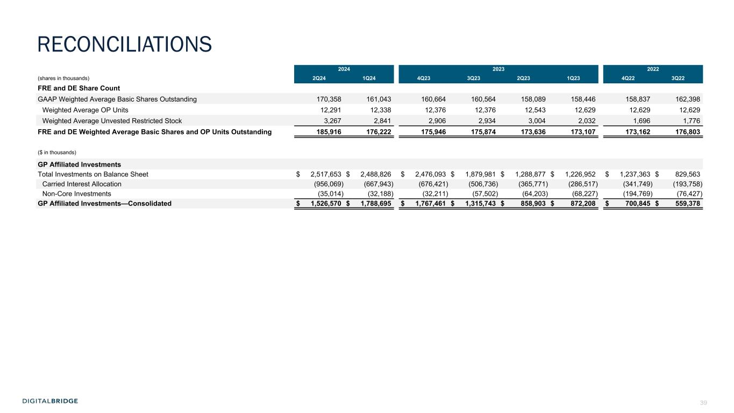
39 2024 2023 2022 (shares in thousands) 2Q24 1Q24 4Q23 3Q23 2Q23 1Q23 4Q22 3Q22 FRE and DE Share Count GAAP Weighted Average Basic Shares Outstanding 170,358 161,043 160,664 160,564 158,089 158,446 158,837 162,398 Weighted Average OP Units 12,291 12,338 12,376 12,376 12,543 12,629 12,629 12,629 Weighted Average Unvested Restricted Stock 3,267 2,841 2,906 2,934 3,004 2,032 1,696 1,776 FRE and DE Weighted Average Basic Shares and OP Units Outstanding 185,916 176,222 175,946 175,874 173,636 173,107 173,162 176,803 ($ in thousands) GP Affiliated Investments Total Investments on Balance Sheet $ 2,517,653 $ 2,488,826 $ 2,476,093 $ 1,879,981 $ 1,288,877 $ 1,226,952 $ 1,237,363 $ 829,563 Carried Interest Allocation (956,069) (667,943) (676,421) (506,736) (365,771) (286,517) (341,749) (193,758) Non-Core Investments (35,014) (32,188) (32,211) (57,502) (64,203) (68,227) (194,769) (76,427) GP Affiliated Investments—Consolidated $ 1,526,570 $ 1,788,695 $ 1,767,461 $ 1,315,743 $ 858,903 $ 872,208 $ 700,845 $ 559,378 RECONCILIATIONS


40 6 APPENDIX

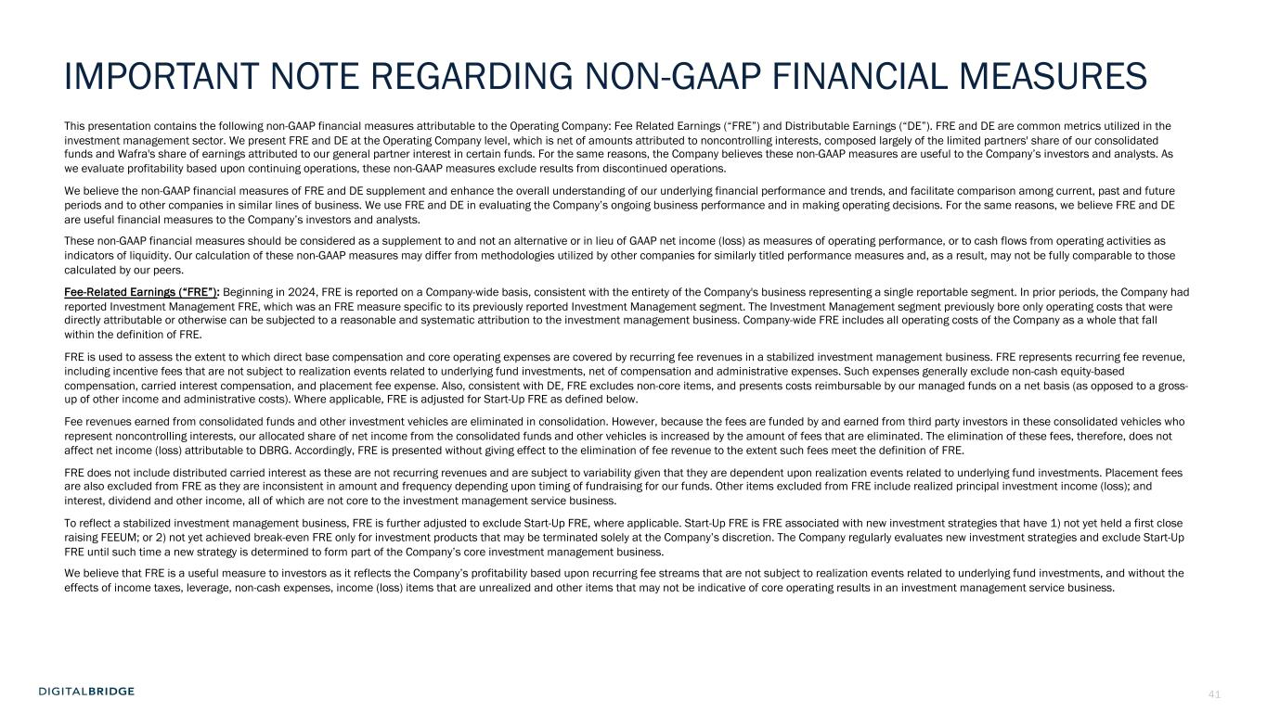
41 This presentation contains the following non-GAAP financial measures attributable to the Operating Company: Fee Related Earnings (“FRE”) and Distributable Earnings (“DE”). FRE and DE are common metrics utilized in the investment management sector. We present FRE and DE at the Operating Company level, which is net of amounts attributed to noncontrolling interests, composed largely of the limited partners' share of our consolidated funds and Wafra's share of earnings attributed to our general partner interest in certain funds. For the same reasons, the Company believes these non-GAAP measures are useful to the Company’s investors and analysts. As we evaluate profitability based upon continuing operations, these non-GAAP measures exclude results from discontinued operations. We believe the non-GAAP financial measures of FRE and DE supplement and enhance the overall understanding of our underlying financial performance and trends, and facilitate comparison among current, past and future periods and to other companies in similar lines of business. We use FRE and DE in evaluating the Company’s ongoing business performance and in making operating decisions. For the same reasons, we believe FRE and DE are useful financial measures to the Company’s investors and analysts. These non-GAAP financial measures should be considered as a supplement to and not an alternative or in lieu of GAAP net income (loss) as measures of operating performance, or to cash flows from operating activities as indicators of liquidity. Our calculation of these non-GAAP measures may differ from methodologies utilized by other companies for similarly titled performance measures and, as a result, may not be fully comparable to those calculated by our peers. Fee-Related Earnings (“FRE”): Beginning in 2024, FRE is reported on a Company-wide basis, consistent with the entirety of the Company's business representing a single reportable segment. In prior periods, the Company had reported Investment Management FRE, which was an FRE measure specific to its previously reported Investment Management segment. The Investment Management segment previously bore only operating costs that were directly attributable or otherwise can be subjected to a reasonable and systematic attribution to the investment management business. Company-wide FRE includes all operating costs of the Company as a whole that fall within the definition of FRE. FRE is used to assess the extent to which direct base compensation and core operating expenses are covered by recurring fee revenues in a stabilized investment management business. FRE represents recurring fee revenue, including incentive fees that are not subject to realization events related to underlying fund investments, net of compensation and administrative expenses. Such expenses generally exclude non-cash equity-based compensation, carried interest compensation, and placement fee expense. Also, consistent with DE, FRE excludes non-core items, and presents costs reimbursable by our managed funds on a net basis (as opposed to a gross- up of other income and administrative costs). Where applicable, FRE is adjusted for Start-Up FRE as defined below. Fee revenues earned from consolidated funds and other investment vehicles are eliminated in consolidation. However, because the fees are funded by and earned from third party investors in these consolidated vehicles who represent noncontrolling interests, our allocated share of net income from the consolidated funds and other vehicles is increased by the amount of fees that are eliminated. The elimination of these fees, therefore, does not affect net income (loss) attributable to DBRG. Accordingly, FRE is presented without giving effect to the elimination of fee revenue to the extent such fees meet the definition of FRE. FRE does not include distributed carried interest as these are not recurring revenues and are subject to variability given that they are dependent upon realization events related to underlying fund investments. Placement fees are also excluded from FRE as they are inconsistent in amount and frequency depending upon timing of fundraising for our funds. Other items excluded from FRE include realized principal investment income (loss); and interest, dividend and other income, all of which are not core to the investment management service business. To reflect a stabilized investment management business, FRE is further adjusted to exclude Start-Up FRE, where applicable. Start-Up FRE is FRE associated with new investment strategies that have 1) not yet held a first close raising FEEUM; or 2) not yet achieved break-even FRE only for investment products that may be terminated solely at the Company’s discretion. The Company regularly evaluates new investment strategies and exclude Start-Up FRE until such time a new strategy is determined to form part of the Company’s core investment management business. We believe that FRE is a useful measure to investors as it reflects the Company’s profitability based upon recurring fee streams that are not subject to realization events related to underlying fund investments, and without the effects of income taxes, leverage, non-cash expenses, income (loss) items that are unrealized and other items that may not be indicative of core operating results in an investment management service business. IMPORTANT NOTE REGARDING NON-GAAP FINANCIAL MEASURES

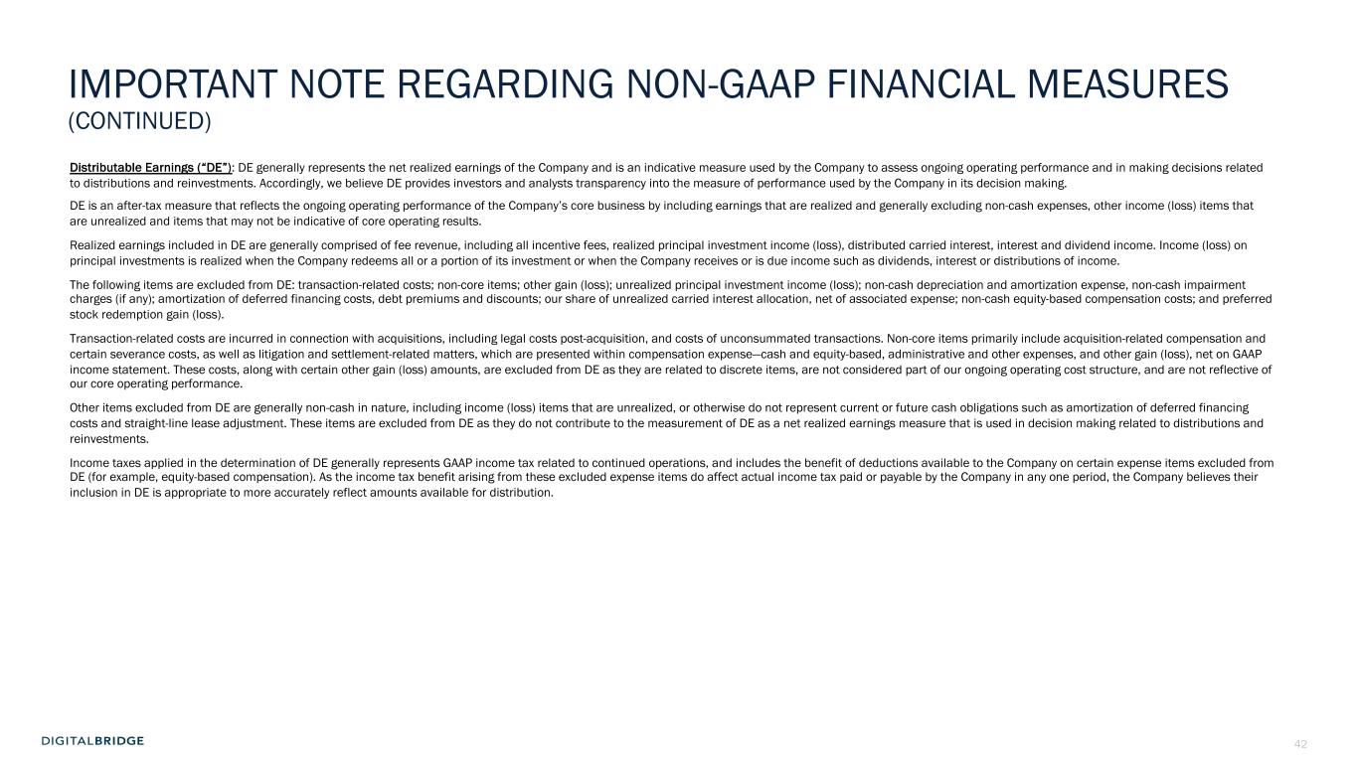
42 Distributable Earnings (“DE”): DE generally represents the net realized earnings of the Company and is an indicative measure used by the Company to assess ongoing operating performance and in making decisions related to distributions and reinvestments. Accordingly, we believe DE provides investors and analysts transparency into the measure of performance used by the Company in its decision making. DE is an after-tax measure that reflects the ongoing operating performance of the Company’s core business by including earnings that are realized and generally excluding non-cash expenses, other income (loss) items that are unrealized and items that may not be indicative of core operating results. Realized earnings included in DE are generally comprised of fee revenue, including all incentive fees, realized principal investment income (loss), distributed carried interest, interest and dividend income. Income (loss) on principal investments is realized when the Company redeems all or a portion of its investment or when the Company receives or is due income such as dividends, interest or distributions of income. The following items are excluded from DE: transaction-related costs; non-core items; other gain (loss); unrealized principal investment income (loss); non-cash depreciation and amortization expense, non-cash impairment charges (if any); amortization of deferred financing costs, debt premiums and discounts; our share of unrealized carried interest allocation, net of associated expense; non-cash equity-based compensation costs; and preferred stock redemption gain (loss). Transaction-related costs are incurred in connection with acquisitions, including legal costs post-acquisition, and costs of unconsummated transactions. Non-core items primarily include acquisition-related compensation and certain severance costs, as well as litigation and settlement-related matters, which are presented within compensation expense—cash and equity-based, administrative and other expenses, and other gain (loss), net on GAAP income statement. These costs, along with certain other gain (loss) amounts, are excluded from DE as they are related to discrete items, are not considered part of our ongoing operating cost structure, and are not reflective of our core operating performance. Other items excluded from DE are generally non-cash in nature, including income (loss) items that are unrealized, or otherwise do not represent current or future cash obligations such as amortization of deferred financing costs and straight-line lease adjustment. These items are excluded from DE as they do not contribute to the measurement of DE as a net realized earnings measure that is used in decision making related to distributions and reinvestments. Income taxes applied in the determination of DE generally represents GAAP income tax related to continued operations, and includes the benefit of deductions available to the Company on certain expense items excluded from DE (for example, equity-based compensation). As the income tax benefit arising from these excluded expense items do affect actual income tax paid or payable by the Company in any one period, the Company believes their inclusion in DE is appropriate to more accurately reflect amounts available for distribution. IMPORTANT NOTE REGARDING NON-GAAP FINANCIAL MEASURES (CONTINUED)

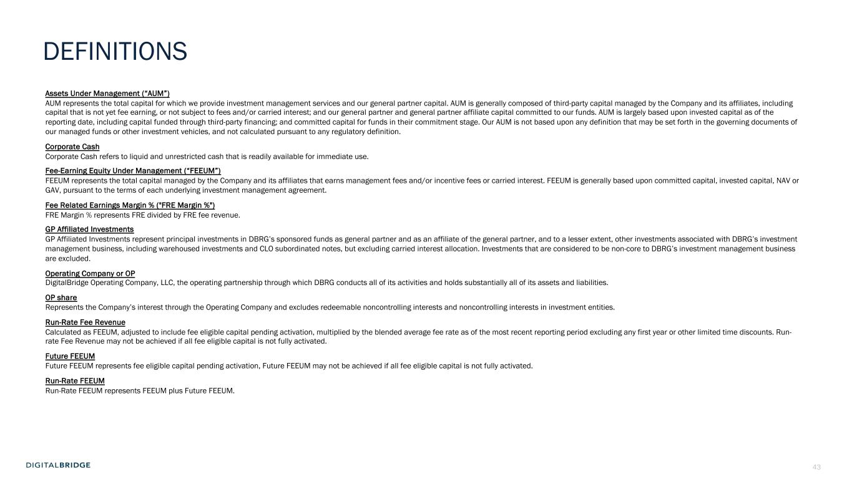
43 DEFINITIONS Assets Under Management (“AUM”) AUM represents the total capital for which we provide investment management services and our general partner capital. AUM is generally composed of third-party capital managed by the Company and its affiliates, including capital that is not yet fee earning, or not subject to fees and/or carried interest; and our general partner and general partner affiliate capital committed to our funds. AUM is largely based upon invested capital as of the reporting date, including capital funded through third-party financing; and committed capital for funds in their commitment stage. Our AUM is not based upon any definition that may be set forth in the governing documents of our managed funds or other investment vehicles, and not calculated pursuant to any regulatory definition. Corporate Cash Corporate Cash refers to liquid and unrestricted cash that is readily available for immediate use. Fee-Earning Equity Under Management (“FEEUM”) FEEUM represents the total capital managed by the Company and its affiliates that earns management fees and/or incentive fees or carried interest. FEEUM is generally based upon committed capital, invested capital, NAV or GAV, pursuant to the terms of each underlying investment management agreement. Fee Related Earnings Margin % ("FRE Margin %") FRE Margin % represents FRE divided by FRE fee revenue. GP Affiliated Investments GP Affiliated Investments represent principal investments in DBRG’s sponsored funds as general partner and as an affiliate of the general partner, and to a lesser extent, other investments associated with DBRG’s investment management business, including warehoused investments and CLO subordinated notes, but excluding carried interest allocation. Investments that are considered to be non-core to DBRG’s investment management business are excluded. Operating Company or OP DigitalBridge Operating Company, LLC, the operating partnership through which DBRG conducts all of its activities and holds substantially all of its assets and liabilities. OP share Represents the Company’s interest through the Operating Company and excludes redeemable noncontrolling interests and noncontrolling interests in investment entities. Run-Rate Fee Revenue Calculated as FEEUM, adjusted to include fee eligible capital pending activation, multiplied by the blended average fee rate as of the most recent reporting period excluding any first year or other limited time discounts. Run- rate Fee Revenue may not be achieved if all fee eligible capital is not fully activated. Future FEEUM Future FEEUM represents fee eligible capital pending activation, Future FEEUM may not be achieved if all fee eligible capital is not fully activated. Run-Rate FEEUM Run-Rate FEEUM represents FEEUM plus Future FEEUM.


44

